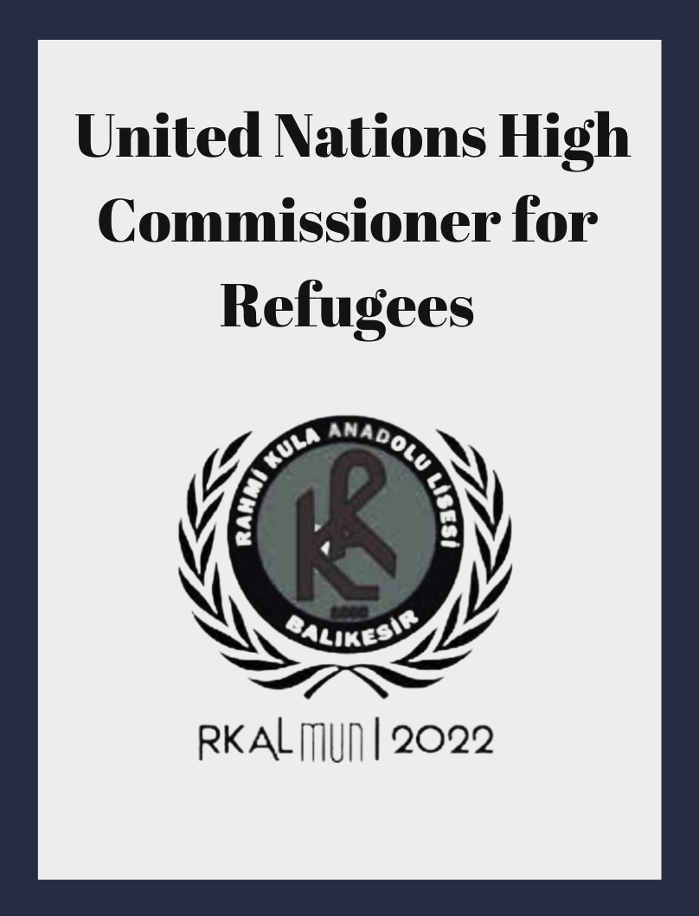

Table of Contents
1.Letter From the Secretary-General
2.Letter From the Under Secretary-General
3.Introducton to the Committee
3.1.Topic to be Discussed and General Overview
3.2.History of the Issue in Hand
3.3.Related Organizations
3.4.Related Agreements
3.5.About the United Nations High Commissioner for Refugees
3.6.Demographics and Statitcs
4.Questions to Consider
5.References

1.Letter From Secretary General
I feel more than honored to be welcoming you to first annual session of Rahmi Kula Anatolian High School Model United Nations . Organized under the framework of Model United Nations it is eager to reach a wide range of attendants from high schools which are deeply interested in diplomacy, international relations, politics, tourism, economy and the United Nations itself while constituting a unique experience of debating and socializing at the same time.
MUN sessions, which were held online with the pandemic, continue their adventure with the effect of the new normal moreover after a long time I share the excitement of the delegates with you.

During the three days of RKALMUN you will simulate all kinds of global issues, I am assured that the participants will observe fruitful debates, participate in reflective activities, and collaborate on marvellous resolutions. With its two General Assembly Committees and five further committees; Commission on the Status of Women (CSW), United Nations High Commissioner for Refugees(UNHCR), World Health Organization (WHO) United Nations Security Council (SC) and World Tourism Organization a UN Specialized Agency (UNWTO).

In the light of these aims, I would like to thank my dear deputies, Mr. Ada Surat and Miss. İlayda Başaran. We worked hard with the organization team in order to make you #FeelTheMoment.
On behalf of our strong and hardworking Secretariat and Executive Team, I welcome all of you to RKALMUN Conference.

Heartily,
Secretary- General
Dilara Çetin

2.Letter From Under-Secretary General
Dear delegates of UNHCR,
It’s a pleasure for me to serve as the Under- Secretary-General of UNHCR in Rahmi Kula Model United Nations conference.In this guide, you will read about the refugee discrimination, related agreements, organizations followed by the statistics. As you read please focus on the sacrifices that have been made by many. If it was worth it, could there be a better way for it to not happen in the future and foremost how we will bind up the wounds that have been open.
Before wrapping up, I would like to thank Yağmur Zülal Yardan; my beloved hardworking Co-Chair, along with our lovely secretariat İlayda Başaran and Dilara Çetin. They were the reason why the preparatory part was nice and smooth as the conference will be.
If you would have any inquiries or questions, please feel free to contact me via emresalur1010@icloud.con
Best regards,
Emre SALUR Under-Secretary-General of UNHCR

3.Introduction to the Committee

3.1. Topic to be Discussed and General Overview
Purpose of this Guidance
States have committed and assumed obligations to address multiple and intersecting forms of discrimination against refugees, internally displaced persons, asylum seekers, returnees and stateless persons. The Global Compact on Refugees places ending discrimination of any kind based on the grounds of race, colour, sex, language, religion, political or other opinion, national or social origin, property, birth, disability, age, or other status at the centre of action to prevent displacement and to ensure peaceful coexistence between refugee and host communities. Narratives about cultural diversity and inclusion are important, but there is also a pressing need in many societies for conversations and action to address racism, racial discrimination, xenophobia and related intolerance.
Racial discrimination and related intolerance are common causes of forced displacement and they can also undermine the protection afforded to refugees, asylum-seekers, internally displaced persons and returnees. Discrimination on the basis of ethnicity, race, religion or language is also a recurrent driver of statelessness, and it is often minority groups who are stateless or at risk of statelessness.1
The Human Rights Liaison Unit in the Protection Policy and Legal Advice (PPLA) section of UNHCR’s Division of International Protection has prepared this Guidance in response to a number of requests for advice from UNHCR operations on issues related to racism and xenophobia affecting persons of concern to UNHCR.
The Guidance aims to:
(1) provide a comprehensive framework for UNHCR’s interventions regarding racism, racial discrimination, xenophobia and related intolerance;
(2) expand the ways UNHCR describes and presents issues related to racism, racial discrimination, xenophobia and related intolerance in order to include intersectional dimensions as well as structural, institutional and historical perspectives;
(3) provide concrete examples of how UNHCR operations have addressed racism, racial discrimination, xenophobia and related intolerance;
(4) highlight avenues to leverage the national, regional and UN human rights mechanisms and other platforms.
3.2.History of the Issue in Hand
Refugee, any uprooted, homeless, involuntary migrant who has crossed a frontier and no longer possesses the protection of his or her former government. Prior to the 19th century the movement from one country to another did not require passports and visas; the right to asylum was commonly recognized and honoured. Although there have been numerous waves of refugees throughout history, there was no refugee problem until the emergence of fixed and closed state frontiers in the late 19th century. By the 1920s and ’30s the tradition of political asylum had deteriorated considerably, partly because of growing insensitivity to human suffering and partly because of unprecedented numbers of refugees.
For many centuries, refugee movements were a result of religious and racial intolerance. Entire groups were uprooted, exiled, or deported by secular or religious authorities in an effort to enforce conformity. Examples of such action include the expulsion of Jews from Spain in the late 15th century, the exodus of Huguenots from France after the revocation of the Edict of Nantes in 1685, and the eviction of Jews from Germany, Austria, and Sudetenland (now in the Czech Republic) in the 1930s
Politically motivated refugee movements, frequent in modern times, have occurred intermittently since the development of governments powerful enough to oppress nonconformist minorities. The Russian Revolution of 1917 and the postrevolutionary civil war (1917–21) caused the exodus of 1.5 million opponents of communism. Between 1915 and 1923 more than 1 million Armenians left Turkish Asia Minor, and several hundred thousand Spanish loyalists fled to France in the wake of the 1936–39 Spanish Civil War. When the People’s Republic of China was established in 1949, more than 2 million Chinese fled to Taiwan and to the British crown colony of Hong Kong. The 1950s were marked by the Korean War (1950–53), the Hungarian Revolution (1956), the Cuban revolution (1959), and the Chinese take-over of Tibet (1959), all of which resulted in the flight of more than a million refugees. Between 1945 and 1961, the year that the communist regime erected the Berlin Wall (opened 1989), more than 3.7 million refugees from East Germany found asylum in West Germany.

Several major refugee movements have been caused by territorial partition. After the defeat of Germany in World War II, for example, the Potsdam Conference of 1945 authorized the transfer of German minorities from a number of European countries, and 12 million Germans were dumped on the truncated territory of Germany, which was split into east and west regions. The partition of the Indian subcontinent in 1947 resulted in the exchange of 18 million Hindus from Pakistan and Muslims from India—the greatest population transfer in history. Some 8–10 million persons were also temporarily made refugees by the creation of Bangladesh in 1971.
Palestine’s partition in 1948 triggered an almost wholesale exodus of Palestinian Arabs in the wake of a military confrontation between the new state of Israel and neighbouring Arab countries. The disintegration of the vast European colonial empires also brought about the return of thousands of British subjects from all parts of Africa and Asia, of French refugees from North Africa and Indochina, of Italians from Libya, and of the Dutch from Indonesia.
International action for refugees did not start until the 1920s. In 1921 Fridtjof Nansen of Norway was appointed by the League of Nations as high commissioner for refugees and devised a so-called League of Nations Passport (“Nansen Passport”), a travel document that gave the owner the right to move more freely across national boundaries. After Nansen’s death in 1930, the protection of refugees was entrusted to the Nansen International Office for Refugees, but this office accomplished little before its mandate expired in 1938. Other refugee-assistance organizations have included the Intergovernmental Committee on Refugees (1938–47), the United Nations Relief and Rehabilitation Refugee Organization (1947–52), and the Office of the United Nations High Commissioner for Refugees (UNHCR), established in 1950. The Intergovernmental Committee for European Migration (renamed the Intergovernmental Committee for Migration in 1980) was founded in 1951. Several nongovernmental and voluntary agencies, such as the International Rescue Committee, have also been established throughout the world.

3.3.Related Organization
United Nations Relief and Works Agency for Palestine Refugees in the Near East –UNRWA
Established in 1949, the United Nations Relief and Works Agency for Palestine Refugees in the Near East (UNRWA) is the UN agency concerned with the Palestinian refugees in Gaza, Jordan, Lebanon, Syria and West Bank. UNRWA focuses its work on the human development of Palestinian refugees, their empowerment and providing them with humanitarian services.

International Organization for Migration – IOM
The International Organization for Migration (IOM) is the UN Migration Agency with focus on regulating global migration in general. Serving this major goal, IOM defined serving refugees within its strategic focus plan. IOM runs projects to support refugees’ integration in countries of asylum, voluntary repatriation to the country of origin or resettlement to third country.

United Nations Children’s Fund – UNICEF
United Nations Children’s Fund is the UN Agency serving mothers and children in developing countries. Children constitute one of the most vulnerable groups during the time of conflict and displacement. In 2015, the number of child refugees was estimated by 10 million. For this reason, UNICEF extends its services to refugees that include: education opportunities for child refugees, enhancing maternity services for pregnant women in camps, and providing vaccines for child refugees.

Save the Children
Save the Children was founded in 1919 to combat hunger in Europe during the First World War. It later extended its activities to respond to the Great Depression in America. Today, Save the Children helps children around the globe in 120 countries. Its services include protecting child refugees in countries such as: Syria, Uganda, Burundi, South Sudan, Egypt, and Myanmar.

World Food Programme – WFP
Established in 1961, the World Food Programme, is the UN Agency that provides food support. It constantly partner with UNHCR to provide food for refugees and displaced people. It also provides water and sanitation services in refugees camps.

The International Committee of the Red Cross – ICRC
The International Committee of the Red Cross is mandated to promote compliance with the Geneva Conventions and principles of International Law. Its work focuses also on protecting victims of conflict such as displaced persons and refugees.

International Catholic Migration Commission – ICMC
In 1951, International Catholic Migration Commission (ICMC) started as another initiative to solve displacement crisis caused by the Second World War. ICMC focuses on serving refugees through various programs; such as: establishing protection centers for Syrian refugees in Jordan, livelihoods support for Afghan refugees in Pakistan, starting refugees’ resettlement support centers in Turkey and Middle East and facilitates the integration of refugees in the European Union.

3.4.Related Agreements
-The 1951 Refugee Convention,
The 1951 Refugee Convention and its 1967 Protocol are the key legal documents that form the basis of our work. With 149 State parties to either or both, they define the term ‘refugee’ and outlines the rights of refugees, as well as the legal obligations of States to protect them.
The core principle is non-refoulement, which asserts that a refugee should not be returned to a country where they face serious threats to their life or freedom. This is now considered a rule of customary international law.
UNHCR serves as the ‘guardian’ of the 1951 Convention and its 1967 Protocol. According to the legislation, States are expected to cooperate with us in ensuring that the rights of refugees are respected and protected.
-Australian and Israeli Agreements for the Permanent Transfer of Refugees: Stretching Further the (Il)legality and (Im)morality of Western Externalization Policies,
This article examines a new and unprecedented policy that has been recently implemented by Australia and Israel against refugees, namely their permanent transfer to less developed and less stable countries in return for some form of payment to these receiving countries. It argues that these policies should be seen as part of an all-Western ‘externalization’ trend, encompassing various policies that were implemented by Western countries over the past two decades with the goal of reducing the number of asylum seekers on a country’s territory. The Australian and Israeli transfers share not only this goal of previous externalization policies, but also some of their methods. Notwithstanding these similarities, the article explores how the Australian and Israeli transfers differ from the externalization precedents, and particularly from ‘Safe Third Country’ transfers. Two main distinctions are discussed. First, these are not transfers for the purpose of Refugee Status Determination, but rather permanent transfers of people with a clear need for international protection. Secondly, the receiving countries are not ‘transit’ countries through which people have crossed. These two differences mean that the Australian and Israeli policies stretch the already questionable legality and morality of previous externalization policies. It is argued that, legally, even if the transfers do not amount to direct refoulement, they constitute ‘constructive’ refoulement, clearly putting Israel in violation of article 32 of the 1951 Refugee Convention (prohibition on expulsion), and both countries in violation of article 3 (prohibition on discrimination), and potentially additional articles. It is further argued that the transfers are unconscionable for several important non-legal reasons: they affect the well-being of vulnerable people, they have no justification (apart from deterrence), they are confidential and extremely expensive, and they constitute a new level of arbitrary burden shifting to poorer and less stable countries. As long as they are seen as a continuation of an established all-Western externalization trend, their unconscionability should prompt scrutiny of the trend as a whole.

3.5.About the United Nations High Commissioner for Refugees
UNHCR is mandated by the United Nations to lead and coordinate international action for the worldwide protection
of refugees and the resolution of refugee problems.
UNHCR’s primary purpose is to safeguard the rights and well-being of refugees. In its efforts to achieve this objective,
UNHCR strives to ensure that everyone can exercise the right to seek asylum and find safe refuge in another State,
and to return home voluntarily. By assisting refugees to return to their own country or to settle permanently in another
country, UNHCR also seeks lasting solutions to their plight.
UNHCR’s efforts are mandated by the organization’s Statute, and guided by the 1951 United Nations Convention relating to the Status of Refugees and its 1967 Protocol. International refugee law provides an essential framework of principles for UNHCR’s humanitarian activities.
In support of its core activities on behalf of refugees, UNHCR’s Executive Committee and the UN General Assembly
have authorized the organization’s involvement with other groups. These include former refugees who have returned to
their homeland; internally displaced people; and people who are stateless or whose nationality is disputed.
UNHCR seeks to reduce situations of forced displacement by encouraging States and other institutions to create conditions which are conducive to the protection of human rights and the peaceful resolution of disputes. In pursuit of the
same objective, UNHCR actively seeks to consolidate the reintegration of returning refugees in their country of origin,
thereby averting the recurrence of refugee-producing situations.
UNHCR is an impartial organization, offering protection and assistance to refugees and others on the basis of their
needs and irrespective of their race, religion, political opinion or gender. In all of its activities, UNHCR pays particular
attention to the needs of children and seeks to promote the equal rights of women and girls.
In its efforts to protect refugees and to promote solutions to their problems, UNHCR works in partnership with governments, regional organizations, international and non-governmental organizations. UNHCR is committed to the principle of participation, believing that refugees and others who benefit from the organization’s activities should be
consulted over decisions which affect their lives.
By virtue of its activities on behalf of refugees and displaced people, UNHCR also endeavours to promote the purposes
and principles of the United Nations Charter: maintaining international peace and security; developing friendly relations among nations; and encouraging respect for human rights and fundamental freedoms.
3.6. Demographics and Statitcs
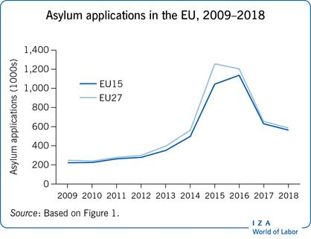

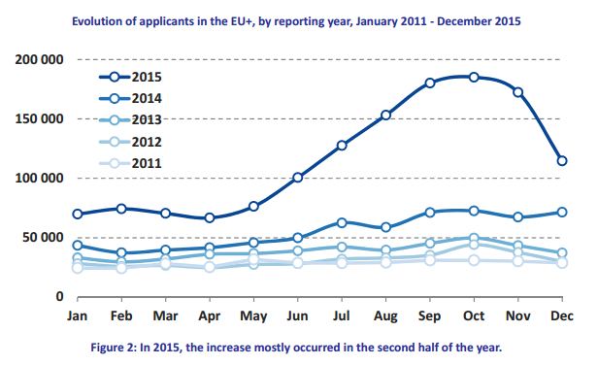
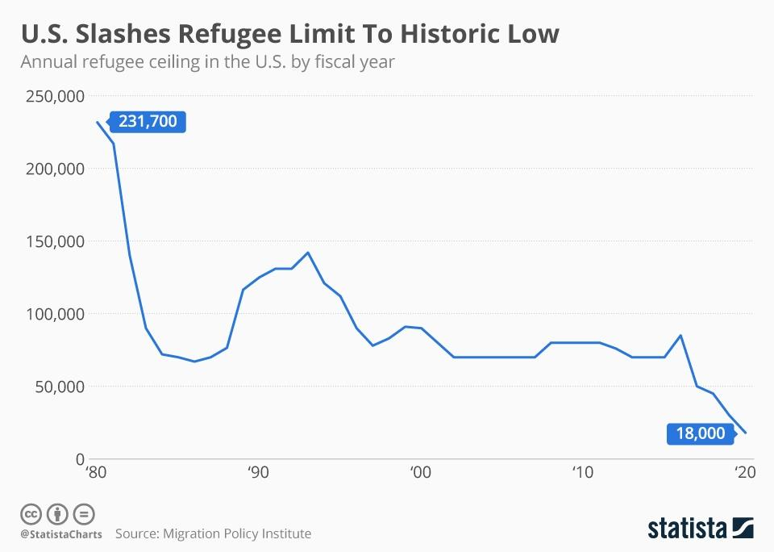

4.Questions to Consider
-What are the discrimination situations that refugees have to take on daily basis and what can countries do to obstruct these situations?
-What causes the problem in immigration safety and what can countries do in order to prevent these problems?
-What can countries provide to their refugees?
-Can international authorities be more efficient on the matter of violation of refugee rights?
-How can national authorities be more effective in social awareness?
-In what ways can refugee rights violations be minimized on the international level?
-How can international organizations address the current situation?

5.References
- https://www.unhcr.org/1951-refugee-convention.html#:~:text=The%201951%20Refugee%20Convention%20and,of%20States%20to%20protect%20them
- https://academic.oup.com/ijrl/article-abstract/30/3/474/5193216
- https://www.unhcr.org/4565a5742.pdf
- https://globalpeacecareers.com/magazine/20-organizations-working-to-support-refugees-rights/
- https://www.britannica.com/topic/refugee

more to read:
- https://www.researchgate.net/profile/Andrew-Butcher-2/publication/270884434_Being_Accepted_The_Experience_of_Discrimination_and_Social_Exclusion_by_Migrants_and_Refugees_in_New_Zealand/links/54bd79080cf27c8f2814b964/Being-Accepted-The-Experience-of-Discrimination-and-Social-Exclusion-by-Migrants-and-Refugees-in-New-Zealand.pdf
- https://onlinelibrary.wiley.com/doi/full/10.1111/1758-5899.12432
- https://onlinelibrary.wiley.com/doi/full/10.1111/japp.12448
- https://bmcpublichealth.biomedcentral.com/articles/10.1186/s12889-019-8068-3

