GA3: SOCHUM

USG AND PRESIDENT
CHAIR OF GA3: SOCHUM
ECE GÖKÇE

Agenda Item: Plan of Action Against Xenophobia
Current Date: 1990

Table of Contents

I. Welcome Letters
A. The Secretariat’s Welcoming Letter
B. Introduction to the Committee by the Secretariat
C. Letter from Under-Secretary-General
II. Introduction of the Social, Humanitarian and Cultural Committee
III. Introduction of the Agenda Item
IV. Characteristics of Xenophobia
V. Key Terms
VI. History of the Issue
VII. The Sociology of Race, Groups and Xenophobia
VIII. Xenophobia and Ethnocentrism
IX. Current Situation
X. Questions to be Addressed

The Secretariat’s Welcoming Letter

Dear Delegate of BHMUN’21,
Since our first session in 2014, we have been establishing a platform where young innovators can have the opportunity to share their thoughts and ideas, whilst also educating themselves on world affairs, so as to learn to approach worldwide issues from different perspectives. This year, the Academic Team of BHMUN has decided to form both General Assembly and Special Committees held according to the most significant historical events from 1990 - 1999.

The variety of committees will allow delegates to discuss many world problems from the viewpoints required by their assigned country and role. We ensure you that every committee will offer issues of interest according to this historical decade together with extremely creative ideas. We promise to provide all delegates with interesting and debatable crises in each committee and offer rewarding opportunities that will allow you to ‘Innovate the Future’ in every aspect of the conference.

Due to the global pandemic, this year’s BHMUN will be held online. However, with the help of our devoted Organisation Team, we affirm that your expectations of our BHMUN conference this year will be surpassed by providing an exceptional experience that will meet your every need from the opening to the closing ceremony.

BHMUN is the first and only entirely historical Model UN conference in Turkey organised under Harvard procedure. Helping delegates verge upon historical issues from modern perspectives is exclusive to our conference. Hence, we believe that BHMUN is a truly unique experience for delegates all around the world, and it is for this reason that we give great value to the discussions delegates will hold on the contemporary issues that are considered timeless.

With all being said, we invite you to join us in BHMUN'21 for an unforgettable and unique experience.

Welcome!
BHMUN’21 Secretariat

Introduction to the Committee by the Secretariat

Committee Description:
The third committee of the UN General Assembly, SOCHUM, carries the goal of solving humanitarian problems around the world. However, it has been hard to solve some of these problems due to the political polarization of the world. Each time there was a way to solve a given problem, either the Western or Eastern bloc countries have opposed this decision and, therefore, it was not implemented. Yet, SOCHUM is dedicated not to stop trying to solve major humanitarian problems and, therefore the committee will meet again in the year 1990 and to try and solve the issues of LGBT rights and xenophobia.

Now, it is up to the delegates to decide upon what they are going to do: Follow the path of history or draw a path of their own. The delegates' performance will shape the flow of the committee and the BHMUN'21 Team will shape their crises in accordance with the flow.
BHMUN’21 Secretariat

Letter From Under Secretary General

Most distinguished participants,

I, as the Under Secretary General and President Chair responsible for SOCHUM, have the honour and privilege to welcome you all to the BHMUN’21 on behalf of our chair board members, every member of our Academic and Organization team.

I, Ece Gökçe, am a 10th grader and this will surely be the most memorable experience ever. I have always tried for the best and most academical and with our team, we have worked so hard to achieve this purpose. Our primary objective in MUN is to teach you delegates for gaining a diplomatic stance in your future careers while experiencing an entertaining conference.

In this committee, we have two agenda items which are; Expanding and legalizing LGBT rights in Member States and Plan of action against Xenophobia. You are expected to read the study guide, brainstorm and research about the topic. This study guide is by no means enough to limit your imaginativeness.

Please bear in mind all of the questions in the “Questions to be Addressed” part should be discussed during sessions and must be included in the resolution paper. I hope you all have an unforgettable experience and I am looking forward to meeting you all. If you have any inquiries or/and questions, please do not hesitate to contact me via ecegokce22@gmail.com

In the end, I would like to thank our Academic team and our Organization team for their efforts and help through the process, my Secretary Generals; Ahmet Özdemir, İnci Sevi Kaya and my Deputy Secretary General; Lara Mengü for their relentless support in making this conference unforgettable for us and the delegates.

With warm regards and respects,
Ece Gökçe
Under Secretary General and President Chair of Social, Humanitarian and Cultural Committee

II. Introduction of the Social, Humanitarian and Cultural Committee

The United Nations General Assembly Third Committee (also known as the Social, Humanitarian and Cultural Committee or SOCHUM or C3) is one of six main committees at the General Assembly of the United Nations. It was established in 1947. It deals with human rights, humanitarian affairs and social matters. The Third Committee meets every year in early October and aims to finish its work by the end of November. All 193 member states of the UN can attend. As in previous sessions, an important part of the work of the Committee will focus on the examination of human rights questions.

III. Introduction of the Agenda Item

“Here, however, as in other cases, we are inclined to think that intelligent xenomania is decidedly preferable to the Xenophobia which is of necessity and always unintelligent.”
—The Daily News (London, England), 12 April 1880

Xenophobia as the dictionary definition is the dislike of or prejudice against people from other countries. Xenophobia has always been an issue for all countries, citizens and cultures. The difference between racism and xenophobia is that racism has a broader meaning, including “a belief that racial differences produce the inherent superiority of a particular race.” when xenophobia is “fear and hatred of strangers or foreigners or of anything that is strange or foreign.”. Although the similarity is visible, they are obviously different enough that a person can be both xenophobic and racist.

Xenophobia usually occurs with forms of prejudice including racism and homophobia. Though, there are more important distinctions. Where racism, homophobia and other forms of discrimination are based on specific characteristics, xenophobia is generally rooted in the perception that members of the outgroup are foreign to the ingroup community. Though xenophobia has been around for a long time, the word 'xenophobia' is relatively new—our earliest citation is from 1880.
In everyday terms, ‘xenophobia’ is now used to refer to dislike of foreigners, such as being anti-immigration, antiforeign, and/or anti-different groups, while ‘xenophobia’ in the social sciences has imported semantic changes that reflect mega-events. In this new development, xenophobia (including Islamophobia) and nativism embrace the idea of cultural incompatibility and the naturalization of xenophobic attitudes following from it. Out of this understanding of xenophobia as a natural reaction, anti-migration springs as a nativist necessity with a right to defend ‘one's culture’ while either legitimizing racism or denying that cultural and political self-defense can be racist.

“There is a wider field for satire in the behavior of Xenophobes, who wherever they wander say “for all we can see foreigners are ‘mostly fools.’ ” ”
—Daily News (London, England), 26 March 1891

IV. Characteristics of Xenophobia

While xenophobia can be expressed in different ways, typical signs include:
- Feeling uncomfortable around people who fall into a different group
- Going to great lengths to avoid particular areas
- Refusing to be friends with people solely due to their skin color, mode of dress, or other external factors
- Difficulty taking a supervisor seriously or connecting with a teammate who does not fall into the same racial, cultural, or religious group.

V. Key Terms

Xenophobia: Dislike of or prejudice against people from other countries.
Xenophobe: A person having a dislike of or prejudice against people from other countries.
Racism: Prejudice, discrimination, or antagonism by an individual, community, or institution against a person or people on the basis of their membership of a particular racial or ethnic group, typically one that is a minority or marginalized.
Prejudice: Preconceived opinion that is not based on reason or actual experience.
Foreign: A person born in or coming from a country other than one's own.
Ethnocentrism: Natural tendency or inclination among all people to view reality from their own cultural experience and perspective.
Race: The idea that the human species is divided into distinct groups on the basis of inherited physical and behavioral differences.
Aboriginal: Inhabiting or existing in a land from the earliest times or from before the arrival of colonists; indigenous.

VI. History of the Issue

Somewhere between the view that race is a peculiarly modern idea without much historical precedent and the notion that it is simply an extension of the ancient phenomena of ethnocentrism and xenophobia may lie a working definition that is neither too broad for historical specificity or too narrow to cover more than the limited span of Western history during which racism based on scientific theories of human variation was widely accepted. If racism is defined as an ideology rather than as a theory, links can be established between belief and practice that the history of ideas may obscure. But ideologies have content, and it is necessary to distinguish racist ideologies from other belief systems that emphasize human differences and can be used as rationalizations of inequality.

The classic sociological distinction between racism and ethnocentrism is helpful, but not perhaps in the usual sense, in which the key variable is whether differences are described in cultural or physical terms. It is actually quite difficult in specific historical cases to say whether appearance or ‘culture’ is the source of the salient differences because culture can be reified and essentialized to the point where it has the same deterministic effect as skin color. But it would stretch the concept of racism much too far to make it cover the pride and loyalty that may result from ethnic identity. Such group-centeredness may engender prejudice and discrimination against those outside the group, but two additional elements would seem to be required before the categorization of the act of xenophobia is justified.

One of the earliest examples of xenophobic sentiment in the Western culture was when Ancient Greek denigrated foreigners as “barbarians”, and with that, the belief of Greek people and culture is superior to all others and the subsequent conclusion that barbarians were naturally meant to be enslaved appeared.

Of course, the fact that the word xenophobia did not exist before Rutherford B. Hayes was president of the United States does not mean that the condition itself was absent. After all, things may very well exist before they are named; additionally, the English language did have another word for the hatred or distrust of strangers prior to this (albeit a very obscure one): misoxenie.

“Indeed the Genius, and common humor of a Nation, is not easily alterable, and our Misoxenie (or hatred to Strangers) was no new quality, for Horace noted it before or about Christ's birth and Englishmen can hardly see when they are well to keep them too. “
—John Speed, The Theatre of the Empire of Great Britain, 1611

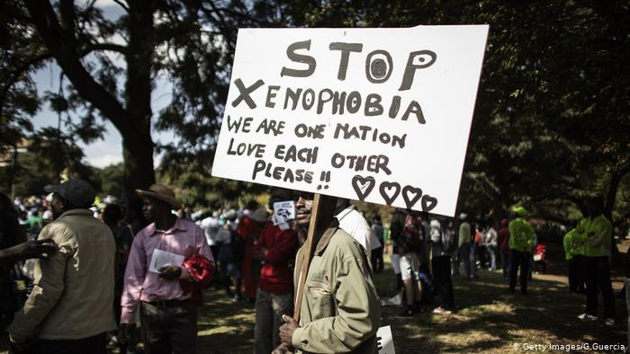

VII. The Sociology of Race, Groups, and Xenophobia

Fromm's studies of prejudice concentrated on historical circumstances conducive to its emergence but also attempted to reveal more universal aspects of oppression. He identified a mechanism in which the dominating authoritarian person feels freer, more secure, and powerful knowing that there is someone whom they can or they have already managed to dominate. In this sense, the term ‘social character’ coined by Fromm to describe common traits of people belonging to the same group can be seen as providing means for the expression of group narcissism (superior ‘us’ as opposed to inferior ‘them’) and of nonegalitarian or authoritarian personality that feeds unconscious racism (Fromm, 1964). In short, Fromm's contribution to the study of prejudice, xenophobia, and racism comes down to highlighting social psychological aspects of these phenomena.
VIII. Xenophobia and Ethnocentrism

The perceived threat of disease also has implications for xenophobia and ethnocentrism. There are many examples of a general tendency to link subjectively foreign peoples with the disease. This link is evident in xenophobic propaganda, in which ethnic outgroups are explicitly likened to pathogenic species or to nonhuman vectors of disease, such as rats, flies, and lice.

There are at least two reasons why a subjective sense of “foreign-ness” may implicitly connote an increased risk for infection. First, historically, contact with exotic peoples increased exposure to exotic pathogens, which tend to be especially virulent when introduced to the local population. Second, outsiders are often ignorant of local behavioral norms that serve as barriers to pathogen transmission (e.g., norms pertaining to hygiene, food-preparation); as a consequence, they may be more likely to violate these norms, thereby increasing the risk of pathogen transmission within the local population. Thus, in addition to other threats connoted by outgroup status, people perceived to be subjectively foreign are likely to be implicitly judged to pose the threat of infection.

If so, prejudice against subjectively foreign peoples is likely to emerge most strongly when people are, or merely perceive themselves to be, especially vulnerable to infection.

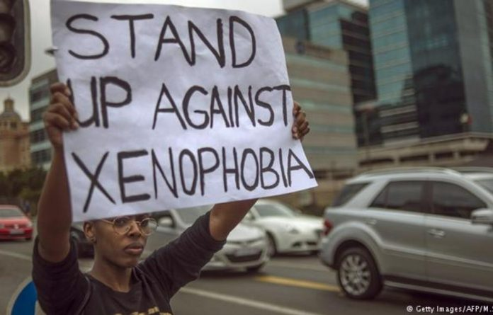
VII. Timeline

1901 - Federation of Australia is established.
1901 - Aboriginal people were denied citizenship. White Australia policy. Deportation of Melanesians.
1901 - Assimilation, the Policy of assimilation for migrants is introduced. Non-British migrants are accepted on the understanding that they should shed their cultures and languages and become indistinguishable from Australians of British background. This policy continued until the 1960s.
1903 - Naturalisation Act, Commonwealth Naturalisation Act acknowledges all naturalized British residents as subjects in the Commonwealth. Applicants from Asia, Africa, or Pacific Islands (except New Zealand) are ineligible for naturalization.
1905 - WA Aborigines Act. Western Australian Aborigines Act extends control over reserves and gives wide powers to the Chief Protector who is made the legal guardian of every Aboriginal and ‘half-caste’ child under 16.
1914 - World War 1, Deportation of Enemy Aliens, Aboriginal Soldiers
1919 - Versailles Conference. British Ex-Servicemen, Armenian Church.
1920 - Northern Europeans Favoured. Responsibility for Immigration. Aboriginal Population.
1921 - Increased Immigration. League of Nations.
1926 - Aboriginal People Killed. Following the killing of a European in Dala, Western Australia, 11 Aboriginal people are murdered in police custody; no prosecutions follow.
1929 - Depression. Due to the Depression, the assisted migration scheme was terminated by the Commonwealth government, leading to a sharp decline in immigration.
1936 - Jewish Refugees. The Commonwealth Government agrees to permit entry to Jewish refugees who are guaranteed by relatives or friends not to cost the state.
1935-1945 - World War 2. Enemy Aliens. World War 2 began. Although Aboriginal people are not recognized as citizens, two Aboriginal military units are established and some Aboriginal people serve in other sections of armed forces. Aboriginal people serve in Europe, the Middle East, the Pacific, and New Guinea. Thousands of nationals of enemy countries, particularly Italians, are interned across the country as ‘enemy aliens’ during the war.
1941 - Italian POWs. First Italian prisoners of war arrive.
1947 - Displaced Persons Scheme. 450,000 migrants arrive. Migrant assimilation. Aliens Act. Immigration Advisory Council. Assisted Passage. European refugees.
1948 - Universal Declaration of Human Rights.
1950 - Russian Migration. Russians living in China begin to leave after the Communist victory in 1949 and migrate to Australia.
1952 - Japanese Wives. Japanese wives of Australian servicemen are admitted under permits valid for 5 years.
1963 - Protest by Yirrkala People. Yirrkala Aboriginal people from Arnhem Land, Northern Territory, protest to the Commonwealth Government about part of their reserve land being given over for mining.
1975 - Racial Discrimination Act. Anti-Chinese Meeting. Indo-Chinese Refugees. Commonwealth Racial Discrimination Act is passed, prohibiting discrimination on the grounds of race, color, descent, or ethnic origin. A mass anti-Chinese meeting is held in Hyde Park, Sydney. In the period, 1975-1984 Australia resettled over 90,000 Indo-Chinese refugees under the humanitarian element of the migration program.
1979 - Australian Institute of Multicultural Affairs. UN Refugee Conference. Refugee Advisory Council. NUMAS. Terra Nullius challenged. National Aboriginal Council. Australian Institute of Multicultural Affairs (AIMA) is established to raise awareness of cultural diversity and promote social cohesion. Over 200,000 Indo-Chinese refugees in camps throughout Asia lead to the United Nations International Refugee Conference. Australia agrees to accept some 36,000 refugees. Australian Refugee Advisory Council is established. A numerical Multi-factor Assessment System (NUMAS), or points system, is introduced for immigrant selection. Coe vs Commonwealth in High Court of Australia: an unsuccessful challenge to the legal concept of terra nullius. The National Aboriginal Conference resolves that a treaty should be concluded between Aboriginal people and the Commonwealth Government.
1986 - Human Rights & Equal Opportunity Commission. The Commonwealth Human Rights and Equal Opportunity Commission (HREOC) is established. It replaces the former Human Rights Commission and has a primary role in implementing Australia’s international human rights obligations.
1988 - National Inquiry into Racist Violence. National Inquiry into Racist Violence is announced by the Human Rights and Equal Opportunity Commission in response to widespread concern that racist attacks are increasing.

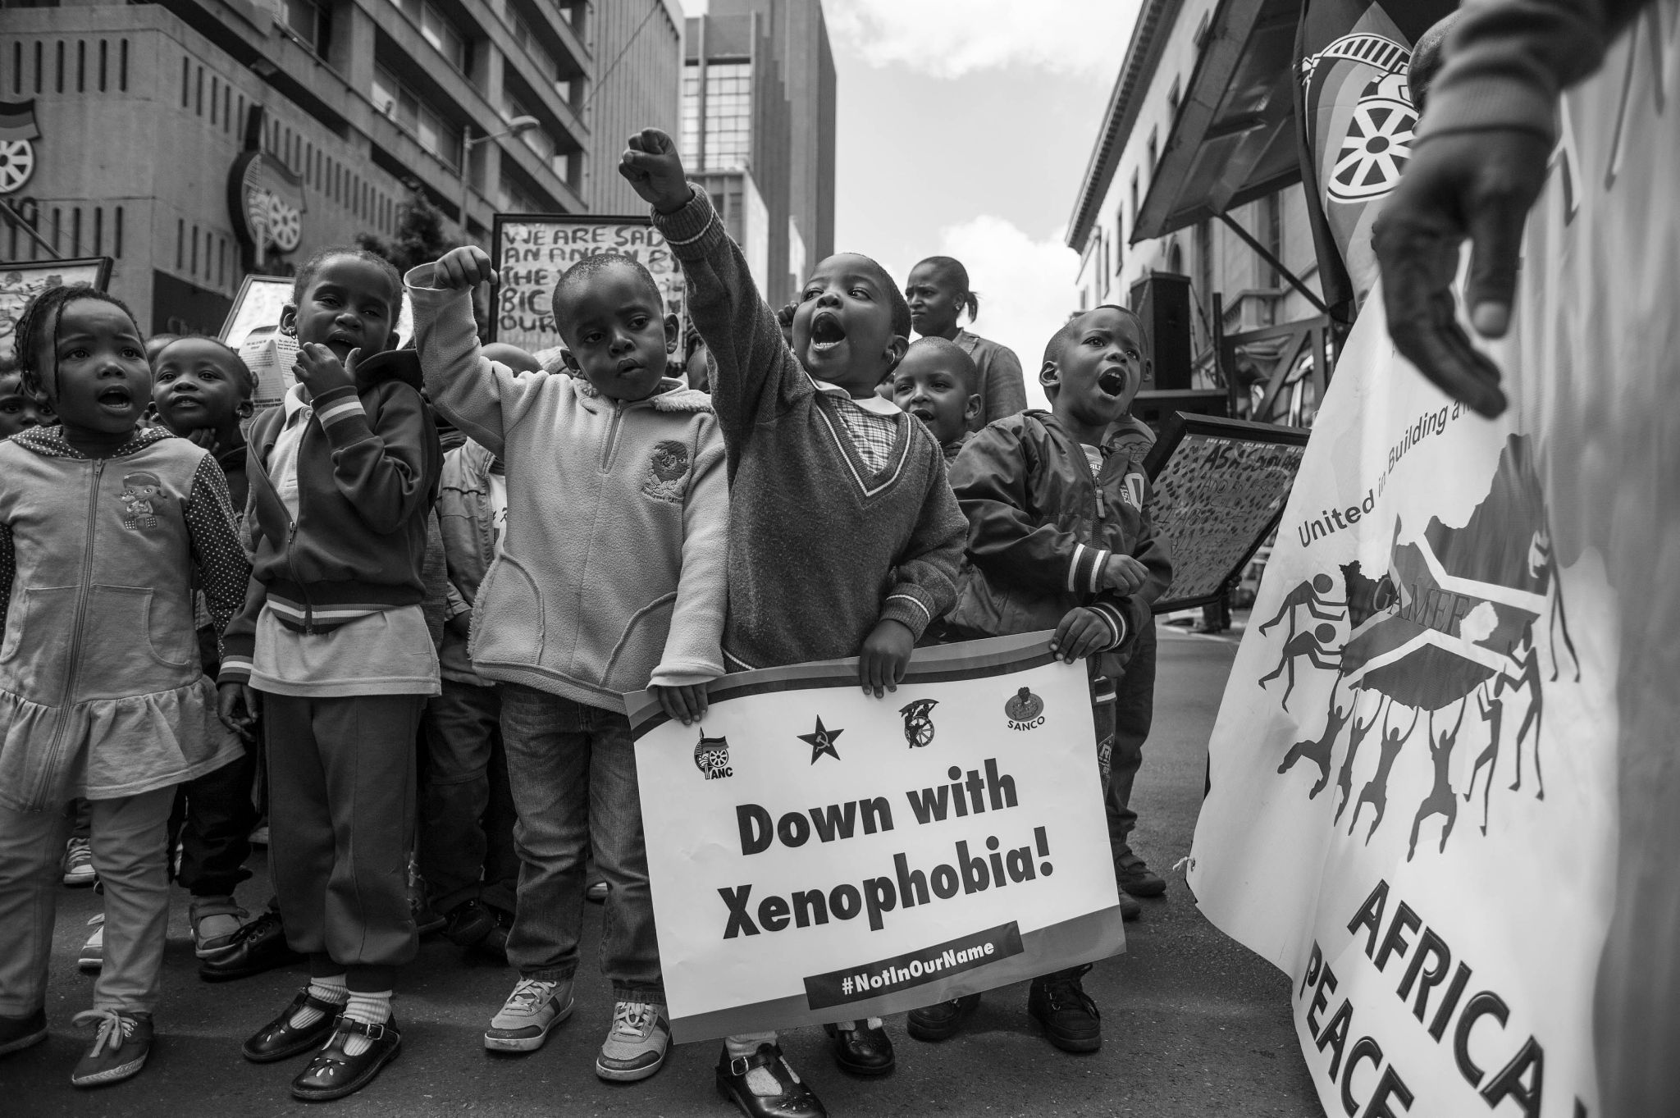

X. Current Situation

Unfortunately, the action from countries against xenophobia and racism is not enough to stop the suffering of people. There is an extremely fast-growing issue in Germany and South Africa. The World Wars had the biggest effect on xenophobic and racist ideals. Prejudice as a social problem is getting worse every day as a cause of the countries’ lack of awareness programs. Xenophobia in 1990 is not only about nationality but also religion, race, gender, sexual choice, etc.

XII. Questions to be Addressed

1. What are the ongoing difficulties faced by xenophobia victims?
2. What are the ways to provide a better life for those who face xenophobia?
3. Are the current efforts done by the member states enough to assure a safe living?
4. What can countries do to prevent discrimination?
5. How can governments and NGOs cooperate in order to solve the issue?
6. What can the international community and governments do to stop or minimize discrimination and xenophobia?
7. How can the efforts be improved to stop/minimize the actions of the violent racist groups?
8. How can people that faced xenophobia who were psychologically or physically abused be integrated back into society?
9. What can be done to raise awareness about discrimination and xenophobia?
10. What further future actions can the countries take to minimize racism and xenophobia?

