Economic and Finance Committee (ECOFIN)

Reassessing the role of central banks during recessions

Approved by President of the general assembly

Letter from the President of the General Assembly
Today, humanity faces the repercussions of its unwillingness to recognize the patterns that constitute the great mosaic of the history of humankind. As Andre Gide once said, “Everything has been said before, but since nobody listens, we have to keep going back and beginning all over again.” The global community is under the threat of a pandemic, and it’s trying to find ways to adapt itself to the structural change after the pandemic, which is called the new normal. However, are we really adapting to a new normal when we have already gone through similar paradigm shifts, especially during the past century? This new normal gave people and governments an insight into their broken systems, an insight into this dispersed world, with everything that's going wrong with the world right now people are trying to go back and find a “ remedy for a dispersed world “ which will be our theme for this year. In the words of Leo Tolstoy, “everyone thinks of changing the world but no one thinks of changing himself.” At SafirMUN we will be tackling most of this year's rising topics that were exposed. We will be presenting our delegates with a platform that can hopefully help them find a remedy for this dispersed world.

Sary Matar
PGA of SafirMUN

Introduction
A recession occurs when a country witnesses a decline in their economic output for two (or more) consecutive quarters. Sometimes after the initial downward turn, there is some positive growth, however,, it doesn’t last. Generally, the first pattern that emerges in a recession is that people cut back on their spending. So, the uncertainty that goes hand in hand with a recession, people tend to focus on saving.
Unfortunately, in light of the fact, this is most people’s natural reaction, what they don’t realize is that it perpetuates a negative cycle. Less spending overall means less consumption, further weakening the economy so the cycle continues. During a recession, banks often cut interest rates to encourage borrowing and investing (an attempt to stimulate the economy). Taxes and government spending also change as the government tries to encourage economic growth through policy change. In the long term, however, this strategy could negatively affect the economy by increasing interest rates. During a recession, unemployment rises, and prices sometimes fall in a process known as deflation. The Monetary Reserves of the countries currently facing recessions, in the case of steep economic downturns, may take dramatic steps to suppress unemployment and bolster prices both to fulfill its traditional mandate and also to provide emergency support to their financial system and economy.

Background Information
Origin
Recession is the title given to an economic period marked by negative real growth, declining output, depressed prices, and rising unemployment, which often follows after a period of notably strong economic growth as measured by these same variables. Recessions are characterized by an unusual, simultaneous, and large grouping of business errors, which some economists call malinvestments. Faced with financial loss and declining margins, businesses scale back production or fail entirely, and business managers (or the new owners) reallocate resources tied up in the failed projects to different uses. During the period of transition, some of these resources will need to be repriced (in terms of goods prices, asset values, or in the case of labor, wages) and some will remain idle for some time until a new use is found. As this process proceeds the economy recovers.

Factors contributing to a recession.
- Decline in the GDP (Gross Domestic Product)
- Widespread decrease in spending.
- A Stock Market Crash
- Manufacturing Orders Slow Down (Demand decreases)
- Sudden crash of House/property prices
- Spike in oil prices
Consequences of recessions
- Low interest loans
- Firms face a scarcity of resources to produce products
- High probability of unemployment
- Deposition of employees to reduce costs and maximize profit margins
Timeline of Events

Date | Description of event
Roosevelt Recession  (May 1937–June 1938) | Businesses blamed the "New Deal," a series of government-financed infrastructure work projects through the Works Projects Administration (WPA) and Civilian Conservation Corps (CCC). These projects provided work for more than 250,000 men  - The stock market crashed in late 1937.  - GDP decline: 10%  - Peak unemployment rate: 20%
The Union Recession: (February 1945–October 1945) | The end of World War II, the beginning of demobilization of military forces, and the slow transition to civilian production marked this period. War production had virtually ceased and veterans were just beginning to re-enter the workforce.  - Peak unemployment rate: 5.2%  - GDP decline: 10.9%  - A sudden increase in minimum wages  - Credit is at maximum
The Oil Crisis Recession: (November 1973–March 1975 | This long, deep recession was brought on by the quadrupling of oil prices and high government spending on the Vietnam War.  - GDP decline: 3%  - Peak unemployment rate: 8.6%
March 2020 | The SARS-COV-2 induced disease COVID-19 is officially declared as a pandemic by the World Health Organization (WHO)
Covid-19 Recession (March 2020–Ongoing) | On June 8, 2020, the National Bureau of Economic Research officially declared a recession in the U.S. economy. Air travel and tourism are restricted. Small businesses were forced to discontinue their services. Implementation of strict social distancing policies induces businesses to reduce their workforce by laying off workers and closure entertainment businesses e.g., sports, cinemas Production houses. Central banks were prompted to reduce interest rates and provide interest-free loans.  - Oil prices, stock market, and industry sectors crashed. Inflations of prices of essentials e.g., masks  - Supply greatly reduced  - Peak unemployment rate: 13.0% in May 2020  - The trade deficit (Exports down 40%-50%)  - GDP decline: Median estimate for the second-quarter GDP at -53.8%.  - Food shortages

TIMELINE: The economic impact for covid-19
31 Dec 2019
Wuhan Municipal Health Commission, China, reported a cluster of cases of pneumonia in Wuhan, Hubei Province. A novel coronavirus was eventually identified.

12 January 2020
China publicly shared the genetic sequence of COVID-19.
13 January 2020
Officials confirm a case of COVID-19 in Thailand, the first recorded case outside of China.

4 February 2020
The Director-General urged the Member States to prepare themselves by taking action now, saying “We have a window of opportunity. While 99% of cases are in China, in the rest of the world we only have 176 cases”.

7 March 2020
To mark the number of confirmed COVID-19 cases surpassing 100 000 globally, WHO issued a statement calling for action to stop, contain, control, delay and reduce the impact of the virus at every opportunity.

11 March 2020
Deeply concerned both by the alarming levels of spread and severity, and by the alarming levels of inaction, WHO made the assessment that COVID-19 could be characterized as a pandemic.
12th March to May 2020
Countries across the globe take measures and large scale lockdowns are practised in some countries, people are quarantined and strict measures for prevention of the spread is taken. The global economy drops and deep recessions are triggered through lower investment, an erosion of human capital through lost work and schooling, and fragmentation of global trade and supply linkages. There is a 5.2% contraction in global GDP and setbacks to potential output and the level of output an economy can achieve at full capacity, full employment⁠ and labour productivity.

December 2020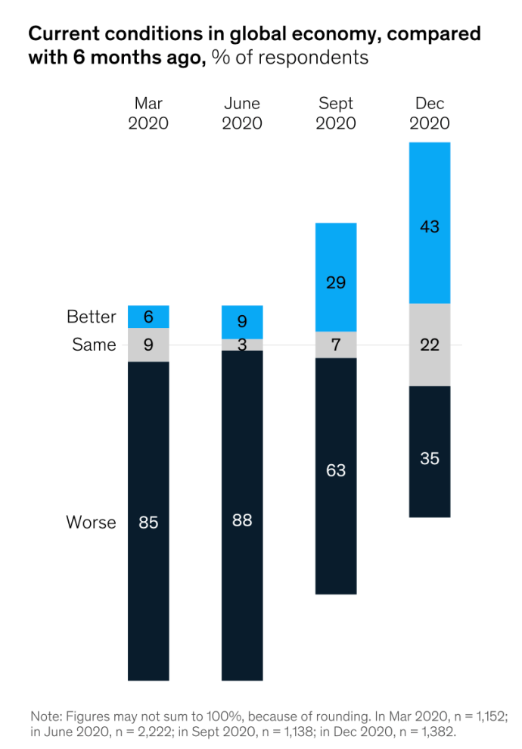
The upturn is most dramatic in India, where three-quarters of respondents report improvements—up from 19 per cent three months ago. At the same time, executives in Europe, North America, and developing markets are more downbeat than the rest. Europe and developing markets are the only regions where respondents are much more likely to report worse than improved conditions. With respect to the world economy, executives’ views are the most sanguine they’ve been in 2020. For the first time, respondents are more likely to report improvements than declines, and they are much more likely now than in earlier surveys to say conditions have stabilized. Emerging-market executives remain more positive than their developed-economy peers about the global economy.

In emerging markets,4 respondents are more than twice as likely to report improved global conditions as declines (58 per cent, versus 26 per cent), while in developed economies, a larger share of respondents reports worse conditions (40 per cent) than improvements (34 per cent) in the world economy.

March 2021
There is a rise in economic optimism as a positive momentum of growth is seen in the global economy. Unemployment concerns also seem to be subsiding, compared with the past few months when pluralities or outright majorities predicted an increasing unemployment rate. At company levels, there is optimism for company profitability and consumer demands as they hit new highs. During this time, we’ve also seen that developed economies are much more likely than their emerging-economy counterparts to say that they’re fully operational again, or that their business has not been disrupted by the pandemic. Despite the overall optimism, the COVID-19 pandemic still looms largest as a risk to growth. It’s the top risk to growth in the global economy, followed by geopolitical instability, which was the most common risk cited in the past two quarters.
Case Studies
Taiwan:
Taiwan is one of the few countries that has handled the pandemic remarkably well, and without resorting to draconian measures like nationwide lockdowns. Since the pandemic began, Taiwan has reported 563 cases and just seven deaths, and as countries witness a coronavirus resurgence, Taiwan, as of the 29th of October, hit 200 days without any domestic transmission of coronavirus infections. This is especially commendable considering Taiwan’s close proximity to the Chinese mainland and direct flights from Wuhan, where the virus emerged but despite that, the Taiwanese government was able to successfully regulate the importation of cases and the transmissibility of the virus. Some of the Taiwanese strategies, as proven, were highly efficient for example, aggressive screening, contact tracing and tracking through mobile sim led to Taiwan becoming the forerunner in battling the virus.
However, Taiwan never really got the opportunity to impart the wisdom and knowledge of its Covid-19 regulation strategy to the rest of the international community because it is locked out of membership from the UN. This is because China does not recognize the island’s sovereignty and thus Taiwan does not have a seat in the UN. Taiwan was hence eliminated from all emergency meetings and global sessions on the pandemic, and as a country that has been praised extensively in the world for its deft handling of the coronavirus outbreak, it could definitely have shared important lessons and recommendations, even technical assistance, with the international community, and maybe played an important part in managing the pandemic.
Moreover, with the infections under control at home, Taiwan has been offering aid to other countries in many forms, for example, the government donated 17 million surgical masks to countries inflicted by the virus, and has been working closely with the U.S. in order to herald the development of vaccines and diagnostic kits, it could have definitely been a reliable partner in combating the crisis. But despite repeated protests, Taiwan was not included in any meetings relating to the crisis, and this elicits the question; could the outcome have been slightly different if Taiwan’s recommendations and advice had been invoked by the UN? Political bones of contention can affect the global community severely, and Taiwan’s exclusion from the UN at a time that calls for concerted global effort demonstrates that because Taiwan is excluded solely as to not upset the political sensitivities of China, which does not recognize Taiwan’s sovereignty.
United States of America:
The United States of America is proof that no country is too powerful for a pandemic. They have famously had a very tragic response strategy that has not only left the people of the USA at risk, it has also majorly affected their economy. With more than 32.5 million total cases and around 578,000 total deaths. The USA is in the midst of a crisis caused by the pandemic. Between February and June 2020, 14.6 million people lost their jobs and the USA has added $3.1 trillion to its public debt. This can be attributed to the social norms and societal outlook on COVID-19 within the United States of America.
A large majority of individuals believe COVID-19 to be trivial, or an issue that will ‘go away on its own. There is seldom any regard for social distancing and schools/colleges open as normal. Examples of these can be found throughout the country. On the 9th of August 2020, Sturgis, South Dakota held its annual biker rally which attracted more than 200,000 people from all over the country. There was little to no regard for social distancing and it showed the norm established within the country. The US government measures have largely failed in containing the virus.

As the virus spirals out of control, it is necessary to recognize that people’s social behaviour is affected by the media around them.
The Trump administration in 2020 consistently used the media to build a narrative of COVID-19 being a trivial issue. This was done to safeguard the economy. However, the economy suffered nonetheless. The US government also set a “state first” policy for the containment of COVID-19. The federal government took a backseat and allowed states to function as they liked in response to COVID-19. This, in a national crisis, divided the nation rather than uniting it. Disjointed policies created difficulties in dealing with the Pandemic. The U.S. elections also created great discourse about COVID-19 with the Democrats consistently finding opportunities to highlight faults in the Trump administration’s response to the Novel Coronavirus resulting in Joe Biden winning.

The Blocs
ECOFIN was created with the purpose to “promote international co-operation in the economic field,” as outlined in Article 13 of the United Nations. According to its mandate, ECOFIN aims to discuss “macroeconomics policy questions like financing for development, globalization and eradication of poverty.’’Therefore, the bloc positions will be based on the socio-economic and political stance of each UN state.
1. Socio-economic Status
Education, wages, and profession are often used to quantify a person's or a group's socioeconomic status as their social position or class. Examining socioeconomic class also reveals inequities in resource availability, as well as questions of privilege, authority, and influence.
2. Political Stance
Political stability is a variable of great importance in a country’s evolution since, across time, it was identified as causing low levels of economic growth, but also it was presented as a consequence of poor economic development.
Political Stability is seen to be dependent on: Absence Of Violence, Government longevity, Existence of Legitimate Constitutional Regime, Financial Sustainability, Absence Of Structural Change and Multifaceted Social Attribute.

Further reading

https://www.oecd.org/coronavirus/policy-responses/global-financial-markets-policy-responses-to-covid-19-2d98c7e0/
https://www.who.int/news/item/27-04-2020-who-timeline---covid-19
https://fas.org/sgp/crs/row/R46270.pdf
https://www.worldbank.org/en/news/feature/2020/06/08/the-global-economic-outlook-during-the-covid-19-pandemic-a-changed-world
https://www.oldmutual.co.za/articles/what-happens-in-a-recession/
https://www.investopedia.com/ask/answers/08/cause-of-recession.asp

QARMA
The Importance of Lockdowns

1. What economically feasible alternatives to lockdowns can be implemented by countries as a Second Wave emerges?

2. Previous lockdowns have amplified the food and unemployment crisis in African countries. How can ECOFIN help these countries recover from the effects of these previous lockdowns?

3. How can vulnerable populations like women and children be protected from violence and abuse as countries impose second, more stringent lockdowns?

The Threat of Future Viruses

1. How can the future be secured from zoonotic viruses?

2. Should an Inter-Agency Coordination Group in consultation with the Food and Agriculture Organization of the United Nations (FAO), the World Organization for Animal Health (OIE) be convened? If so, what will be its aims and how will it be structured? Which will be the leading countries in this Global Action Plan?

3. Some populations are at higher risk of contracting and serving as hosts for zoonotic viruses. These include rural populations in close contact with livestock, markets selling meat or animal by-products and people involved in animal testing. What protective measures can be incorporated in countries’ national plans in order to safeguard these populations?

4. How can ECOFIN collaborate with the World Trade Organization (WTO) to develop the biosecurity of international wildlife trade?

Funding

1. What kind of precinct does the USA’s decision to defund the WHO set, and how can WHO be restructured to prevent future withdrawals?

2. While the ECOFIN has called for an increase in flexible funding arrangements, what are some of the reservations countries may have in appropriating flexible funds and how can ECOFIN eliminate these reservations and help WHO?

3. How is the WHO’s funding structure reformed in order to offer protection against future pandemics?

4. How can ECOFIN prioritize funding to areas that are in urgent need of international attention and medical aid? Should a committee be convened that surveils health conditions across countries and decides, through a mutually agreed criteria, the appropriation of funds to countries in compliance with their healthcare needs? How can the credibility and accountability of such a committee be ensured?

Economic Safety

1.What measures could be integrated into national policies to impose the strict implementation of SOPs by citizens and businesses alike?

2.How can governments reform current policies to recover from the negative impacts of the coronavirus and re-imagine the long-term economy to be more equitable and accessible?

3. How can we ensure “Leave No One Behind” in the context of poor countries?

4. If a nation does not abide by the plan created, what could be possible compliance mechanisms?

5. In the covid times, how can we ensure that governments do not misuse the help given to them?

6. What steps can we take to ensure economic recovery for the world?

