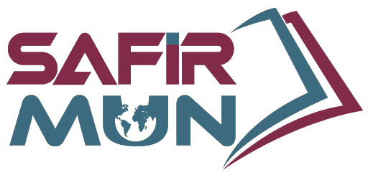
World Health Organisation (WHO)

Combating the evolving COVID-19 virus

Approved by president of the general assembly

Letter from the President of the General Assembly
Today, humanity faces the repercussions of its unwillingness to recognize the patterns that constitute the great mosaic of the history of humankind. As Andre Gide once said, “Everything has been said before, but since nobody listens, we have to keep going back and beginning all over again.” The global community is under the threat of a pandemic, and it’s trying to find ways to adapt itself to the structural change after the pandemic, which is called the new normal. However, are we really adapting to a new normal when we have already gone through similar paradigm shifts, especially during the past century? This new normal gave people and governments an insight into their broken systems, an insight into this dispersed world, with everything that's going wrong with the world right now people are trying to go back and find a “ remedy for a dispersed world “ which will be our theme for this year. In the words of Leo Tolstoy, “everyone thinks of changing the world but no one thinks of changing himself.” At SafirMUN we will be tackling most of this year's rising topics that were exposed. We will be presenting our delegates with a platform that can hopefully help them find a remedy for this dispersed world.

Sary Matar
PGA of SafirMUN

Introduction:

Fellow delegates, I am your president chair Deniz Uçar. I am a 10th grader at Istek Bilge Kağan High School. This conference will be my 8th conference. This year conditions are harder for everyone. I encourage you to participate in the debate and please do not hesitate to ask any questions to me or to my vice president.

The World Health Organization (WHO) is a specialized agency of the United Nations responsible for international public health. The WHO Constitution, which establishes the agency's governing structure and principles, states its main objective as "the attainment by all peoples of the highest possible level of health". It is headquartered in Geneva, Switzerland, with six semi-autonomous regional offices and 150 field offices worldwide.

The WHO was established by constitution on 7 April 1948, which is commemorated as World Health Day. The first meeting of the World Health Assembly (WHA), the agency's governing body, took place on 24 July 1948. The WHO incorporated the assets, personnel, and duties of the League of Nations' Health Organization and the Office International d'Hygiène Publique, including the International Classification of Diseases (ICD). Its work began in earnest in 1951 following a significant infusion of financial and technical resources.

The WHO relies on contributions from member states (both assessed and voluntary) and private donors for funding. Its total approved budget for 2020–2021 is over $7.2 billion, of which the majority comes from voluntary contributions from member states. Contributions are assessed by a formula that includes GDP per capita. Among the largest contributors were Germany (which contributed 12.18% of the budget), the Bill & Melinda Gates Foundation (11.65%), and the United States (7.85%).

Coronavirus is something that we all know. Millions of people have been affected by this virus and many more because of this virus’s effects on the economy and other aspects of our lives. Covid-19 is the first pandemic since the Spanish Flu in 1920. This virus showed us how hung by the eyelids we are. This virus was detected in China in december 2019 and It was all over the world until March. Life has not been the same since 2020 but it has not changed in 2021 as well. Humankind could not find a %100 effective vaccine nor vaccinated citizens with the existing vaccines. LEDCs (Least economically developed countries) suffered extensive damage both economically and humanely.

History of the virus:

This virus is a zoonotic virus and it has a lot different versions throughout history. SARS-CoV and MERS-CoV are two main examples. The ‘R’ stands for respiratory in the abbreviation. Mers was from camels, Sars was from bats and palm civets. The main difference was about the infected area. Neither SARS nor MERS were able to escape from the focal point.

Since December 2019, 153.331.206 people have been infected and 3.212.555 have passed away.

The Timeline:

2019
Based on the retrospective analysis, starting from December 2019, the number of COVID-19 cases in Hubei gradually increased, reaching 60 by 20 December and at least 266 by 31 December.On 24 December 2019, Wuhan Central Hospital sent a bronchoalveolar lavage fluid (BAL) sample from an unresolved clinical case to sequencing company Vision Medicals.^{[citation needed]} On 27 and 28 December, Vision Medicals informed the Wuhan Central Hospital and the Chinese CDC of the results of the test, showing a new coronavirus. A pneumonia cluster of unknown cause was observed on 26 December and treated by the doctor Zhang Jixian in Hubei Provincial Hospital, who informed the Wuhan Jianghan CDC on 27 December.
On 30 December 2019, a test report addressed to Wuhan Central Hospital, from company CapitalBio Medlab, stated that there was an erroneous positive result for SARS, causing a group of doctors at Wuhan Central Hospital to alert their colleagues and relevant hospital authorities of the result. Eight of those doctors, including Li Wenliang (who was also punished on 3 January), were later admonished by the police for spreading false rumours; and another doctor, Ai Fen, was reprimanded by her superiors for raising the alarm. That evening, the Wuhan Municipal Health Commission issued a notice to various medical institutions about "the treatment of pneumonia of unknown cause". The next day, the Wuhan Municipal Health Commission made the first public announcement of a pneumonia outbreak of unknown cause, confirming 27 cases—enough to trigger an investigation.
The following day, on December 31, the WHO learned about a cluster of viral pneumonia cases of an unknown cause in Wuhan. An investigation was launched at the start of January 2020.According to official Chinese sources, the early cases were mostly linked to the Huanan Seafood Wholesale Market, which also sold live animals. However, in May 2020, George Gao, the director of the Chinese Center for Disease Control and Prevention, said animal samples collected from the seafood market had tested negative for the virus, indicating the market was not the source of the initial outbreak. In March 2021, the WHO published their report on the potential zoonotic source of the virus. The WHO concluded that human spillover via an intermediate animal host was the most likely explanation, with direct spillover from bats next most likely and introduction through the food supply

2020
Timelines of the COVID-19 pandemic in 2020 by month: January, February, March, April, May, June, July, August, September, October, November, December
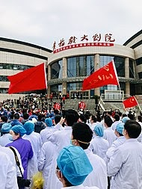
Chinese medics in the city of Huanggang, Hubei on 20 March 2020
During the early stages of the outbreak, the number of cases doubled approximately every seven and a half days. In early and mid-January 2020, the virus spread to other Chinese provinces, helped by the Chinese New Year migration and Wuhan being a transport hub and major rail interchange. On 10 January, the SARS-CoV-2 genetic sequence data was shared through GISAID. On 20 January, China reported nearly 140 new cases in one day, including two people in Beijing and one in Shenzhen. A retrospective official study published in March found that 6,174 people had already developed symptoms by 20 January (most of them would be diagnosed later)and more may have been infected. A report in The Lancet on 24 January indicated human transmission, strongly recommended personal protective equipment for health workers, and said testing for the virus was essential due to its "pandemic potential". On 31 January The Lancet would publish the first modelling study explicitly warning of inevitable "independent self-sustaining outbreaks in major cities globally" and calling for "large-scale public health interventions’’.On 30 January 2020, with 7,818 confirmed cases across 19 countries, the WHO declared the COVID-19 outbreak a Public Health Emergency of International Concern (PHEIC), and then a pandemic on 11 March 2020 as Italy, Iran, South Korea, and Japan reported increasing numbers of cases.
On 31 January 2020, Italy had its first confirmed cases, two tourists from China. As of 13 March 2020, the WHO considered Europe the active centre of the pandemic. On 19 March 2020, Italy overtook China as the country with the most reported deaths. By 26 March, the United States had overtaken China and Italy with the highest number of confirmed cases in the world.Research on SARS-CoV-2 genomes indicates the majority of COVID-19 cases in New York came from European travelers, rather than directly from China or any other Asian country. Retesting of prior samples found a person in France who had the virus on 27 December 2019 and a person in the United States who died from the disease on 6 February 2020.
On 11 June 2020, after 55 days without a locally transmitted case being officially reported, the city of Beijing reported a single COVID-19 case, followed by two more cases on 12 June. As of 15 June 2020, 79 cases were officially confirmed. Most of these patients went to Xinfadi Wholesale Market.
On 29 June 2020, WHO warned that the spread of the virus was still accelerating as countries reopened their economies, despite many countries having made progress in slowing down the spread.
On 15 July 2020, one COVID-19 case was officially reported in Dalian in more than three months. The patient did not travel outside the city in the 14 days before developing symptoms, nor did he have contact with people from "areas of attention."
In October 2020, the WHO stated, at a special meeting of WHO leaders, that one in ten people around the world may have been infected with COVID-19. At the time, that translated to 780 million people being infected, while only 35 million infections had been confirmed.
In early November 2020, Denmark reported on an outbreak of a unique mutated variant being transmitted to humans from minks in its North Jutland Region. All twelve human cases of the mutated variant were identified in September 2020. The WHO released a report saying the variant "had a combination of mutations or changes that have not been previously observed." In response, Prime Minister Mette Frederiksen ordered for the country – the world's largest producer of mink fur – to cull its mink population by as many as 17 million.
On 9 November 2020, Pfizer released their trial results for a candidate vaccine, showing that it is 90% effective against the virus. Later that day, Novavax entered an FDA Fast Track application for their vaccine. Virologist and U.S. National Institute of Allergy and Infectious Diseases director Anthony Fauci indicated that the Pfizer vaccine targets the spike protein used to infect cells by the virus. Some issues left to be answered are how long the vaccine offers protection, and if it offers the same level of protection to all ages. Initial doses will likely go to healthcare workers on the front lines.
On 9 November 2020 the United States surpassed 10 million confirmed cases of COVID-19, making it the country with the most cases worldwide by a large margin.
It was reported on 27 November, that a publication released by the Centers for Disease Control and Prevention indicated that the current numbers of viral infections are via confirmed laboratory tests only. However, the true number could be about eight times the reported number; the report further indicated that the true number of virus infected cases could be around 100 million in the U.S.
On 14 December 2020, Public Health England reported a new variant had been discovered in the South East of England, predominantly in Kent. The variant, named Variant of Concern 202012/01, showed changes to the spike protein which could make the virus more infectious. As of 13 December, there were 1,108 cases identified. Many countries halted all flights from the UK;France-bound Eurotunnel service was suspended and ferries carrying passengers and accompanied freight were cancelled as the French border closed to people on 20 December.

Economical Aspects:

Global shares in flux
Big shifts in stock markets, where shares in companies are bought and sold, can affect the value of pensions or individual savings accounts (Isas).
The FTSE, Dow Jones Industrial Average and the Nikkei all saw huge falls as the number of Covid-19 cases grew in the first months of the crisis.
The major Asian and US stock markets have recovered following the announcement of the first vaccine in November, but the FTSE is still in negative territory.
The FTSE dropped 14.3% in 2020, its worst performance since 2008.

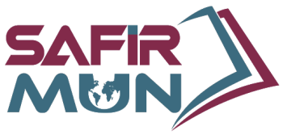
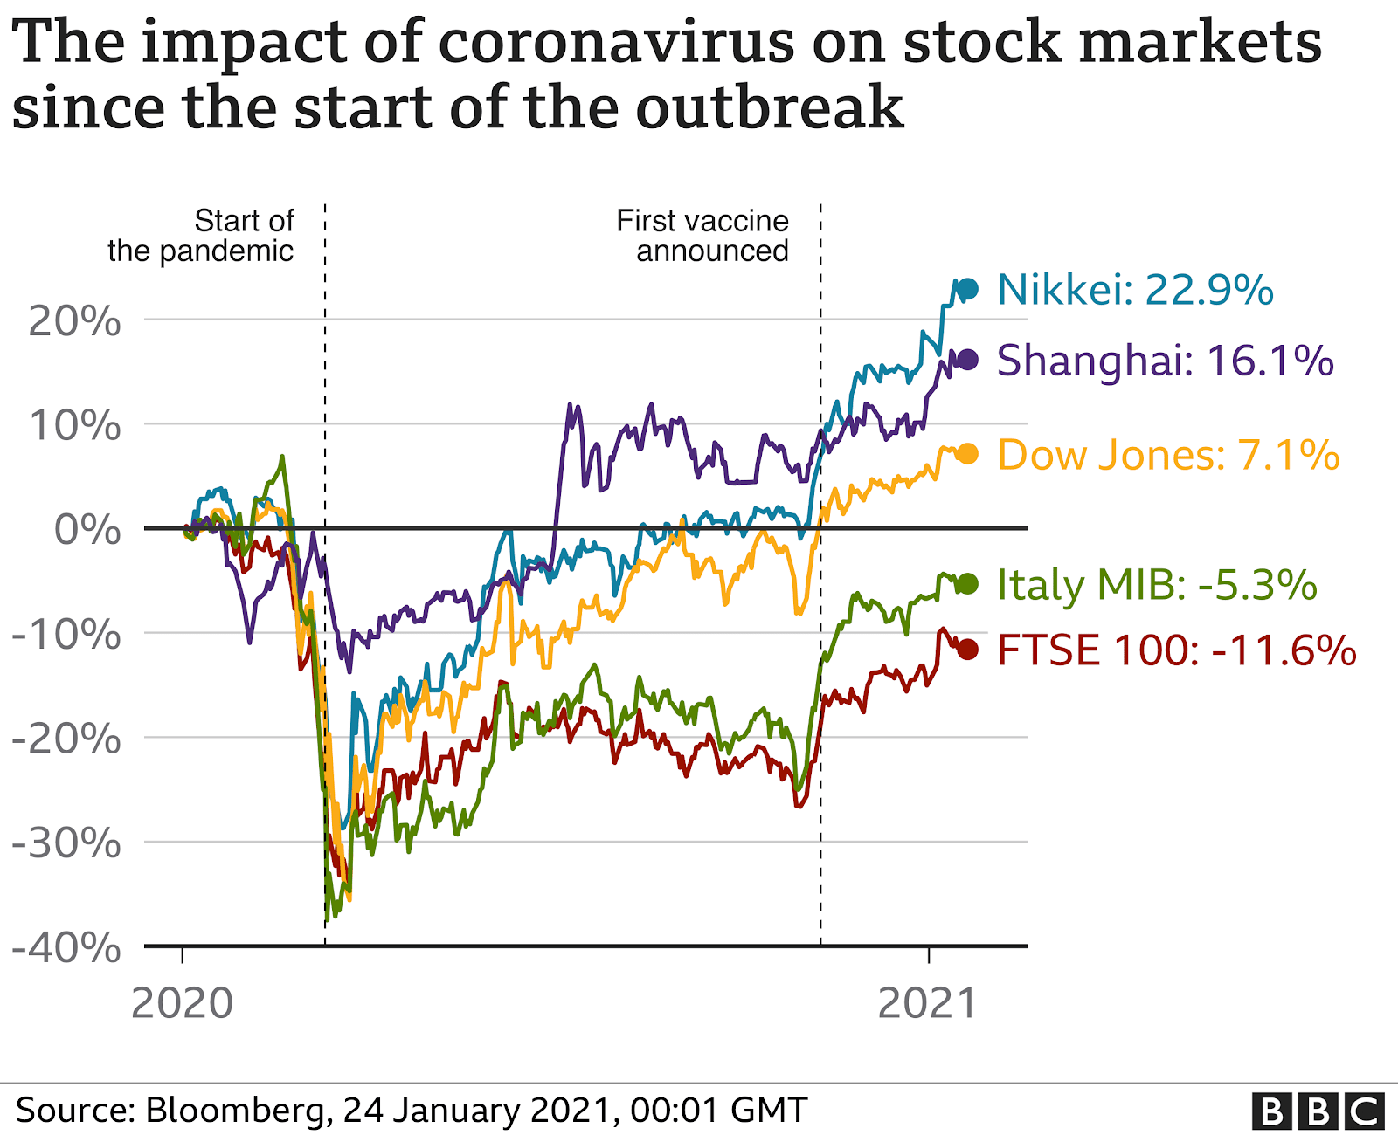
In response, central banks in many countries, including the UK, have slashed interest rates. That should, in theory, make borrowing cheaper and encourage spending to boost the economy.
Some markets recovered ground in January this year, but this is a normal tendency known as the "January effect".
Analysts are worried that the possibility of further lockdowns and delays in vaccination programmes might trigger more market volatility this year.

A difficult year for job seekers
Many people have lost their jobs or seen their incomes cut.
Unemployment rates have increased across major economies.
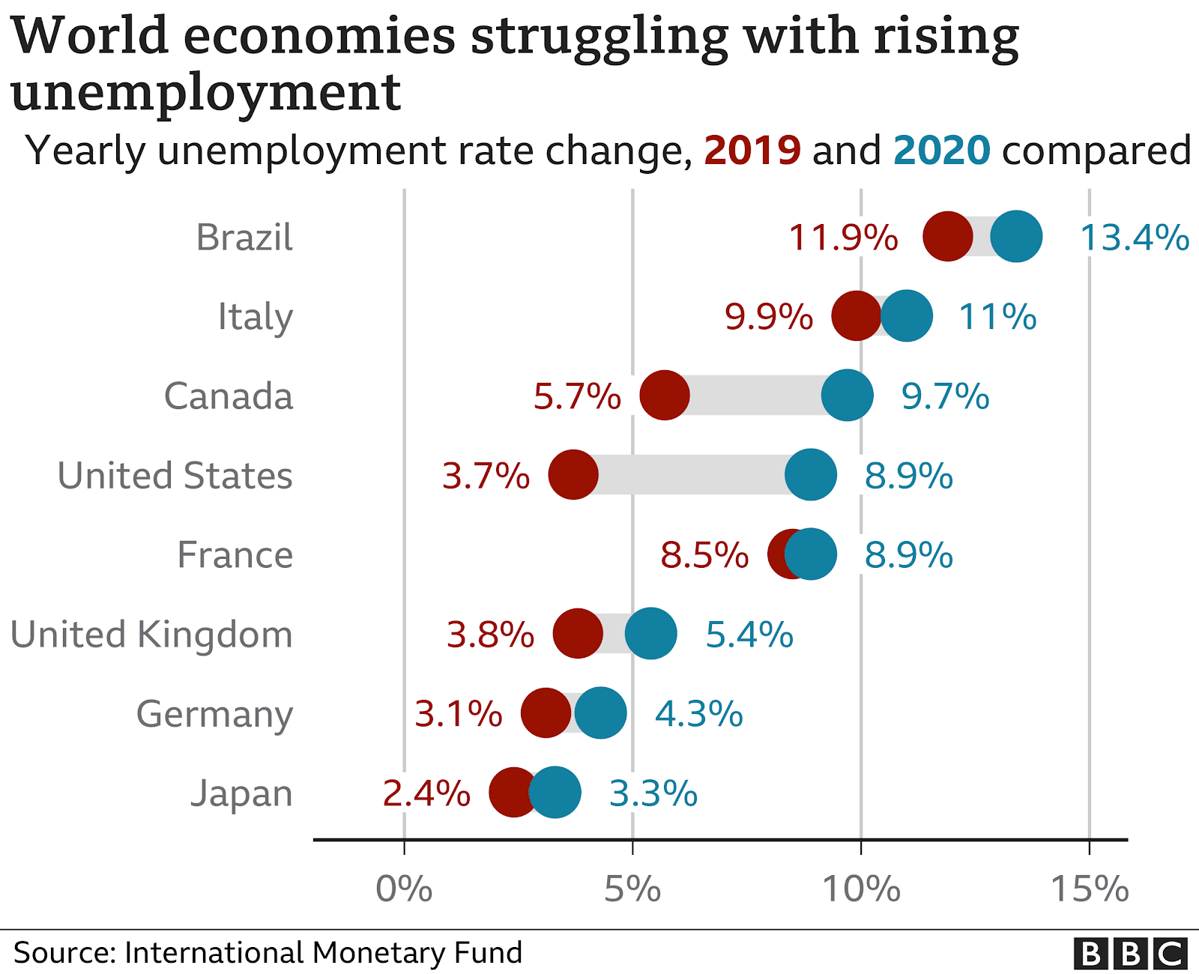
In the United States, the proportion of people out of work hit a yearly total of 8.9%, according to the International Monetary Fund (IMF), signalling an end to a decade of jobs expansion.
Millions of workers have also been put on government-supported job retention schemes as parts of the economy, such as tourism and hospitality, have come to a near standstill.
The number of new job opportunities is still very low in many countries.
Job vacancies in Australia have returned to the same level as of 2019, but they are lagging in France, Spain, the UK and several other countries.
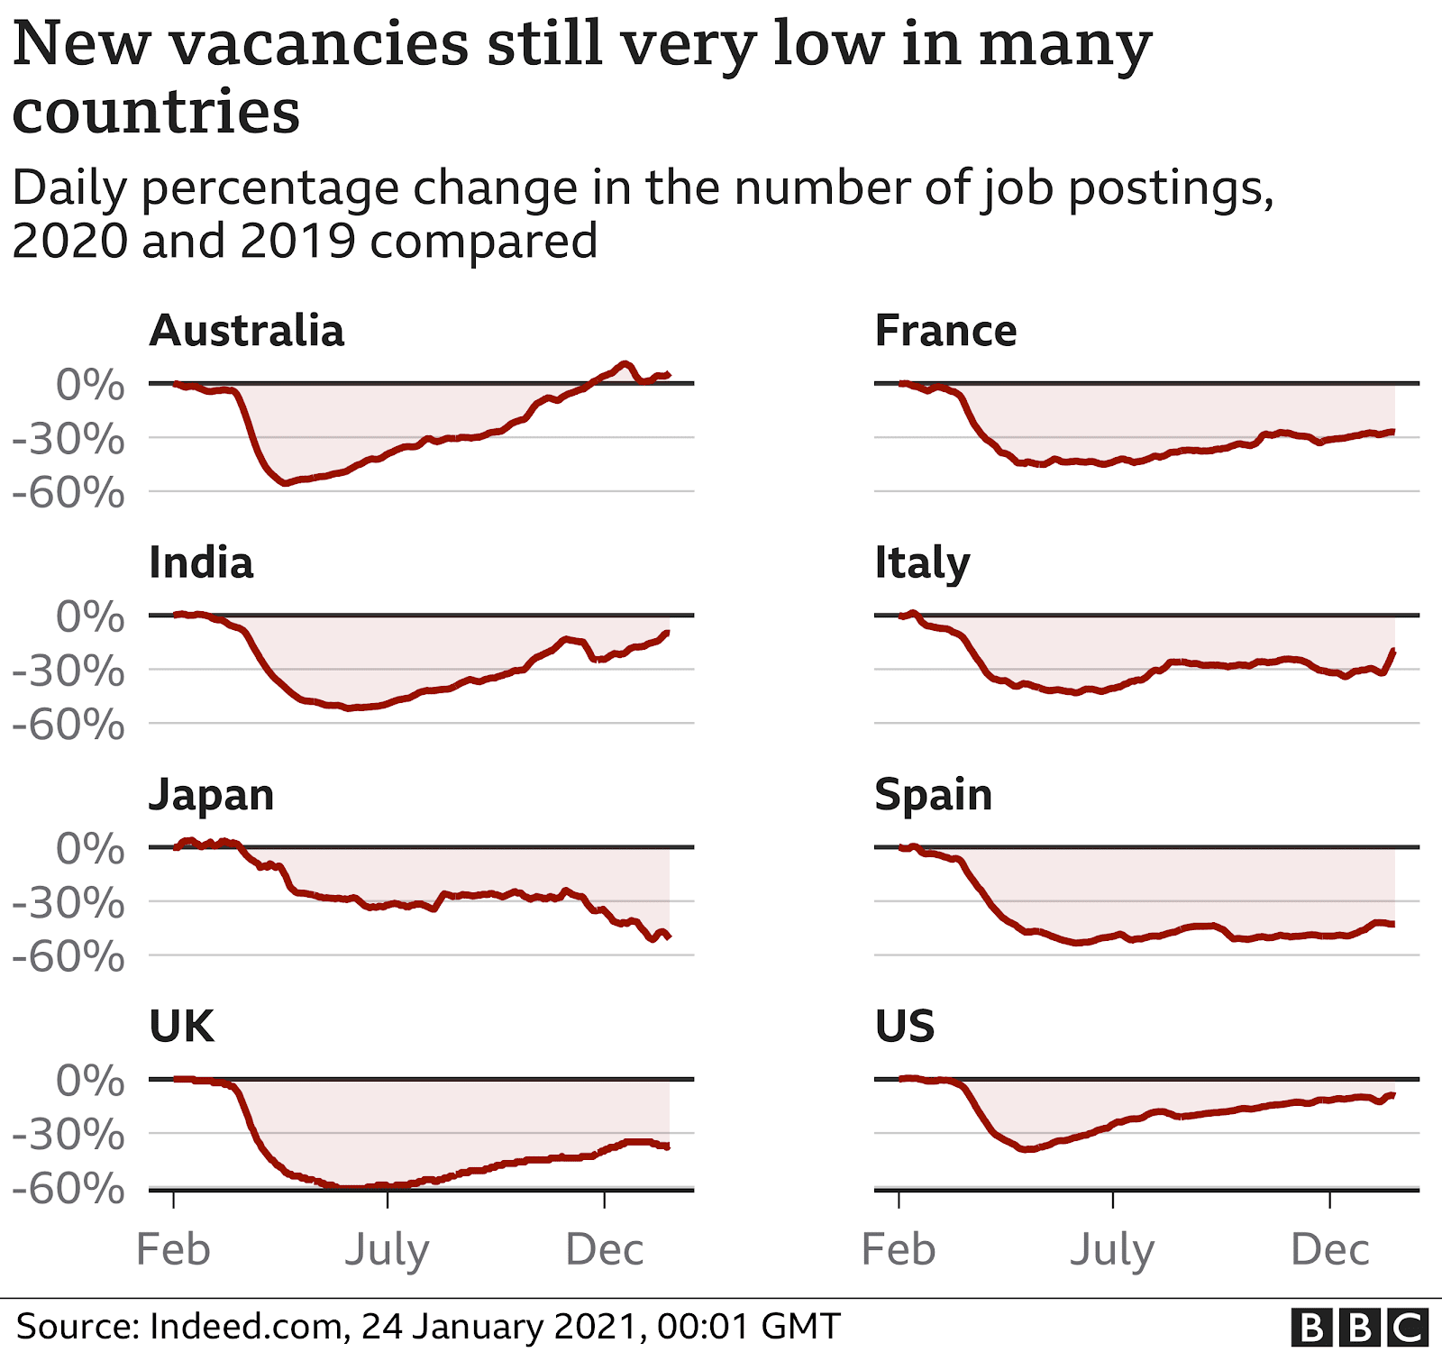
Some experts have warned it could be years before levels of employment return to those seen before the pandemic.

Most of countries now in recession
If the economy is growing, that generally means more wealth and more new jobs.
It's measured by looking at the percentage change in gross domestic product, or the value of goods and services produced, typically over three months or a year.
The IMF estimates that the global economy shrunk by 4.4% in 2020. The organisation described the decline as the worst since the Great Depression of the 1930s.
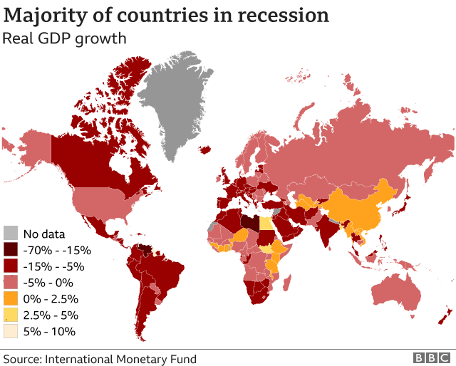
The only major economy to grow in 2020 was China. It registered a growth of 2.3%.
The IMF is, however, predicting global growth of 5.2% in 2021.
That will be driven primarily by countries such as India and China, forecast to grow by 8.8% and 8.2% respectively.
Recovery in big, services-reliant economies that have been hit hard by the outbreak, such as the UK or Italy, is expected to be slow.

The Future:

Coronavirus affects the globe dramatically. People are scared. Investors cannot predict what is next due to this economy suffers. When the economy suffers all systems become dysfunctional. Therefore vaccination is a key in order to solve this issue. Public places need to be opened in order to reinvigorate the economy. Recovery in big, can only be sustained with vaccination but LEDCs cannot afford the price therefore we may try to lower the price or enable possible financial aid.

Block Positions:

This topic may be political but the main agenda is to save people from suffrage therefore every politician has to bear in mind that they are representing citizens of their country. At most a country can propose a beneficial solution for their country but our agenda is to solve the issue not to make money.

Conclusion:

People are suffering from this situation. The World Health Organization is founded for these situations. We encourage every delegate to represent their country as best as they can.

Useful Links:

https://www.bbc.com/news/business-51706225
https://en.wikipedia.org/wiki/COVID-19_pandemic#2020
https://en.wikipedia.org/wiki/Severe_acute_respiratory_syndrome_coronavirus
https://www.nhs.uk/conditions/coronavirus-covid-19/
https://tr.usembassy.gov/covid-19-information-2/
https://www.cia.gov/the-world-factbook/countries/
https://www.who.int/health-topics/coronavirus#tab=tab_1

Bibliography:

https://www.wikipedia.org/
https://www.bbc.com/news
https://news.sky.com/
www.who.int/
https://www.cia.gov/the-world-factbook/countries/

