- Letter from the President chair

Honorable delegates,

My name is Serra Dikmen, a junior at TED KDZ Eregli College in Turkey. I’m excited to welcome you all to KETMUN 2021 as the President Chair of WHO. My MUN career began last year when I was a sophomore student in high school. The reason that I decided to attend our MUN club was my teacher’s advice and it has quiet a story. We were debating. I just defended my moot point, and my teacher told me that I should join the club also i liked to debate since I was 10 so I did. Since then, I have not stopped to attend. Due to the Coronavirus pandemic, most of my MUNs were online Model United Nations conferences and I wanted to improve both my debating and moderating skills. KETMUN 2021 will be my 7th conference, and I am so glad to be a part of this marvelous journey.

Always keep in mind that, this might be a competition for you but solve these problems like a real diplomat since these all are recent topics that consider our World and we, as individuals.

With this guide, I want you to have the fundamental information that you will add on more with your research. Do not forget to read the additional part of the further recommendation part of the guide to cover your fundamental knowledge about the topic. It is important to study possible solutions while integrating your country’s policy. We’re expecting you to show your leadership abilities under the terms of negotiation, influencing and supporter. Creating and implementing valid arguments during your speeches and paperwork are also crucial for the delegates. If you believe in yourself, don’t forget that you are capable of doing everything!

If you wish to contact me, either for any inquiries or a conversation, do not hesitate to contact me via email. You may contact me via serrademirdikmen@gmail.com

I wish you all the best!

Best Regards,
Serra DİKMEN PRESIDENT CHAIR

- Introduction to the Committee: World Health Organization

The World Health Organization (WHO) is a specialized agency of the United Nations responsible for international public health. The WHO Constitution, which establishes the agency's governing structure and principles, states its main objective as "the attainment by all peoples of the highest possible level of health". It is headquartered in Geneva, Switzerland, with six semi-autonomous regional offices and 150 field offices worldwide.

The WHO was established by constitution on 7 April 1948, which is commemorated as World Health Day. The first meeting of the World Health Assembly (WHA), the agency's governing body, took place on 24 July 1948. The WHO incorporated the assets, personnel, and duties of the League of Nations' Health Organization and the Office International d'Hygiène Publique, including the International Classification of Diseases (ICD). Its work began in earnest in 1951 following a significant infusion of financial and technical resources.

The WHO's broad mandate includes advocating for universal healthcare, monitoring public health risks, coordinating responses to health emergencies, and promoting human health and wellbeing. It provides technical assistance to countries, sets international health standards and guidelines, and collects data on global health issues through the World Health Survey. Its flagship publication, the World Health Report, provides expert assessments of global health topics and health statistics on all nations. The WHO also serves as a forum for summits and discussions on health issues.

The WHO has played a leading role in several public health achievements, most notably the eradication of smallpox, the near-eradication of polio, and the development of an Ebola vaccine. Its current priorities include communicable diseases, particularly HIV/AIDS, Ebola, COVID-19, malaria and tuberculosis; non-communicable diseases such as heart disease and cancer; healthy diet, nutrition, and food security; occupational health; and substance abuse. As part of the United Nations Sustainable Development Group, the WHA, composed of representatives from all 194 member states, serves as the agency's supreme decision-making body. It also elects and advises an executive board made up of 34 health specialists. The WHA convenes annually and is responsible for selecting the director-general, setting goals and priorities, and approving the WHO's budget and activities. The current director-general is Tedros Adhanom, former health minister and foreign minister of Ethiopia, who began his five-year term on 1 July 2017.

The WHO relies on contributions from member states (both assessed and voluntary) and private donors for funding. Its total approved budget for 2020–2021 is over $7.2 billion, of which the majority comes from voluntary contributions from member states. Contributions are assessed by a formula that includes GDP per capita. Among the largest contributors were Germany (which contributed 12.18% of the budget), the Bill & Melinda Gates Foundation (11.65%), and the United States (7.85%).

- Introduction to the Agenda Item: ZIKA VIRUS

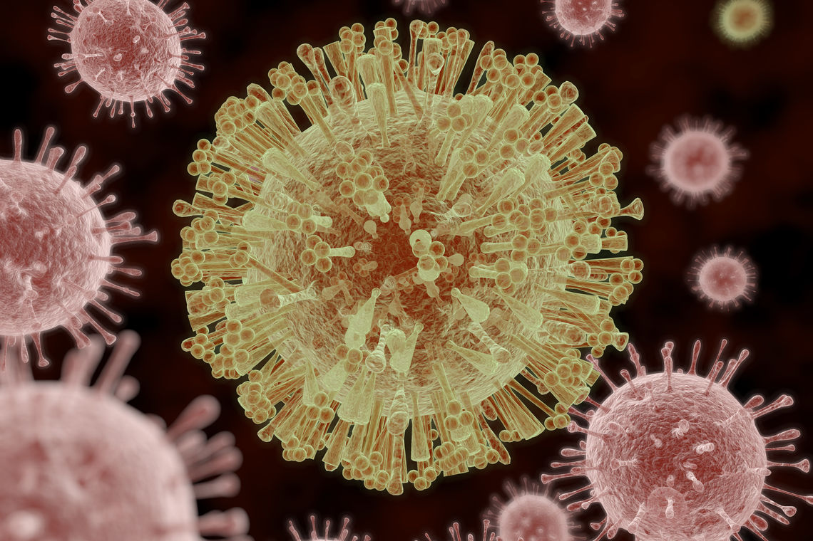

Zika virus (ZIKV) is a member of the virus family Flaviviridae. It is spread by daytime-active Aedes mosquitoes, such as A. aegypti and A. albopictus. Its name comes from the Ziika Forest of Uganda, where the virus was first isolated in 1947 .Zika virus shares a genus with the dengue, yellow fever, Japanese encephalitis, and West Nile viruses. Since the 1950s, it has been known to occur within a narrow equatorial belt from Africa to Asia. From 2007 to 2016, the virus spread eastward, across the Pacific Ocean to the Americas, leading to the 2015–2016 Zika virus epidemic.

The infection, known as Zika fever or Zika virus disease, often causes no or only mild symptoms, similar to a very mild form of dengue fever. While there is no specific treatment, paracetamol and rest may help with the symptoms. As of April 2019, no vaccines have been approved for clinical use; however a number of vaccines are currently in clinical trials. Zika can spread from a pregnant woman to her baby. This can result in microcephaly, severe brain malformations, and other birth defects. Zika infections in adults may result rarely in Guillain–Barré syndrome.

- Zika Transmission

- Through mosquito bites
Zika virus is transmitted to people primarily through the bite of an infected Aedes species mosquito (Ae. aegypti and Ae. albopictus). These are the same mosquitoes that spread dengue and chikungunya viruses.
- These mosquitoes typically lay eggs in or near standing water in things like buckets, bowls, animal dishes, flower pots, and vases. They prefer to bite people, and live indoors and outdoors near people.
- Mosquitoes that spread chikungunya, dengue, and Zika bite during the day and night.
- A mosquito gets infected with a virus when it bites an infected person during the period of time when the virus can be found in the person’s blood, typically only through the first week of infection.
- Infected mosquitoes can then spread the virus to other people through bites.

b) From mother to child
- A pregnant woman can pass Zika virus to her fetus during pregnancy. Zika is a cause of microcephaly and other severe fetal brain defects. We are studying the full range of other potential health problems that Zika virus infection during pregnancy may cause.
- A pregnant woman already infected with Zika virus can pass the virus to her fetus during the pregnancy or around the time of birth.
- Zika virus has been found in breast milk. Possible Zika virus infections have been identified in breastfeeding babies, but Zika virus transmission through breast milk has not been confirmed. Additionally, we do not yet know the long-term effects of Zika virus on young infants infected after birth. Because current evidence suggests that the benefits of breastfeeding outweigh the risk of Zika virus spreading through breast milk, CDC continues to encourage mothers to breastfeed, even if they were infected or lived in or traveled to an area with risk of Zika. CDC continues to study Zika virus and the ways it can spread and will update recommendations as new information becomes available.

c) Through sex
- Zika can be passed through sex from a person who has Zika to his or her partners. Zika can be passed through sex, even if the infected person does not have symptoms at the time. Learn how to protect yourself during sex.
- It can be passed from a person with Zika before their symptoms start, while they have symptoms, and after their symptoms end.
- Though not well documented, the virus may also be passed by a person who carries the virus but never develops symptoms.
- Studies are underway to find out how long Zika stays in the semen and vaginal fluids of people who have Zika, and how long it can be passed to sex partners. We know that Zika can remain in semen longer than in other body fluids, including vaginal fluids, urine, and blood.

d) Through blood transfusion
- To date, there have not been any confirmed blood transfusion transmission cases in the United States.
- There have been multiple reports of possible blood transfusion transmission cases in Brazil.
- During the French Polynesian outbreak, 2.8% of blood donors tested positive for Zika and in previous outbreaks, the virus has been found in blood donors.

e) Through laboratory and healthcare setting exposure
- There are reports of laboratory acquired Zika virus infections, although the route of transmission was not clearly established in all cases.

- Zika Symptoms

Many people infected with Zika virus won’t have symptoms or will only have mild symptoms. The most common symptoms of Zika are
- Fever
- Rash
- Headache
- Joint pain
- Red eyes
- Muscle pain
Symptoms can last for several days to a week. People usually don’t get sick enough to go to the hospital, and they very rarely die of Zika. Once a person has been infected with Zika, they are likely to be protected from future infections.

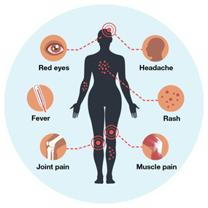

- Effects of the Zika virüs

- Ecological effects
Chemical substances are thrown into the lakes in the central area for precautionary measures, however this situation harms the creatures in the fresh water.
- Health effects

- Microcephaly

Other than microcephaly and ZIKV infections, genetic conditions during pregnancy (chromosomal abnormalities), mother's use of alcohol, radiation or mercury
It can also occur depending on exposure29. Associated with microcephaly
infectious agents herpes simplex virus (HSV), Cytomegalovirus
(CMV), Treponema pallidum, Rubella virus, Lymphocytic choriomeningitis Virus
(LCMV) and known to be Toxoplasma gondii. Depending on these reasons
mental retardation and seizures in babies with severe microcephaly,
Hearing and vision loss have been reported22,30. The problems seen in this life
While it may take a long time, depending on the course of the situation or sometimes vital
may be in danger22. In the ZIKV epidemic in Brazil,
It has been reported that the number of babies born with microcephaly has increased. Europe
Research by the Center for Disease Prevention and Control (ECDC)
as a result; The number of microcephaly babies seen in Brazil was 153 in 2010, 2011
139 in 2012, 175 in 2012, 167 in 2013 and 147 in 2014.
Since November 28, 1248 cases have been reported in 201522. Both
It has been found that there has been a very high increase in both Pernambuco and Paraiba states.

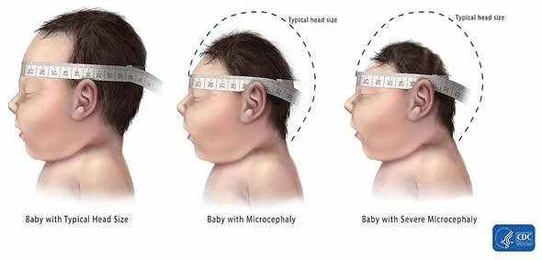
- Guillain-Barre Syndrome (GBS)

GBS is a rare occurrence of damage to nerve cells of immune system cells.
It is a peripheral nervous system and autoimmune disease that occurs when it is given. It
The syndrome is manifested with serious symptoms. Common in many parts of the skin
seen as fidgeting, numbness in the tips of the fingers and toes,
weakness or laziness, more advanced paralysis or even respiratory arrest,
It progresses with symptoms such as permanent nerve damage31. These symptoms may last for weeks or months
It can continue throughout. Many patients who catch GBS are completely
While it may improve, this may cause permanent damage to some patients and
In the French Polynesia, autoimmune and neurological diseases are almost 20 times greater after the ZIKV epidemic.
increased 32. In a place with a population of approximately 268,000 in this epidemic, a total of 74
autoimmune and neurological diseases were observed in the patient, among these 74 patients
GBS was detected in 42 patients

- Economic effects
According to the World Bank Group, “Initial estimates of the short-term economic impact of the Zika virus epidemic for 2016 in the Latin American and the Caribbean region (LCR) are a total of US$3.5 billion, or 0.06% of GDP”.

VII. Epidemiology and Geographic Spread

- Countries with the disease
ZIKV was first established in Rhesus in April 1947 in the forests of Uganda. Isolated from monkeys. ZIKV infection and disease first in 1954 It was defined in Nigeria. In a study conducted in 1952 The prevalence rate of zika seen in Uganda has been determined as 6.1%. Later, These virus infections were detected again in Nigeria in 1971 and 1975. With fever symptoms of 219 people on the island of Java, Indonesia in 1977 and 1978 ZIKV prevalence as a result of the researches made upon the application rate was determined as 7.1%. 130 patients in Nigeria again in 1979 Neutralizing antibodies specific to Zika were found in 52% of their sera. More Reports about the disease in later times were not remarkable. However, with the start of the 2000s, notifications of ZIKV infection were repeated. started. Sparse in Cambodia, Indonesia and Thailand in 2007 and 2013 as there have been case reports. Also in 2007 from Yap Island Approved in the Federal States of Micronesia with 49 patients and 59 possible suspects patients were identified. The symptoms these patients have; fever, joint pain and it has been observed as eye fever. Vector of the infection spreading in Micronesia Aedes was found hensilli. Chikungunya in Gabon country in 2007 (CHIKV) and Dengue (DENV) viruses. has come. Later in 2010, another epidemic was reported on the same viruses. has been. Serums obtained in both outbreaks and mosquitoes ZIKV was found, 5 serum samples and 2 Aedes albopictus specific to 2007 ZIKV was detected as a result of examinations on mosquitoes.
it was revealed that the epidemic that occurred in this country was caused by Aedes albopictus.
As a result of phylogenetic studies, the African shown to be of origin. ZIKV outbreak in French Polynesia in 2013 was observed and the ZIKV genome was detected in 2 cases, phylogenetic The study revealed that it is an Asian genotype. Emerged in 2013 epidemic is the biggest epidemic. After this epidemic, Japan, France and Easter ZIKV has also been detected on the island. In summary, the Zika virus has been reported in virological studies in African countries. (Uganda, Nigeria, Gabon, Senegal, Ivory Coast, Tanzania, Egypt, Central Africa Republic and Sierra Leone) and Asian countries (Cambodia, India, Indonesia, Malaysia, Pakistan, Philippines, Singapore, Thailand and Vietnam) revealed has been released. In recent years, Oceania (Micronesia, Polynesia, New Caledonia and Cases have been reported from the Cook Islands) continent.
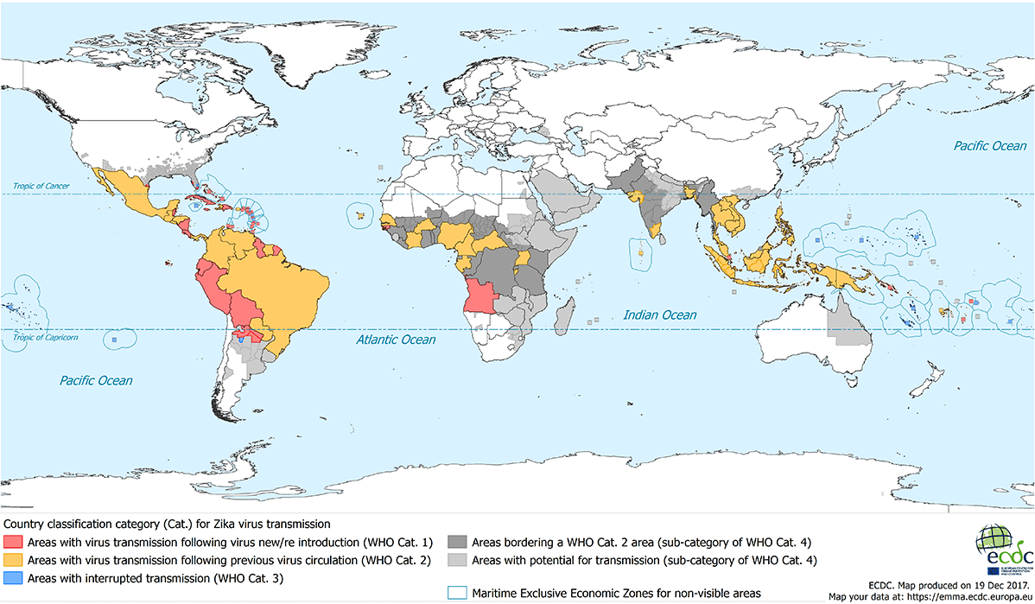

- Zika Virus in European Countries

ZIKV in European Union countries on February 4, 2016 by ECDC It has been reported that there are no infections. In the first months of 2015-2016 Some of the tourists visiting different countries have been diagnosed with the disease. 60-year-old female patient returning from a three-week Paramaribo trip in the Netherlands; with redness, itching, fever, joint swelling, and signs of mosquito bites It is the first case reported in European countries upon his admission, and ZIKV in this patient Clinically diagnosed PCR on a sample taken on the 3rd day of the disease (Erasmus MC, Rotterdam). In recent years, three people in England and Germany Five people who have traveled to Latin America and the Caribbean have has been determined. Reports of the disease have also been detected from Denmark.

- Zika Virus in the American continent

ZIKV epidemics in Colombia and Brazil in 2015 were reported very frequently.
has been. In addition, the patient who had GBS in French Polynesia in 2014
There has been an increase in the rate. Latin in the State of Texas in January 2015
ZIKV infection has occurred in a person traveling to America. Again
In 2015, the first notifications were made from South America. In 2015
There is a serious increase in congenital microcephaly cases in Brazil.
has come. The number of babies with congenital microcephaly, which was 150 cases in 2014, in 2015 It has been reported as 2400 cases. At the same time, on November 28, 2015, Brazil Ministry of Health, as a result of autopsy of a newborn baby with microcephaly He reported that ZIKV was found. On December 17, 2015 in Panama, between the ages of 25-59 and confirmed as a result of laboratory research
ZIKV case occurred in 4 persons. From the Caribbean islands, Martinique and
The disease has been reported from Puerto Rico. Generally, North America, South
ZIKV outbreak has been seen in 21 countries in the United States and the Caribbean.

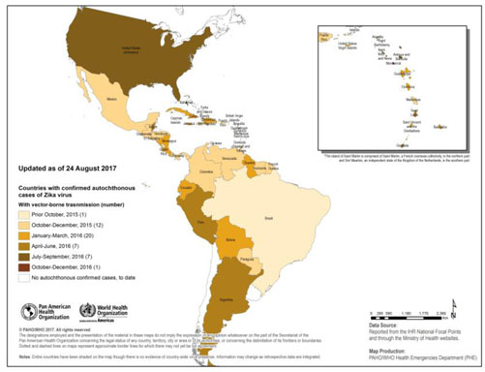

- Points that a Resolution Should Cover

- What precautions should be taken in the wave of a possible Zika virus?
- What should be in precaution methods of the country for a possible virus in the future?
- If technology is needed for this crisis, what should it be? (Such as computer models, drones, x ray scanner devices etc.)
- What can be prevented for water resources and marine life?
- Should the government of Uganda need an additional/different policy or law for their current health system for this topic?
- Which supports will be used for mental states of citizens?
- How can we keep the health values ​​of pregnant women stable?
- How can we speed up the process of finding a treatment or vaccine?
- How can we get rid of mosquitoes without disturbing the ecosystem?
- What kind of precautions should be taken to travel to countries at risk?

- Further Recommendation

In this part, delegates are going to reach more fundamental information about our agenda item. However, it does not mean that further research would not necessary. The delegates are RECOMMENDED to check additional information which would increase your knowledge in order to debate.

Keep in mind that, this is an online debate. We want to restrict the debate by requesting you to give relevant remarks only. Because of that reason, we're expecting your speeches to be purified from all unnecessary and irrelevant claims. So, if you study earlier and list your motions, the debate of the committee flows easier.

- A video for visual understanding of the topic.
https://www.youtube.com/watch?v=zc7yvvl5qTM

- I would like to add one Turkish article that I think it would be useful
for some delegates.
https://dergipark.org.tr/tr/download/article-file/395779

- An artical about Zika travel information
https://wwwnc.cdc.gov/travel/page/zika-information

- This is a recommendation for health care systems classification by country
https://en.wikipedia.org/wiki/Health_care_systems_by_country

- This is an article with questions and answers about Zika virus disease https://www.ecdc.europa.eu/en/zika-virus-infection/facts/questions-and-answers

- This is an article which is very detailed about zika
http://www.undp.org/content/dam/undp/library/HIV-AIDS/UNDP-Zika-04-03-2017-English-WEB.pdf

- Reference

https://dergipark.org.tr/tr/download/article-file/395779

https://doi.org/10.1371/journal.pntd.0002348.

http://dx.doi.org/10.1016/S0140-
Öztürk I. Küresel tehdit: Zika virüsü. Tubitak Bilim ve Teknik.
2016;580:30-33.

https://doi.org/10.1016/j.tvjl.2012.08.019

http://ecdc.europa.eu/en/healthtopics/zika_virus_infection/Pages/index.aspx.

http://promedmail.org/post/20151213.3858300

http://www.bbc.com/news/world-europe-35437877.

http://www.bbc.com/news/uk-35391712.

http://www.independent.co.uk/news/world/europe/zika-in-europepatient-in-denmark-tests-positive-for-mosquito-borne-virus-after-returnfrom-south-a6836001.html

http://newsworldindia.in/world/brazil-declares-emergencyafter-over-2400-babies-are-born-with-braindisorder/164280/

http://www.who.int/csr/don/22-december-2015-zika-panama/en/

http://www.bbc.com/news/world-us-canada-35417979

https://en.wikipedia.org/wiki/World_Health_Organization

https://www.hopkinsmedicine.org/zika-virus/what-is-zika-virus.html

https://en.wikipedia.org/wiki/Zika_virus

https://www.cdc.gov/zika/prevention/transmission-methods.html#:~:text=Zika%20virus%20is%20transmitted%20to,spread%20dengue%20and%20chikungunya%20viruses.

https://www.nytimes.com/2019/07/02/health/zika-virus.html

https://www.who.int/health-topics/zika-virus-disease

https://www.cdc.gov/zika/symptoms/index.html

https://www.passporthealthusa.com/travel-medicine/zika-virus-prevention-symptoms-and-pregnancy/

https://www.jns-journal.com/article/S0022-510X(16)30535-4/abstract

https://www.factcheck.org/2016/02/the-facts-about-zika/?gclid=Cj0KCQjwutaCBhDfARIsAJHWnHteW7EvefuUdqRyzUMuniyk7SIIePazk7a8Vb2DxehFjaoEjYzGa7UaAuWUEALw_wcB

https://www.who.int/nationalpolicies/nationalpolicies/en/

