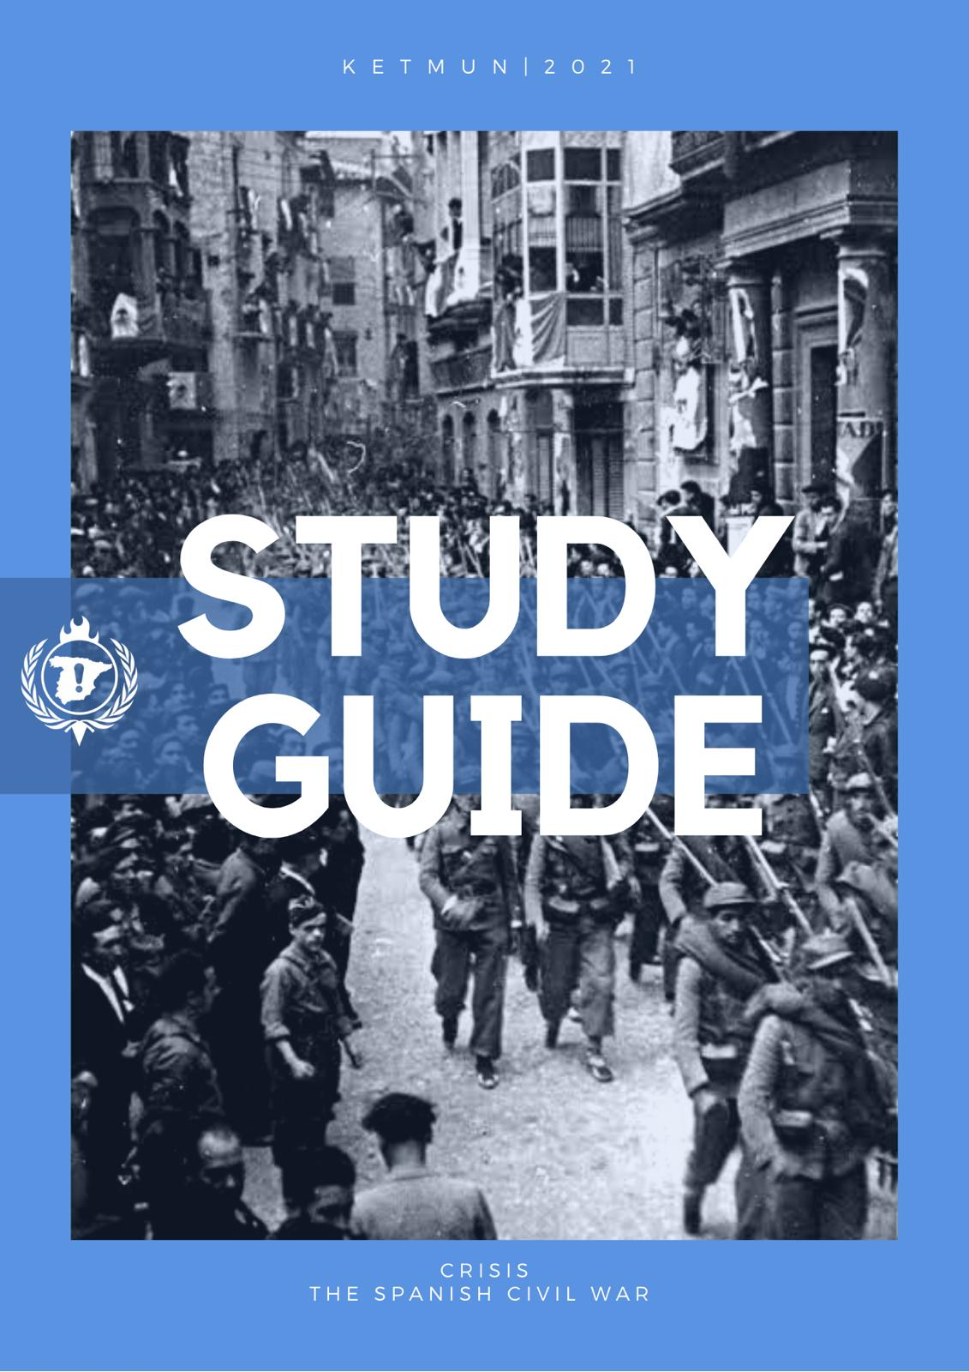
Study Guide for JCC:The Spanish Civil War
Written by:
Berke Yaren: Chair of the Nationalist Side
Yiğit Alp Özdemir:Chair of the Republican Side
Seren Anaçoğlu:Co-chair of the Republican Side
İrem Koşucu:Co-chair of the Nationalist Side

Introduction
Spanish Civil War, (1936–39) was a military revolt against the Republican government of Spain, supported by conservative elements within the country. When an initial military coup failed to win control of the entire country, a bloody civil war started, fought with great ferocity on both sides. The Nationalists, as the rebels were called, received aid from Fascist Italy and Nazi Germany. The Republicans received aid from the Soviet Union as well as from the International Brigades, composed of volunteers from Europe and the United States.

Why did Spain have a civil war ?
When Nationalist Side Leaders decided to launch an uprising towards the republic their initial efforts have come to success for creating the biggest uprising of all time.

Political ideologies :

Nationalism: Spanish nationalism, the nationalism of the Spaniards who supported the nation and it’s cultural unity. It consists of political and social movements and Spanish supremacy, language and Spanish turnaround. The origins of Spanish nationalism are thought to begin with Muslim attacks in Granada back in 1492. Those attacks and furious barbaric behaviour of Muslims bring the existence of patriotic feelings and movements among the Spaniards.

Conservatism : Conservatism is a political principle that supports traditional values, private ownership and it relies on the individual to maintain society, it is believed that change or innovation should be restricted.

Socialism : Socialism is the political basis that believes in where everyone in the society equally owns the share. Factories and corporations can be owned by the citizens. Socialism idea in Spain takes its roots from Marxist parties. It was founded by Pablo Iglesias in 1879.

Monarchy : The monarchy ideology believes that the political power should only be determined by one person and the administration is passed on to family members, usually through inheritance. The Spanish monarchy has its roots in the Visigothic Kingdom of Toledo founded after the fall of the Western Rome Empire.

Communism : Communism is a political and economic system where productive resources (factories, mines,farms) are owned by the public or the state and the wealth is divided among citizens equally or according to individual need. Communism in Spain has its roots from the Communism Manifesto in 1848.

Fascism : Fascism comes from ultranationalism characterized by dictatorial power. It believes in strong regimentation of society and of the economy. Spanish fascism was a mixture of fascism with Catholicism. Fascism ideology gained prominence in Spain during the interwar period, especially from the 1930s through World War 2.

Alfonsism: This is the ideology that supported the restoration of Alfonso XIII as the King of Spain after the foundation of the 2nd Spanish Republic.

Carlism: Carlism is an ultra-reactionary political ideology supporting a descendant of Don Carlos, Count of Molina being the King of Spain.

Anarchism: Anarchism is a political ideology calling for the abolition of all hierarchies seen as unjust including the state. In Spain, its history starts with the opening of the first chapter of the First International in Madrid in 1868, slowly gaining steam since then up to the Spanish Civil War.

Right-wing politics: Right-wing politics is politics that sees social order and hierarchy as desirable or inevitable. Right wing ideologies range from moderate conservatism to extreme fascism.

Left-wing politics: Left-wing politics is politics that sees social equality as its most desirable goal. Left wing ideologies range from moderate social democracy to extreme communism.

Centrist politics: Centrism is a political philosophy which seeks to set a balance between social hierarchy and equality. One example of such an ideology is social liberalism. Centre-left and centre-right express ideologies which,while centrist, lean more towards the left or the right side of the political spectrum. An example of a centre-left ideology is social democracy, while an example of a centre-right ideology is liberal conservatism.

Republicanism: Republicanism is an ideology which defends the republic as the ideal government form. In Spain, republicanism,while starting with the existence of the French Revolution, has truly manifested itself with the First and Second Spanish Republics of 1873 and 1931 respectively.

The Background of the War
In the end of the 19th century, latifundios, which were large tracts of land ,were owned by a few select people who ruled in an oligarchy based on land ownership. The powers of the landowners were challenged by the industrial and merchant sectors,but it was unsuccessful,unlike some other countries in Europe. In 1868, an event known as the Glorious Revolution led to the overthrow of the Queen Isabella II of the Bourbon dynasty, followed by a provisional government of 3 years,with a constitution that spawned the most progressive 19th century Spanish constitution,the 1869 constitution. In 1871 the new king, Amadeo I of the House of Savoy (the same dynasty that ruled Italy at the time) ascended to the crown,however,in 1873, he had to abdicate due to increasing political pressure,which led to the proclamation of the short lived First Spanish Republic. The Bourbon dynasty was restored to the throne in 1874, ending a 6 year period known as the Sexenio Democratico (6 democratic years). During Bourbon rule, Carlists and anarchists emerged as opposition. Alejandro Lerroux brought republicanism in Catalonia to the limelight, where severe poverty was experienced. Opposition to the conscription laws and the military culminated in the Tragic Week of 1909 which was a confrontation between socialists,anarchists and republicans; and the Spanish Army. After the 1st World War, the working class,the industrial class and the military united for the common goal of removing the corrupt central government but they failed. Fears of communism grew. In 1923, a military coup brought Miguel Primo de Rivera into power,who ran the country as a military dictatorship. As the support for his regime gradually decreased he resigned in 1930. There was little support for monarchy in the major cities so King Alfonso XIII abdicated in 1931, which led to the formation of the Second Spanish Republic,which would be in power until the culmination of the Spanish Civil War. Monarchists would keep opposing the Republic.

The revolutionary committee led by Niceto Alcala-Zamora became the provisional government,with him taking the roles of President and head of state. The Republic was supported by all segments of society,which was proven by the elections of June 1931,which had a large majority of seats won by the Republicans and Socialists. With the onset of the Great Depression, attempts were made to comfort the rural regions of the country by instituting an 8-hour work day and giving tenure to farm workers. Land reform and working conditions remained important issues during the existence of the Republic. Fascism remained a reactive threat, aided by controversial military reforms. In December a new constitution was proclaimed which was reformist,liberal and democratic. The constitution introduced secularism into the government,and this,coupled by unresponsiveness against anti-clerical violence led committed Catholics to lose their support for the current coalition government. In 1932, General Jose Sanjurjo,who would later lead the coup that started the civil war, attempted an unsuccessful coup. On the other hand ,the right-wing parties attained a victory in the elections of 1933.

Events in the two year period following November 1933 , called the “black biennium” seemed to make a civil war more likely. Alejandro Lerroux of the Radical Republican Party (RRP) formed a government with the support of the Catholic-conservative Spanish Confederation of Autonomous Right-wing Groups (CEDA) and reversed the major changes done under the previous administration,along with giving amnesty to General Jose Sanjurjo. Extremization of the parties followed; some monarchists moved to the fascist Falange Espanola to achieve their goals while the socialist PSOE (Spanish Socialist Workers’ Party) set up a revolutionary committee and secretly commenced the training of the socialist youth. Open violence occurred on Spanish cities’ streets as militancy was increasing,which showed a willingness for radical upheaval as opposed to democratic reform to solve Spain’s problems. Rebellions of socialists and Catalan nationalists occurred in Asturias and Catalonia,which was suppressed by Francisco Franco. In the last months of 1934, two government collapses brought members of CEDA into the government causing it to become more right wing. Farm workers’ wages were halved and the military was purged of republican members and reformed. A popular front alliance, which was composed of socialists,anarchists and liberals,won the election in 1936. Azana led a minority government but was able to replace Zamora as president in April. Prime Minister Casares failed to pay attention to the claims of military conspiracy among several generals,who wanted to replace the government to prevent the dissolution of Spain. These generals organized a military coup in July 1936, starting the Spanish Civil War.
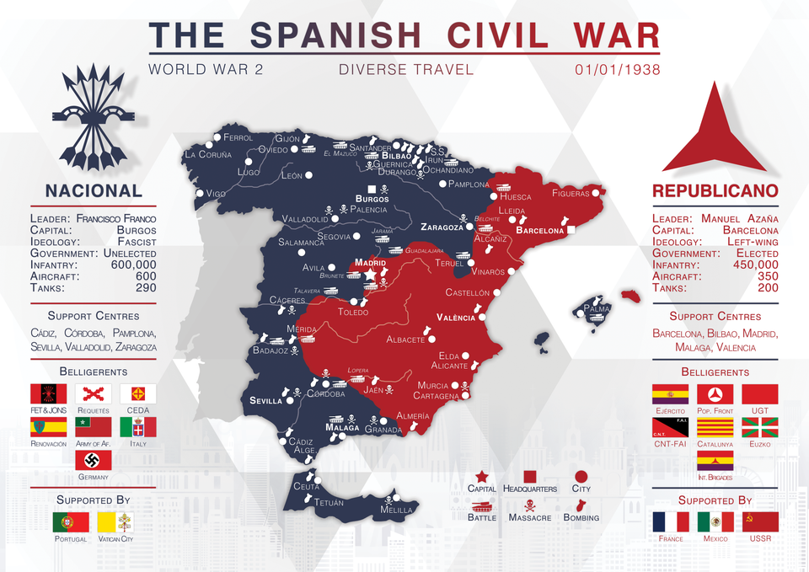

The Progression of the War
The military coup began with the declaration of revolt by some generals of the Spanish Republican Armed Forces including Emilio Mola as the de facto head and Jose Sanjurjo as a figurehead. This Nationalist group was supported by a number of conservative groups including CEDA, monarchists including both the opposing Alfonsists and Carlists, and the Falange Espanola de las JONS, a fascist party. After Sanjurjo, Emilio Mola and Manuel Goded Llopis died, Franco emerged as the leader of the Nationalist side of the civil war.

While the coup was supported by units in places such as Morocco, Pamplona, Burgos, Zaragoza, Valladolid, Cádiz, Córdoba, and Seville; they were not able to take over some important cities such as Madrid, Barcelona, Valencia, Bilbao, and Málaga, which remained under government control. This situation caused Spain to be divided militarily and politically. Thus, the Spanish Civil War began. The Republican side, composed of the old government, received aid and support from the Soviet Union and Mexico while the Nationalist side received munitions,soldiers and air support from Nazi Germany and fascist Italy. Other countries such as the US, UK and France, while continuing to recognize the Republican government, pursued a policy of non-intervention. Despite this policy, tens of thousands of these countries’ citizens directly participated in the conflict,mostly fighting in the pro-Republican International Brigades which also included several thousand exiles from pro-Nationalist regimes.

The Nationalists captured most of the northern coastline in 1937,advancing from their southern and western strongholds. They also besieged Madrid and the areas to the south and west of it for much of the war. After much of Catalonia was captured in the following two years ,and after Madrid was cut off from Barcelona, the Republican military situation became hopeless.
After the fall of Barcelona without resistance in 1939, the Francoist regime was recognized by France and the UK in February of that same year. In March of 1939, General Segismundo Casado launched a revolt against the Republican government. After the internal conflict between Republican factions in Madrid, Franco entered Madrid on 1st of April 1939. But this was not a joke. Hundreds of thousands of Spaniards escaped to refugee camps in Southern France while those who were associated with the Republicans and then stayed were persecuted by the new Nationalist regime. Franco established a dictatorship which fused all the right-wing parties into the structure of his regime.

Important Battles of the War

Battle of Malaga : Battle of Malaga 3rd of April 1937 was started between Frankish Spain, Italy and on the other side the Republic of Spain. The assault's main reason is to eradicate the Republicans hold over in Malaga. 15.000 troops were commanded by Queipo de Llano, they were supported by 10.000 Italian battalions.

Battle for Jarama : Battle of Jarama was an attempt by general Francisco Franco’s Nationalists to eject the Republican lines along the river Jarama. Nationalist sides have used around 25.000 to 40.000 infantry, 55 tanks. The Republic side has used 30.000 infantry and 30 tanks.

Battle of Guadalajara : The battle of Guadalajara was fought between Spanish Republican army and Italy, Nationalist. Spanish Republican army was defeated while Italy and nationalists attempted to encircle Madrid during the Spanish Civil War. Nationalist side have used 15.000 Moroccan colonial troops, 35.000 Italian troops, 270 artillery, 140 armoured vehicles, 62 aircraft. The Republican side used 20.000 infantry, 45 artillery, 70 armoured vehicles, 80 aircraft.

Battle of Bilbao : The battle of Bilbao was a part of the war in the North in the Spanish Civil War, had the Nationalist Army captured Bilbao and the rest of the Basque country that was still being held by the Republic. Nationalist side used around 60.000 troops and 15.000 troops. The Republic side used 50.000 troops and militia.

Battle of Brunete : Battle of Brunete was fought 24 km away from Madrid. Republicans decided to relieve the pressure exerted by the Nationalist in the north and the capital during the war. Although their effort was coming to a success, Republicans were forced to retreat from Brunete and eventually lost the battle. Nationalist used around 65.000 infantry and 105 aircraft while on the other siders Republicans used around 205.000 infantry, 400 aircraft 50 bombers, 90 fighters and 230 tanks.

The Advance in the Mediterranean Coast : Nationalists launched the Aragon Offensive, and by 14 April, they had pushed through to the Mediterranean, cutting the Republican-held portion of Spain in two.

The Battle of the Ebro : Battle of Ebro was the longest and the bloodiest battle of the Spanish Civil War, it occurred between July and November 1938. The fight was mainly concentrated in two areas on the lower part of the Ebro River and Terra Alta in Catalonia. Nationalist side around 90.000 infantry 100 fighters, 140 bombers, 100 tanks, 300 guns, 500 aircraft. The Republican side used 80.000 infantry, 70-80 field batteries, 27 anti aircraft guns, 22 tanks, 150 guns.

The Battle For Barcelona (Catalonia Offensive) : The nationalist army started the offensive on 23 December 1938 and quickly conquered Republican-held Catalonia with Barcelona. Barcelona was captured on 26 January 1939 after the Republican government headed to the French border. Thousands of people fleeing the Nationalists also crossed the frontier in the following month, to be placed in internment camps. The Republican government retreated from Barcelona to Girona. Franco closed the border with France by 10 February 1939.

Important Factions and Organizations of the War

Nationalist Side

FE de las JONS
Falange Española de las Juntas de Ofensiva Nacional Sindicalista (The Spanish Phalanx of the Councils of the National Syndicalist Offensive) or FE de las JONS for short was a fascist organization in Spain formed from the merger of Falange Espanola (Spanish Phalanx) and the Juntas de Ofensiva Nacional Sindicalista (Councils of the National Syndicalist Offensive) in 1934. It was the main fascist group in Spain until 1937 when Francisco Franco merged it with the Carlist organization called the Traditionalist Communion to form the similarly named Falange Española Tradicionalista y de las Juntas de Ofensiva Nacional Sindicalista or FET de las JONS for short. This organization merged with the rest of the parties on the Nationalist side and ruled Spain until 1975 when its leader Franco died and the government started gradually transitioning to a democracy under King Juan Carlos I,under a process known as The Transition.

CEDA
The Confederación Española de Derechas Autónomas (Spanish Confederation of Autonomous Rights) was a national-conservative Catholic party in the Second Spanish Republic. It won a plurality of seats in the 1933 general election but was not invited to the government,until it pressured the government to include 3 ministers from it. As time went on, it became more and more extreme,moving further to the right.

Requetes
Requetes were members of the Carlist paramilitary organization Requete. They were also called “boinas rojas” (red berets) While it emerged in 1907, it was reformed in 1931,reorganizing with some members receiving training in Fascist Italy. It was 25,000 strong at the beginning of the war.

Renovación Española
Renovacion Espanola (Spanish Renovation) was an Alfonsist, far-right political party. It was dissolved in 1937 with the formation of FET de las JONS.

Republican Side

Popular Front
The Popular Front (Frente Popular) was an electoral coalition and pact formed in 1936 between various leftist groups. These groups included the leftists :the Spanish Socialist Workers' Party (PSOE), Communist Party of Spain (PCE), the Workers' Party of Marxist Unification (POUM, Trotskyist) and the republicans: Republican Left (IR) and Republican Union (UR). It was supported by Galician and Catalan nationalists, the Workers General Union (UGT) and the anarchist trade union CNT. It defeated the nationalists in the 1936 election,with Manuel Azana as president but PSOE did not join the government due to Francisco Largo Caballero. The government ruled by them armed workers’ groups organized under its member parties after the break out of the Spanish Civil War.

UGT
Unión General de Trabajadores (General Workers Union) is a socialist Spanish trade union founded in 1888. It has been associated with the Spanish Socialist Workers Party. While it was united in action with the CNT since WW1, it was more moderate compared to it,avoiding confrontation. Its size grew from around 277 thousand to 1.04 million in two years from 1930 to 1932. Much of this growth came from the land workers section,tripling the percentage of land workers within the organization, which caused it to be radicalized. The breakout of the Spanish Civil War amplified its internal divisions.
After Franco’s victory it had to go underground, but during the Spanish transition to democracy, it emerged from secrecy,becoming one of the two most important trade unions in Spain,along with the communist Workers’ commissions.

CNT/FAI
Confederación Nacional del Trabajo (National Confederation of Labour) and Federación Anarquista Ibérica (Iberian Anarchist Federation) are two closely-knit anarchist organizations in Spain. The CNT is a confederation of anarcho-syndicalist trade unions while the FAI is a more radical and militant subsection of the CNT. The CNT was founded in 1910 while the FAI was founded in 1927. During the civil war they controlled Catalonia and the eastern parts of Aragon, later on having internal conflicts with other Republican factions. After the civil war it was outlawed and operated clandestinely. It was legalized after the transition to democracy,with considerably less influence and power compared to the 1930s.

Basque Nationalist Party
The Basque Nationalist Party (Basque: Euzko Alderdi Jeltzalea, EAJ; Spanish: Partido Nacionalista Vasco, PNV) are a Basque nationalist party founded in 1895. During the civil war they supported the Republicans in exchange for Basque autonomy, and raised the Basque Army. After the war it was banned and it went into exile,but after democratization it was legalized.

Generalitat de Catalunya
The Generalitat de Catalunya (Catalan Government) is the autonomous government of Catalonia. It was established in 1931 first as an independent state but then agreed to be an autonomous part of Spain. During the Spanish Civil War, the Catalan Government led by Lluis Companys remained loyal to the Republican government,taking over its duties in Catalonia. It exerted varying degrees of exerted control over its territory due to the revolutionary situation. After the war it was abolished by Franco but it was reestablished during the democratization of Spain.

International Brigades
The International Brigades were forces raised by the Comintern International to aid the Popular Front during the civil war. It existed from 1936 to 1938 and had 50.000 members , 15.000 of which were killed in action. It was integrated into the Spanish army in the last year of its existence and later disbanded by Prime Minister Juan Negrin in a vain attempt to gain support of liberal democracies who were signatories of the Non-Intervention agreement. The largest number of volunteers came from France, Italy and Germany. Many Jews were also involved in the brigades. Anti-Stalinist volunteers did not join this group,instead joining other groups such as the Popular Front’s POUM and the anarchist Durruti Column.

End of the War
In Spain, the Republican guardians of Madrid raised the white flag over the province and the three-year terrifying Spanish Civil War ended.

In 1931, King Alfonso XIII of Spain approved the vote to decide on the Spanish government, and voters overwhelmingly chose to abolish the monarchy in favor of a liberal republic. Alfonso then went into exile and the Second Republic was proclaimed, initially dominated by middle-class liberals and moderate socialists. In the first five years of the republic, organized worker and leftist radicals forced widespread liberal reforms, and the libertarian-minded Spanish regions of Catalonia and the Basque provinces gained de facto autonomy.

The landed aristocracy, the church, and a large military clique inflicted increasing violence on the Second Republic, and in July 1936, General Francisco Franco led a right-wing army revolt in Morocco, resulting in the separation of Spain into two main camps. : Nationalists and Republicans. Franco's Nationalist army swiftly destroyed most of the Republic-controlled areas in central and northern Spain, and Catalonia became the Republicans stronghold.
In 1937, as the Republicans came under the rule of the communists, Franco united the nationalist forces under the Spanish fascist party Falange. Germany and Italy aided and abetted Franco with large quantities of aircraft, tanks and weapons, while the Soviet Union helped the Republican side. In addition, a small number of communists and other radicals from France, the USSR, America, and elsewhere formed International Brigades to aid the Republican cause. The most important aid of these foreign troops was the successful protection of Madrid until the end of the war.

In June 1938, the Nationalists went to the Mediterranean and divided the territory of the Republic into two. Later in the year, Franco staged a massive attack against Catalonia. In January 1939, its capital, Barcelona, ​​was captured and the rest of Catalonia fell shortly thereafter. While the Republican case was almost lost, its leaders tried to conclude a peace treaty, but Franco did not agree. On March 28, 1939, victorious Nationalists entered Madrid with profits and the Spanish Civil War ended. Up to a million were killed in the worst conflict in Spanish history.
The new regime signed an Aggression Prevention Pact with Portugal and a friendship treaty with Nazi Germany on March 31, and on April 6, Franco made public Spain's commitment to the Non-Agression Pact. The Intervention Prevention Committee was dissolved on 20 April, and both Italian and German troops left Spain in June. The Francoist dictatorship remained in power until Franco's death on 20 November 1975.

Casado remained in exile in Venezuela until he returned to Spain in 1961. Cipriano fled to Mera, Oran and Casablanca, but returned to Spain in February 1942. Sentenced to death in 1943. 30-year prison sentence was changed; He was released in 1946 and fled to France, where he died in 1975. Besteiro still works in the basement of Revenue. The building on 7 Alcalá Street in Madrid was arrested by the Nationalists when they entered the city and encountered a military court. Nationalists arrested 150,000 soldiers and hundreds of thousands of Republican soldiers and civilians captured in the last attack and took them to improvised concentration camps. In 1939 there were between 367,000 and 500,000 prisoners. In the first years after the war, 50,000 Republican prisoners were executed.
There were also some Spanish Republicans who kept on fighting a guerilla conflict against Francoists up until 1965 called the Spanish Maquis.
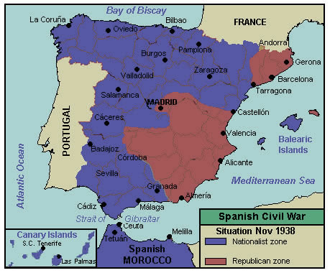

Sources
Wikipedia (https://en.wikipedia.org/wiki/Spanish_Civil_War and various related pages)
Britannica
Timetoast.com
NZ History
https://www.reddit.com/r/MapPorn/comments/hl1bsw/the_spanish_civil_war_oc/

