Country: United States of America
Committee: United Nations Development Programme
Agenda Item: Achieving Sustainable Development Goals 8 & 9

The United States of America is located between Canada and Mexico and has borders with the North Atlantic Ocean and the North Pacific Ocean. The United States of America is a federal constitutional republic with fifty states, one federal district, and 16 overseas territories. The United States of America, whose capital is Washington, D.C., has a legal system that is based on English common law at the federal level; state legal systems are based on various acts. The official language of the United States of America is English. The total population is estimated to be 322,180.000 people. United States of America is a member of such as NATO, BIS, ANZUS, ICC, Interpol, OECD, SPC, and WTO. The United States of America’s Gross Domestic Product (GDP) is 23 trillion USD. The United States of America is home to 44.9 million migrants.
United Nations Development Programme (UNDP) works in 170 countries and territories to eradicate poverty and reduce inequality. It helps countries develop policies, leadership skills, partnering abilities, and institutional capabilities, and build resilience to achieve the Sustainable Development Goals, which is adopted by United Nations Member States in 2015 to eradicate severe poverty for all people worldwide by the year 2030 as one of its key objectives. In addition, 17 Sustainable Development Goals have been accepted as a road map for building a sustainable future in the United States of America.
Sustainable Development Goals 8 and 9 contain decent work and economic growth, industry, innovation, and infrastructure. In general, actions for qualified work and a better environment within the sub-targets have made the United States of America one of the leading countries in contributing to goals 8 and 9.
According to the International Labour Organisation (ILO), decent work is defined as "productive work for women and men in conditions of freedom, equity, security, and human dignity." The United States Equal Employment Opportunity Commission (EEOC) enforced laws to ensure that everyone, no matter what gender, religion, race, disability, or color, gets the same amount of salary. Moreover, Title VII of the Civil Rights Act "prohibits an employer from treating an employee differently, or less favorably, because of sex, which is defined to include pregnancy, sexual orientation, and gender identity. This law also prohibits employment decisions based on stereotypes (unfair or untrue beliefs) about abilities and traits associated with gender." In addition, Title VII "prohibits employment discrimination based on gender identity or sexual orientation." These protections apply even if state or local laws take a different position." Everyone, regardless of gender, is protected from sex discrimination under Title VII. In general, decent work is the key to sustainable economic growth.
The economic growth that the United States of America has made shows that the United States is one of the biggest economies in the world. The graphic that will be given below proves that this economic growth is bigger than the European Commission on its own. That leads to the United States of America’s economy being independent and based on trade. Trade has a significant role in fueling economic growth, supporting good jobs at home, raising living standards, and helping Americans provide for their families with affordable goods and services. In general, trade and its benefits are crucial to the United States.
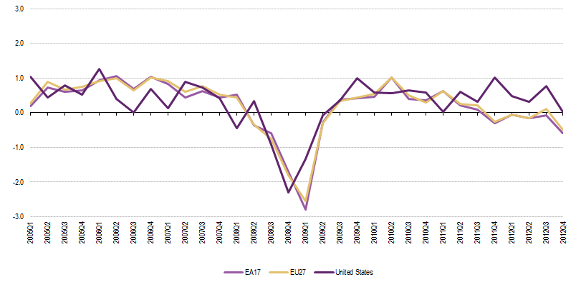
Figure 1: U27, EA17, and United States GDP growth rates

Trade expansion benefits include: supporting more productive, higher-paying jobs in our export sectors; expanding the variety of products available for purchase by consumers and businesses; encouraging investment, and fostering more rapid economic growth. In conclusion, trade keeps the United States of America’s economy open, dynamic, and competitive and helps ensure that the United States of America continues to be the best place in the world to do business.
Unemployment rates after the COVID-19 pandemic rose due to company losses; however, as seen in the graphic below, the United States is one of the countries that got better after the COVID-19 pandemic. Since the pandemic is over, unemployment rates have decreased.
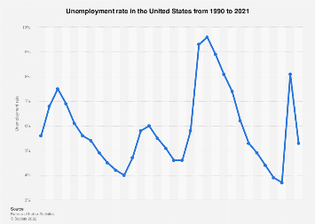
Figure 2: The unemployment rate in the United States from 1990 to 2021
Since the pandemic, economic growth has been unstable in the United States of America. Tourism and the service industry are some of the main sources of income that contribute to the United States of America’s treasury. Therefore, with these sources of income, the United States of America can balance its economic growth.
The United States of America declares that the migrants in the workforce have undeniable contributions; however, most of them work in horrendous conditions. Moreover, most of these migrants are children. The United States Fair Labor Standards Act (1938) "prohibits those under the age of 14 from working in most industries, restricts hours to no more than three on a school day until 16; and prohibits hazardous work until 18 for most industries."
Promoting good jobs in the United States of America, according to the National Employment Law Programme is possible by protecting employee rights. More than 60 million U.S. workers are blocked from suing their employers due to forced arbitration clauses, with women, people of color, and low-wage workers disproportionately impacted. However, with the help of the laws that the EEOC enforces, employees have the right to defend themselves.
In addition, 38 percent of the total population, 0.52 percent of the migrant population, are entrepreneurs in the United States, which is why, to ensure that promoting entrepreneurship is on the agenda, the United States is actively working on various programs such as the Veteran Federal Procurement Entrepreneur Training Program (VFPETP), The Program for Investment in Entrepreneurs (PRIME), Small Business Development Centers (SBDCs), Women’s Business Centers (WBCs), and more. These programs provide support and help to the owners of small businesses and employment for women and minorities, such as migrants. Moreover, they also provide financial support when it comes to infrastructure.
The United States ranked 13th when it comes to the overall quality of infrastructure. To build resilient and better infrastructure, The Bipartisan Infrastructure Law (Infrastructure Investment and Jobs Act), passed by Congress and signed by the president of the United States, aims to modernize the current infrastructure and seek to turn this around with a historic amount of investment in critical infrastructure, also including: improving and rebuilding roads, bridges, public transit, rail, ports, and airports; ensuring safe, lead-free drinking water for everyone; supporting climate-friendly car and bus transport; transitioning to clean energy; and providing access to high-speed internet regardless of where one lives.
91.8 percent of the population has access to the internet in the United States of America, which is ranked third in the usage of the internet worldwide. That rate leads the country to focus on technological developments such as online purchases, aircraft, spacecraft, online jobs, and more.
Those developments brought several innovations that caused the development of industries in the United States of America and made it one of the leading countries in innovation. Furthermore, according to Sustainable Development Goal 9, sustainable growth must include industrialization, which creates opportunities accessible to all people and is supported by innovations and resilient infrastructure. Analyzing the Global 100 most sustainable corporations in the world between 2016-2019, the United States takes the lead with the highest number of businesses at 71. In 2019, leading industrial real estate business Prologis, Inc., ranked as the sixth-most sustainable business in the world. The corporation holds five sustainability objectives, including providing industry-leading energy-efficient buildings, partnering with community organizations to promote environmentally friendly initiatives, and delivering employee and customer awareness about sustainability.
The United States of America has come a long way in order to achieve Sustainable Development Goals by enforcing laws, programs, and acts such as the Federal Sustainability Plan (FSP), which aims to foster citizens and companies to ensure that they are aware of climate change and its effects, as well as raising awareness and promoting Sustainable Development Goals. Not in the just United States of America but in the whole world dealing with the consequences of climate change.
Simultaneously, the world has been facing severe unemployment, bad infrastructure, and unsustainable industries’ effects on climate change. The graphic that will be given below will show that approximately a quarter of gas emissions are just because of industry.
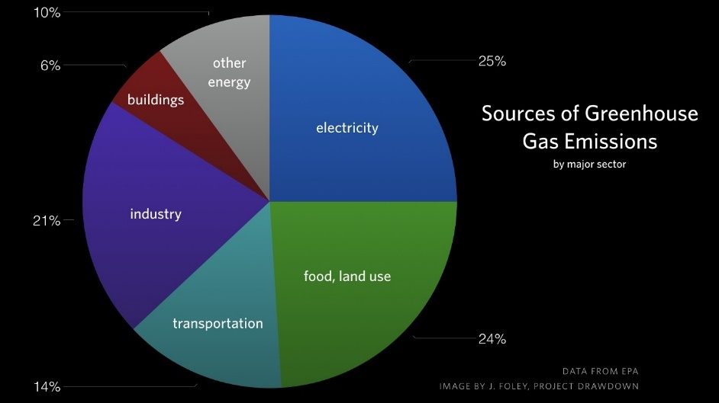
Figure 3: The sources of gas emissions.
Moreover, the world’s economy is also affected by the COVID-19 pandemic, and the global Gross Domestic Product (GDP) fell by 3.4 percent. In addition, the current war between Russia and Ukraine affects economic growth and may be an obstacle. All of these incidents caused unemployment. As seen in the graphic below, the role of COVID-19 is massive. However, the end of the pandemic shows that unemployment rates have decreased.
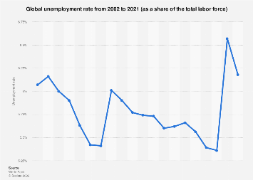
Figure 4: Global unemployment rate from 2002 to 2021

The United States of America’s incentives for sustainable economic growth are marketable permit systems; emission taxes, fees, and charges; subsidies; and tax-subsidy combinations that provide financial help to companies that are planning sustainable economic growth and supporting entrepreneurship with training programs such as Small Business Development Centers (SBDCs), a non-financing program that will teach small businesses about management and marketing. Another program that provides help is the Program for the Investment in Microentrepreneurs (PRIME). It is a training program for microentrepreneurs, whether they are on loan or not. Also, PRIME provides limited funds to microentrepreneurs for building their budgets and establishing organizations that are based on the microentrepreneur community. Lastly, SCORE and Women’s Business Centers (WBC) are other programs that the United States encourages.
Enforced laws protect the work environment and state the fundamental rights of employees that they have, such as suing the employer in certain conditions and prohibiting discrimination in the workplace that is based on race, sex, religion, color, and age. The United States of America believes that enforcing laws against discrimination is an important step to ensuring decent work in the workplace. Moreover, child labor is certainly prohibited and guaranteed by law. For the migrants in the workforce, the United States also enforced laws in order to protect their rights. The infrastructure problem caused internet disconnection in workplaces, which affected efficiency at the workplace. Following those incidents, the United States Congress passed the Bipartisan Infrastructure Act, which aims to modernize infrastructure and make it more accessible to all.
The U.S. government’s incentives for sustainable economic growth have led industries to be sustainable since there is financial support for companies that are sustainable. Overall, the innovation industry is affected by that change. The United States of America is one of the leading countries in the innovation industry in the world. With the need for a workforce in the growing industry, employment rates have decreased.
Further solutions that are the United States of America suggests creating public announcements that will emphasize the rights of employees. Calls out Member States to create infrastructure plans according to the Sustainable Development Goals. Suggests the introduction of jobs and fields to increase attraction. Establishing specialized schools to improve abilities and create environments for the workplace. The International Labor Organization and the United Nations Development Programme should form alliances to enhance employee rights around the world. United States of America encourages Cooperation with the United Nations Human Rights Council (UNHRC) in order to inspect the conditions at work and whether they are appropriate for human dignity.

References:
https://www.cia.gov/the-world-factbook/countries/united-states/#government
https://www.statista.com/topics/760/united-states/#dossier-chapter5
https://fred.stlouisfed.org/series/GDP#
https://www.americanimmigrationcouncil.org/research/immigrants-in-the-united-states
https://www.undp.org/about-us
https://sdgs.un.org/goals
https://unfoundation.org/blog/post/why-do-the-sustainable-development-goals-matter-in-america/
https://dashboards.sdgindex.org/profiles/united-states
https://www.eeoc.gov/youth/pay-discrimination,
https://www.statista.com/statistics/193290/unemployment-rate-in-the-usa-since-1990/
https://ec.europa.eu/eurostat/statistics-explained/index.php?title=File:EU27,_EA17_and_United_States_GDP_growth_rates_2012Q4.png
https://www.aft.org/community/child-labor-united-states
https://www.epi.org/publication/state-agenda-for-americas-workers/
https://www.nelp.org/publication/state-agenda-americas-workers-18-ways-promote-good-jobs-states/
https://ustr.gov/about-us/benefits-trade
https://www.cbo.gov/publication/56906
https://www.sba.gov/document/information-notice--veteran-federal-procurement-entrepreneur-training-program-vfpetp
https://www.sbc.senate.gov/public/index.cfm/entrepreneurialdevelopmentprograms
https://www.forbes.com/sites/johncaplan/2021/11/05/the-ongoing-wave-of-entrepreneurship-is-set-to-reshape-the-us-economy/?sh
https://www.whitehouse.gov/cea/written-materials/2021/11/15/the-time-is-now-to-modernize-u-s-infrastructure/
https://www.statista.com/topics/2237/internet-usage-in-the-united-states/
https://www.business-money.com/announcements/banking-named-most-sustainable-industry-worldwide/
https://www.sustainability.gov/pdfs/federal-sustainability-plan.pdf
https://globalecoguy.org/the-three-most-important-graphs-in-climate-change-e64d3f4ed76
https://www.statista.com/statistics/279777/global-unemployment-rate/
https://www.epa.gov/environmental-economics/economic-incentives

