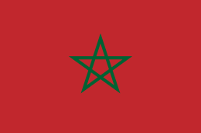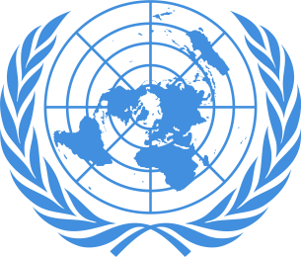

Country: Kingdom of Morocco
Committee: United Nations Social Cultural and Humanitarian Committee (SOCHUM)
Topic: Protecting the Right and Freedoms of Refugees in Wars
Delegate: Beril Pekmez

Morocco is both a sending and a receiving country in terms of immigration: a land of immigration since the first wave of World War one. Morocco has become a land of asylum and long-term settlement for immigrants. It welcomes regular immigrant workers, a relatively large number of foreign students, immigrants with an irregular status, and finally asylum seekers and refugees. To those immigrants, we can add groups who have been settled in Morocco for generations and an increase of immigration as illustrated, for example, by the circular immigration of an elite highly qualified professional workers between Europe and Morocco. The combination of these diverse forms of immigration makes Morocco gradually and irreversibly a cosmopolitan country. The regular and irregular immigration of Moroccans and the growing visibility of new populations of immigrants in Moroccan cities.
In 2003, a law on the entry and residency of foreigners, illegal immigration was adopted, followed in 2007 by the signing an agreement with the UNHCR, delegating the review and the granting of asylum applications.
Without contesting the right of Moroccan authorities to control the entry and stay permits of foreigners and their duty to fight against human trafficking, the CNDH believes that public authorities cannot, in the fulfillment of their missions, evade the constitutional provisions in the matter of human rights and foreigners’ rights.
The international commitments under the ratification of all the instruments of protection of human rights in particular: the International Covenant on Civil and Political Rights, the International Covenant on Economic, Social and Cultural Rights, the UN Convention against Torture, the Convention on the Rights of the Child, the Convention on the Elimination of All Forms of Discrimination against Women, the International Convention for the Protection of the Rights of All immigrant Workers and Members of Their Families and the 1951 Refugee Convention.
In 2013, the government of Morocco was the first in the Middle East and North Africa region to launch the National Strategy on Immigration and Asylum (NSIA), which sets out mechanisms of response to meet the needs of refugees and asylum seekers on Moroccan territory. The NSIA falls under the leadership of his majesty king Mohammed VI (who was nominated leader of immigration in Africa by the African Union in 2018) upon the recommendations the National Council of Human Rights. To bring the NSIA to life, an inter-ministerial commission was formed, the Bureau of Refugees and Stateless people was established to conduct joint Refugee Status Determination (RSD) procedures, and strategic collaboration among different ministries helped to set up the institutional building blocks of a national asylum system.
In further implementation of the Global Compact on Refugees, Communication and awareness-raising campaigns about asylum and refugee rights were conducted for members of public administration and security forces. Efforts are underway to give refugees equal access to public services and programs of education and health, and to reduce barriers of the economic inclusion of refugees through administrative and operational measures.
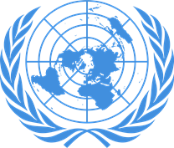

Country: Kingdom of Morocco
Committee: United Nations Social Cultural and Humanitarian Committee (SOCHUM)
Topic: Tacking Refugee Trafficking
Delegate: Beril Pekmez

Morocco is a source, a destination, and a transit country for men, women, and children who are subjected to human trafficking, specifically forced labor and forced prostitution. Children are kidnapped within their country’s rural areas to urban centers to work as maids or laborers, or for commercial sexual exploitation. Moroccan men, women, and children are exploited for forced labor and prostitution in European and Middle Eastern countries. Young Moroccan girls from rural areas are recruited to work as child maids in cities, but often experience non-payment of wages, threats, physical or sexual abuse, and sometimes face restrictions on movement. These practices indicate that these girls are subjected to involuntary servitude. Moroccan boys experience forced labor as apprentices in the artisan and construction industries and in mechanic shops. Moroccan women are forced into prostitution in Gulf States – including the United Arab Emirates and Bahrain – Jordan, Libya, Syria, and European countries; some of them experience restrictions on movement, threats, and emotional and physical abuse. Some Moroccan men reportedly are promised jobs in the Gulf but experience confiscation of their passports and are coerced into debt bondage after arrival. A few Moroccan men and boys are lured to Europe by fraudulent job offers, and are subsequently forced to sell drugs. In addition, men and women from sub-Saharan Africa, South Asia, and the Philippines enter Morocco voluntarily but illegally with the assistance of smugglers; once in Morocco, some of the women are forced into prostitution or, less frequently, forced into domestic service. Nigerian gangs, who engage in a variety of criminal activities like people smuggling and drug trafficking, compete to control the trafficking of sub-Saharan Africans in Morocco.
The Government of Morocco made progress in investigating human traffickers and punished human traffickers during the reporting period. Moroccan law prohibited all forms of trafficking.
In 2009 the UNODC released a report indicating that Morocco indeed had a law within its penal code prohibiting human trafficking.
The Moroccan government made some efforts in preventing human trafficking in 2010. The government included anti-human trafficking modules in training programs for the Royal Gendarmerie, the Auxiliary Forces, and the police. In April 2009, the Ministry of Justice conducted an awareness raising course for magistrates about victim protection and working with trafficking victims who have been affected by violence or sexual exploitation. All Moroccan soldiers participating in UN peacekeeping missions receive training on the issue of commercial sexual exploitation. The Moroccan government cooperated with the IOM in preparing a publicly available report that included a comprehensive overview of the government's strengths and weaknesses on trafficking issues and included recommendations for legislative and policy reforms.

