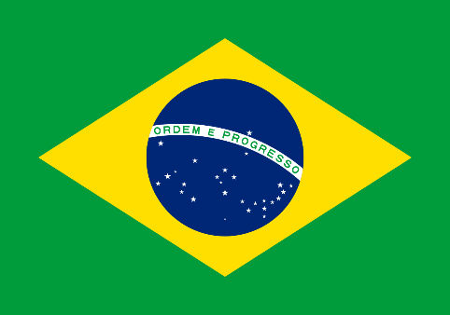
Committee: UNICEF
Country: Brazil
Agenda Items:
Agenda Item A: Elimination of child labor
Agenda Item B: Regulation and reintegration of child labor survivors

Brazil, officially Federative Republic of Brazil, which covers almost half of the region is the largest country in South America and the fifth largest nation in the world. With over 214 million people Brazil is the world’s sixth most populous country. Brazil’s capital with 2.8 million people, is Brasília. Brazil’s official language is Portuguese because Brazil was colonized by Portugal in the past. On 7 September 1822 colonial dominance of Portugal over Brazil and Brazil became independent. That’s why Brazilians celebrate Independence Day on 7 September.
For as long as history can remember, Brazil has been one of the most affected countries in terms of forcing a child to work. With gaps in Brazil’s legal framework to adequately protect children from the worst forms of child labor, more than three million Brazilian children between the ages of 5 and 17 are working unwillingly in hazardous and poor conditions. From those, almost 560.000 are household workers who strive in domestic farms, which are said to be the most difficult places to reach, therefore, the ones where invisible child labor is most extensive. According to ILO (International Labor Organization) poverty is the leading cause of child labor in the world. Beside this, lack of access to quality education, poor access to decent work, conflicts and mass migration are some of the root causes of child labor.
--There are a multitude of NGOs, associations, public organs, and networks in Brazil working to ensure the rights of children and adolescents. They generally seek to fulfil their objectives through activities serving that specific population as well as by offering consultations and professional development to those working with that age group.—
Solution offers
One of our offers is well-of societies lend a helping hand to countries suffering with poverty, thus, several countries with different socio-economic developments are able to strengthen their friendly relations.
Children's access to basic education should be facilitated and the education expenses of poor families should be covered by the state.
The gaps should obliterate from all key international conventions concerning child labor.

