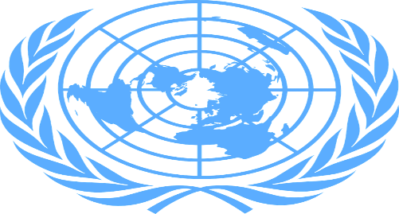
Country: United Arab Emirates

Committe: Social, Humanitarian & Cultural Issues (SOCHUM)

Delegate: Çınar Çelebioğlu

Topic: Protecting the rights and freedoms of refugees in Wars
In the past decade, amount of refugees in all countries is rapidly growing due to wars. Moreover United Arab Emirates that affected by it, takes the lead. Our country is second-highest refugee destination in Middle-East and the Gulf.
We endorsed the Global Compact for Safe, Orderly, and Regular Migration as well as the Global Compact on Refugees in December 2018. For all this, Pope Francis honored us with his visit in 2019 and it was the first visit of a Pope to the Arabian Peninsula. He celebrated a public Mass here and signed the Document on Human Fraternity for World Peace and Living Together.
Within Global Compact for Safe, Orderly, and Regular Migration, we agreed to review the progress made at the local, national, regional and global levels in implementing the Global Compact at an International Migration Review Forum (IMRF) through a State-led approach and with the participation of all relevant stakeholders at the UN General Assembly
Since the start of the pandemic, there has been a systemic failure in our country to protect the rights of migrant workers and hold employers accountable for ensuring accommodation and food are supplied until employees can be repatriated. However with waning pandemic effects, we do our best to provide them good lifes day by day. As a proof of that, In Dubai, they represent 95% of workforge.

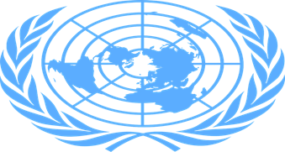
Country: United Arab Emirates

Committe: Social, Humanitarian & Cultural Issues (SOCHUM)

Delegate: Çınar Çelebioğlu

Topic: Tacking refugee trafficking
Unfortunately, In 2020-2021, the UAE prosecuted 54 people in 19 sex trafficking cases and found 15 individuals guilty. Although the numbers are not objectively high, the UAE is a leader in North Africa and the Middle East in the number of trafficking convictions. However our state trying to decrease trafficking in our country.
At the international level, the UAE has exerted important efforts in the global campaign against human trafficking and has ratified several international agreements related to migrants and victims of human trafficking: the ILO Forced Labour Convention; the Equal Remuneration Convention; the ILO Abolition of Forced Labour Convention; the Discrimination (Employment and Occupation) Convention; the Minimum Age Convention; the Worst Forms of Child Labour Convention; the Convention Against Transnational Crime & the Protocol to Prevent, Suppress, and Punish Trafficking in Persons, especially Women and Children; and the Optional Protocol to the Convention of the Rights of the Child on the Sale of Children, Child Prostitution and Child Pornography.
The UAE uses the kafala system to manage its large migrant worker population because our economy relies on migrant workers.
In the UAE, kafala allows private citizens to employ migrant workers. In turn, the employers agree to relinquish some of their political and social rights to the government. Kafala creates a significant power imbalance, favoring employers over migrant workers. As a result, migrant workers are at risk of falling prey to human trafficking and forced labor.
To prevent this, shelters supporting trafficking victims have published informational packets via social media. These packets inform at-risk groups about indicators for human trafficking situations. Additionally, the Federal Public Prosecution published an online brochure. This brochure explains the punishments for people who know of human trafficking activities but do not report them.

