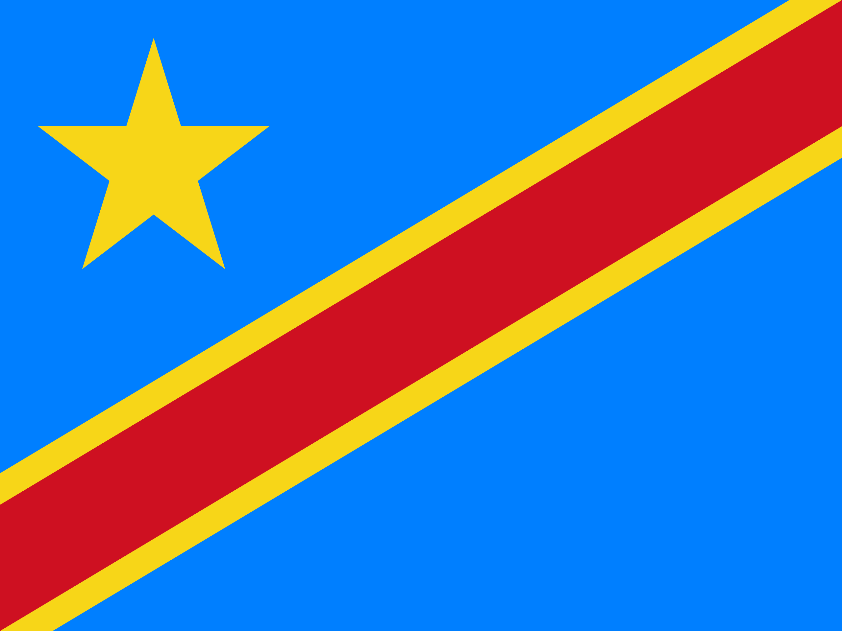 REFUGEE TRAFFICKING 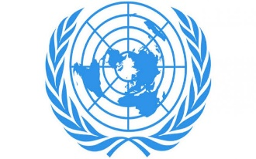
Name:Gülnur Çelik
School:Isparta Süleyman Demirel Fen Lisesi
Committee:Social Humanitarian and Culturel Committee
Delegate:Democratic Repoblic of Congo
The Congo republic is a country of sixty-five million inhabitants in the mid-west of Africa. The Republic of the Congo, which lived under colonialism until the 1960s, declared independence in 1960. It has rich natural reserves. Despite this, it is an economically undeveloped country.It was supposed that the main determinants of human trafficking issue had been economic development rate as well as the lack of social policy, and social security implementations. However, in the aftermath of the research, it was seen that there is no such relevance between human trafficking and the level of the economy, lack of social policy and security deficiencies for Southern African countries.the economic development, the strength of the social policy and security implementations are not the direct indicators for human trafficking activity. Therefore, it can be stated that the act of human trafficking is not in line with the economy and the public policies for these countries mentioned. Internal conflicts have been ongoing in the Congo Republic for the past two decades due to the wealth of natural resources. Migrations due to internal conflicts are numerous. In 2018, six hundred thousand congos had to leave their homes abroad, and four and a half million people had to leave their homes.In addition to that we are trying take a precaution for refugee trafficking.First time we convicted who make refugee trafficking in 2017.And we gave refuge to eight victims.We tried to do improve the provision pf protective services to trafficking victims to provide appropriate care to victims nationwide.We increased overall anti-trafficking law enfarcement effors. Who did refugee trafficking we judged them in addition we imposed five to ten years in prison.We investigated six traffickers and prosecuted the smuggler in 2019.

