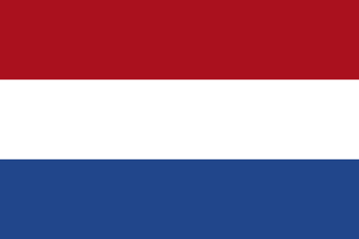
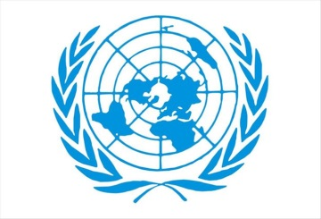

Committee: Social Cultural and Humaniratian Committee (SOCHUM)
Representing: Netherlands
Delegate Name: Verda Özdemir
Topic: (1) Tacking refugee trafficking
(2) Protecting the rights and freedoms of refugees in Wars.
The topics before the Social Cultural and Humaniratian Committee are: tacking refugee trafficking and protecting the rights and freedoms of the refugees in wars. The Kingdom of the Netherlands is committed to demonstrating international cooperation and collaboration through working with fellow UN Member States to improve quality of human and child traffic policy and rights of the refugees.
Our world is facing from many obstacles created by natural and manmade disasters which further results in problems in every country’s economy and social welfare of every person is jeopardized an done of the problems faced by majority of the nations of this world due to economic downfall is human trafficing. Human trafficking is believed to be the world’s fastest growing criminal enterprise and is an estimated $150 billion-a-year global industry.
In the Netherlands, it is estimated that there are from 1,000 to 7,000 trafficking victims a year. Most police investigations relate to legal sex businesses, with all sectors of prostitution being well represented, but with window brothels being particularly overrepresented. In 2008, there were 809 registered trafficking victims, 763 were women and at least 60 percent of them were forced to work in the sex industry. In 2000, the Netherlands established the Dutch National Rapporteur on Trafficking in Human Beings and Sexual Violence against Children to report on the progress of the Dutch Government in combating human trafficking, which produced its first report in 2002.
The Government of the Netherlands fully meets the minimum standards for the elimination of trafficking. The government continued to demonstrate serious and sustained efforts during the reporting period. These efforts included doubling the number of trafficking victims it identified, passing legislation to criminalize knowingly soliciting a sex trafficking victim, more than doubling its funding for NGO-managed shelters for trafficking victims, and increasing efforts to combat labor trafficking. Moreover, authorities in Bonaire conducted two trafficking investigations, and identified and offered services to two victims, the first time in several years that the islands of Bonaire, Sint Eustasius, and Saba (BES islands) investigated a trafficking case or identified a victim.
The Government maintained mixed law enforcement efforts. Article 273f of the criminal code criminalized sex trafficking and labor trafficking and prescribed punishments of up to 12 years’ imprisonment or a fine of up to €87,000 for trafficking offenses involving an adult victim and up to 15 years’ imprisonment or a fine of up to €87,000 for those offenses in which the victim was a child. These penalties were sufficiently stringent and, with respect to sex trafficking, commensurate with those prescribed for other serious crimes, such as rape.
The government continued to participate in international investigations and led joint investigation teams with other EU nations, including Austria, Bosnia and Herzegovina, Hungary, and Romania. The government led EUROPOL’s European Multidisciplinary Platform Against Criminal Threats (EMPACT) program on human trafficking. The Ministry of Justice and Security (MJS) posted new police liaison officers in Croatia, Italy, and Poland to monitor migrants vulnerable to trafficking. The government provided police and prosecutorial assistance and training overseas, and it funded anti-trafficking programs in victim source countries; the government supported law enforcement capacity-building projects that included combating trafficking in Nigeria, Egypt, Mali, Niger, Ghana, Zambia, Morocco, and Côte d’Ivoire.
In 2018, the Dutch government implemented its new anti-trafficking plan. It focuses on identifying victims, strengthening communication between shareholders, encouraging governments to take anti-trafficking action at a local level and amping up the work done to prevent labor trafficking. Since then, the task force has moved into inspecting brothels, training community leaders to identify human trafficking in order to safely intervene and has increased efforts against child trafficking.
The UN has passed many decisions, such as launching the Protocol to Prevent, Suppress and Punish Trafficking in Persons, which established a victim-centred approach to trafficking. It has since been signed by 177 countries. The Government of the Netherlands believes that an effective migration policy is a European migration policy. That is why they are proposing changes that can make not just the Netherlands but the EU as a whole stronger. After all, making clear, fair agreements on the admission of immigrants and effectively enforcing these rules will increase political and public support for the European Union.

