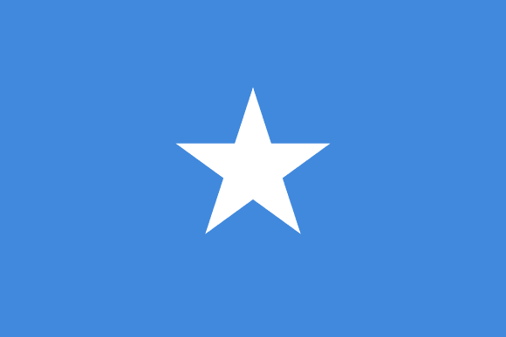



Country: Somalia

Committee: SOCHUM

Agenda Items: Tackling Refugee Trafficking,

Protecting refugees' rights and freedoms in wars.

**Somalia**, easternmost [country](https://www.britannica.com/topic/nation-state) of [Africa](https://www.britannica.com/place/Africa), on the [Horn of Africa](https://www.britannica.com/place/Horn-of-Africa). It extends from just south of the [Equator](https://www.britannica.com/place/Equator) northward to the [Gulf of Aden](https://www.britannica.com/place/Gulf-of-Aden) and occupies an important geopolitical position between sub-Saharan Africa and the countries of [Arabia](https://www.britannica.com/place/Arabia-peninsula-Asia) and southwestern [Asia](https://www.britannica.com/place/Asia). The capital, [Mogadishu](https://www.britannica.com/place/Mogadishu), is located just north of the Equator on the [Indian Ocean](https://www.britannica.com/place/Indian-Ocean). Somalia has an estimated population of around 15 million, of which over 2 million live in the [capital](https://en.wikipedia.org/wiki/Capital_city" \o "Capital city) and largest city [Mogadishu](https://en.wikipedia.org/wiki/Mogadishu" \o "Mogadishu), and has been described as Africa's most culturally homogeneous country. The Republic of Somalia was formed in 1960 by the federation of a former Italian colony and a British [protectorate](https://www.britannica.com/topic/protectorate-international-relations). [Mohamed Siad Barre](https://www.britannica.com/biography/Mohamed-Siad-Barre) (Maxamed Siyaad Barre) held dictatorial rule over the country from October 1969 until January 1991, when he was overthrown in a bloody civil war waged by clan-based guerrillas.

Crisis of refugees can refer to large groups of displaced people, who could be either internally displaced persons, refugees or other migrants, the incidents in their country of origin, or to problems while on the move, or it can refer to problems in the hosting countries after arrival involving large groups of displaced peoples, asylum seekers or refugees. As of 2018, 70.8 million individuals have been forcibly displaced worldwide because of persecution, conflict, violence, or human rights violations, per the [UN High Commissioner for Refugees](https://en.wikipedia.org/wiki/UN_High_Commissioner_for_Refugees) (UNHCR). Of these, 5.5 million were Palestinian refugees, which are not under UNHCR but under [UNRWA](https://en.wikipedia.org/wiki/UNRWA" \o "UNRWA)’s mandate. Causes for the crisis of the refugees can include war and civil war, human rights violations, environment and climate issues, and economic hardship

Following the outbreak of civil war in Somalia, many of the country's residents left in search of asylum. According to the UNHCR, there were around 976,500 registered refugees from the nation in adjacent states as of 2016. The majority of these individuals were registered in [Kenya](https://en.wikipedia.org/wiki/Kenya) (413,170: 326,611 in [Dadaab](https://en.wikipedia.org/wiki/Dadaab" \o "Dadaab), 54,550 in [Kakuma](https://en.wikipedia.org/wiki/Kakuma), 32,009 in [Nairobi](https://en.wikipedia.org/wiki/Nairobi)),[Yemen](https://en.wikipedia.org/wiki/Yemen) (253,876 in UNHCR centers and urban areas) and [Ethiopia](https://en.wikipedia.org/wiki/Ethiopia" \o "Ethiopia) (213,775 in five camps in [Dollo Ado](https://en.wikipedia.org/wiki/Dolo_Odo" \o "Dolo Odo)).] Additionally, 1.1 million people were internally displaced persons (IDPs). Most of the IDPs were [Bantus](https://en.wikipedia.org/wiki/Bantus_(Somalia)" \o "Bantus (Somalia)) and other ethnic minorities originating from the southern regions, including those displaced in the North, An estimated 60% of the IDPs were children. Causes of the displacement included armed violence, diverted aid flows and natural disasters, which hindered the IDPs' access to safe shelter and resources. IDP settlements were concentrated in south-central Somalia (893,000), followed by the northern [Puntland](https://en.wikipedia.org/wiki/Puntland" \o "Puntland) (129,000) and [Somaliland](https://en.wikipedia.org/wiki/Somaliland" \o "Somaliland) (84,000) regions.  Additionally, there were around 9,356 registered refugees and 11,157 registered asylum seekers in Somalia. Most of these foreign nationals emigrated from Yemen to northern Somalia after the [Houthi insurgency](https://en.wikipedia.org/wiki/Houthi_insurgency_in_Yemen) in 2015.

The flow of migrants can be reduced by removing the causes of migration like wars, for example. The [United Nations](https://en.wikipedia.org/wiki/United_Nations) urge to make more efforts for achieving this type of solutions.

The [European Union](https://en.wikipedia.org/wiki/European_Union" \o "European Union) has many tools for addressing the root causes of the crisis: "such as the trust funds for Africa and for the Syrian refugee crisis, the Facility for Refugees in Turkey and the EU's External Investment Plan". However, as the [Transnational Institute](https://en.wikipedia.org/wiki/Transnational_Institute" \o "Transnational Institute) criticised in a 2021 report, "Europe is creating refugees through its arms trade. If the EU and its member states genuinely want to address what they perceive as a “migration crisis”, they must curb arms exports, improve accountability mechanisms, and end the unbridled lobbying efforts of arms companies in the corridors of power in Brussels and other European capitals."

[Germany](https://en.wikipedia.org/wiki/Germany) is trying to prevent the root causes of the migrant crisis in Africa. It created a "Marshall Plan with Africa" (Eckpunkte für einen Marshallplan mit Afrika). The main objectives of the plan are: "increasing trade and development on the continent and hopefully reducing mass migration flows north across the Mediterranean". It will concentrate on " fair trade, increased private investment, bottom-up economic development, entrepreneurship, and job creation and employment". The [European Union](https://en.wikipedia.org/wiki/European_Union" \o "European Union) offered an aid package to [Mali](https://en.wikipedia.org/wiki/Mali) in return for taking back her refugees. Among other ways, it is trying to reduce the migrant flow from Ghana by helping the population to find employment in this country.

.