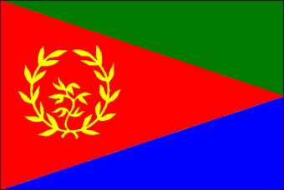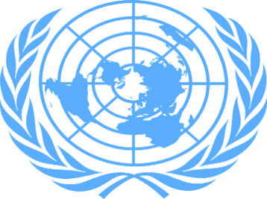

Tacking Refugee Trafficking
Country: Eritrea
Committee: Social Cultural and Humaniratian Committee (SOCHUM)
Delegate: Hale ŞENOL

Eritrea is located in northeastern Africa along of the coast of the Red Sea, bordered by Sudan, Ethiopia, and Djibouti.There is a conflict between Eritrea and Ethiophia and this conflict has been going on for over a century. As a result of this conflict, Eritrea has huge secrutiy issues which is caused refugee traffick. For us, this problem has been one of the most important difficulty. It affects many Eritrean.

Trafficking of Eritreans in Sudan and Egypt has been reported since the 1990’s and reached unprecedented levels between 2009 and 2013. In 2016, Eritrea was the country that gave 5 thousand people as refugee per month and we were one of the countries with the fastest immigration. As reported over the past five years, human traffickers exploit domestic victims and exploit foreign victims in Eritrea, and traffickers exploit victims Eritrean abroad. The thousands of Eritreans who have fled the country, illegal immigrants who already want to be reunited with family members overseas; those who seek to evade human rights abuses, including arbitrary arrest and detention, lack of legal action, and religious persecution; Eritreans were looking for better economic opportunities and hoped to avoid the often indefinite lengths of service in the government's mandatory National Service.

Eritrea is part to the Khartoum Process, initiated in 2014, which seeks to actively prevent and tackle human trafficking between the Horn of Africa and Europe. The AU-Horn of Africa Migration Route Initiative (Khartoum Process) seeks to develop a cooperative network between countries of destination, transit, and origin, and to establish effective mechanisms for information sharing, capacity building, law enforcement, the prosecution of criminal networks, and the support and protection of the rights of migrants. Eritrea is not a party to the Refugee Conventions, nor the Kampala Convention, and it has no domestic legislation for the protection of asylum seekers and refugees.

