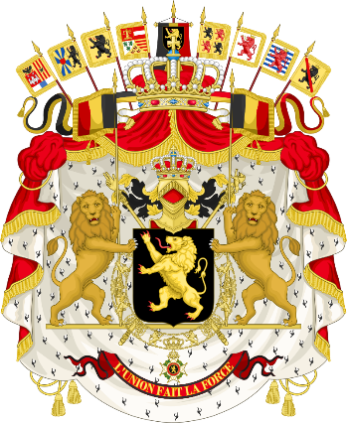

Country: Belgium
Committee: NATO
Agenda Item: NATO’s political and military role in the Balkan Region

NATO's involvement in the Balkans has evolved over the past decade. The Alliance initially intervened in the region to end the Bosnian War and the Kosovo War.
In Bosnian War, NATO-led peacekeeping force Implementation Force (IFOR) was deployed in Bosnia and Herzegovina from 1995 to 1996. IFOR was responsible for implementing the military aspects of the Dayton Peace Accords, which ended the Bosnian War. The operation was a success and helped to bring peace to Bosnia and Herzegovina.
Similar happened in Kosovo War. It was an armed conflict in Kosovo that lasted from February 1998 until June 1999. It was fought between the forces of the Federal Republic of Yugoslavia (i.e. Serbia and Montenegro), which controlled Kosovo before the war, and the Kosovo Albanian rebel group known as the Kosovo Liberation Army (KLA). The conflict ended when the North Atlantic Treaty Organization (NATO) intervened by beginning air strikes in March 1999 which resulted in Yugoslav forces withdrawing from Kosovo. After these wars, NATO also carried out operations for the independence of North Macedonia (2001-2003). NATO has since become more involved in defense reforms and promoting regional cooperation. Even though NATO's relationship with the Western Balkans is controversial, the Alliance remains committed to promoting peace and security in the region.
Belgium was involved in the Yugoslav Wars in a number of ways. Belgium was one of the first countries to provide humanitarian aid to refugees fleeing the Yugoslav Wars. In 1992, the Belgian government sent a team of doctors and nurses to Croatia to provide medical assistance to refugees. Belgium also provided food, clothing, and shelter to refugees. In 1992, Belgium also contributed to the UN peacekeeping mission in Croatia. The mission, known as UNPROFOR, was tasked with monitoring the ceasefire between Croatian forces and Serbian forces. Belgium provided troops, police, and medical personnel to UNPROFOR and in 1995, Belgium arrested and extradited two Bosnian Serb war criminals. The two men, Radislav Krstić and Goran Jelisić, were accused of committing crimes against humanity and genocide. Krstić was sentenced to 40 years in prison by the International Criminal Tribunal for the former Yugoslavia (ICTY). Jelisić was sentenced to life in prison.

As Belgium, we believe that Yugoslavian Serbians’ violent invasions were unacceptable and NATO’s airstrike was necessary. The airstrikes were launched in response to the Serbian government's campaign of ethnic cleansing against Kosovar Albanians. NATO, which has many allies in Europe, must not remain silent to this attack. To ensure peace in Europe, we must support the newly established states that left Yugoslavia. Only after peace ensured, NATO can continue its expansion in Europe.

