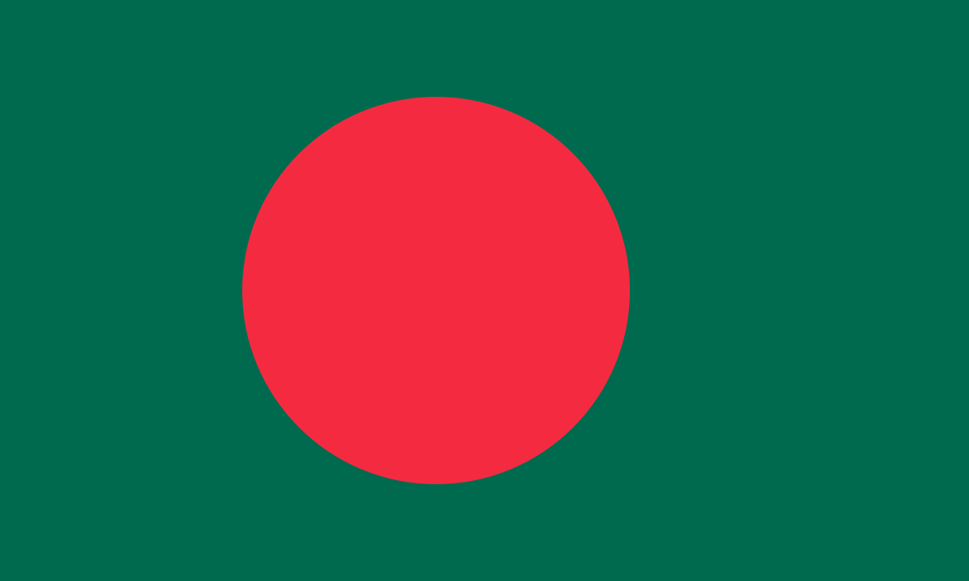
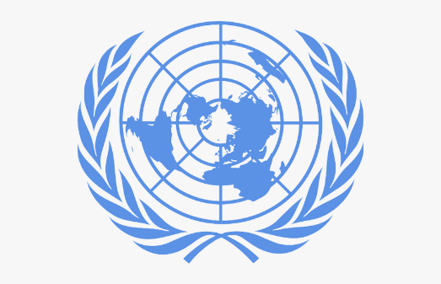

Elemination of Child Labor

Country: Bangladesh
Committee: UNICEF
Delegate: Yağmur EROCAĞI

POSITION PAPER
Bangladesh is a country in South Asia. Due to too much rain on the country, Bangladesh has got a temperate climate. This place used to have got forests. Since they could not use the forests for planting, they destroyed these places. For that reason now Bangladesh has got 2 forests and their names are Madhupur and Sundarbans. As for Bangladesh’s social life and population, Dakka is the capital city of Bangladesh. Bangladesh’s population was 164.7 million in 2020. Bangladesh is one of the most crowded cities in the world. 60 - 70 percent of Bangladesh people are Muslims. Bangladesh’s offical language is Bengal Language. 79 percent of Bangladesh people are educated. Bangladesh’s economy depends on textile, agriculture and leatherwork.

According to a recent report, there has been a 94 million reduction in the number of children subjected to child labor since 2000, but that gain is now at risk. In this subject UNICEF ( United Nations International Children’s Emergency Fund ) has been opened ( December 11, 1946, New York ) a lot of country in worldwide. Children living in Bangladesh are also subject to children labor. Of the 1.7 million children working in child labor, every quarter is between the ages of 6 and 11. Fort hat reason UNICEF Bangladesh founded in 1952. UNICEF Bangladesh launched the lifecycle approach. This approach was in 2016 and continued into 2020. This approach determine specific priorities and planning positive outcomes for every age group. All of the UNICEF’s arms are unite for reach same priorities in this approach. It has proven to be quite effective in adressing the problems faced by children.

In our opinion, the introduction of a law in Bangladesh that employing children under a certain age limit will result in large fines could reduce child labor. Or witnesses of child abuse labor are opposed and stand up fort he rights of the child, we can give an instruction that he state will stand behind it and provide all kind of support. The United Nations can provide more financial aid to the countries that are not good in terms of social opportunities for such situations.

Thank you.

