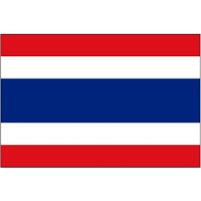
Committee: The Social, Cultural and Humanitarian Committe (SOCHUM)
Delegation of The Kingdom of Thailand
Topic: Rights and Freedoms of Refugees
Delegate: Eylül Özbay

Our country, Thailand, is historically known as Siam, but now it is called The Kingdom of Thailand, in Southeast Asia. The population is about 67 million. The capital and the most crowded city of the country is Bangkok. The official language of the country is Thai.
Thailand has the second biggest economy in Southeast Asia. The industrial and service sectors are the main sectors for Thailand’s economy.
Thailand’s form government is Constitutional monarchy. The king of the country is Maha Vajiralongkorn who has been on the throne since 2016, and Prayuth Chan-o-cha has been the prime minister of Thailand since 2014.
Thailand cares human rights and refugee rights. For example, Prime Minister Prayut Chan-o-cha has promised to protect every refugees whom have to left their country because of the problems between Myanmar which is Thailand’s neighbour country and Karen National Union.
According to information reported in May 2022, Thailand is protecting 91.275 refugees from Myanmar. They are staying in refugees relief camp. Some assistances in refugee camps are about education, protection, psycho-social health, shelter, food and nutrition. First refugee camp in Thailand was Sa Kaeo Refugee Camp. It was opened in October 1979 and closed in July 1980. The population in this camp was over 30,000.
Before we finish our words, we also would like to say that for a peaceful world, we must work together against wars, discrimination and the other stuations which are people will have to left their country.

