Country: New Zealand
Committee: UNEP (United Nations Enviroment Program)
Agenda Item: Enhancing the Transition to Sustainable Energy as a Response to the Energy Crisis and Climate Change

As the Representatives of the New Zealand and one of the founding members of UNEP, we are immensely involved in throughly discussing the topic of energy and climate change. New Zealand is aware of and recognizes the silent problem of climate change, its causes and effects on an individual and on a global scale as well as expanding the usage of possible renewable sources instead of traditional energy sources such as coal, oil and gas and has set ambitious policies as we recently released an emissions reduction plan for setting out measurements and strategies and already published the first three emission budgets in 16 May 2022. We are and will go on to work tirelessly to keep up our work with the United Nations Enviroment Programme (UNEP), the United Nations Division for Sustainable Development (DSD), the Global Enviroment Facility (GEF), the Organisation for Economic Cooperation and Development (OECD), the Intergovernmental Science-Policy Platform on Biodiversity and Ecosystem Services (IPBES).

New Zealand’s share of global GHG emissions is small but our gross emissions per capita are high.“New Zealand’s diverse economy has a sizable service sector, accounting for 63% of all GDP activity as of 2013. Large scale manufacturing industries include aliminium production, food processing, metal fabrication, wood and paper products”. Therefore adding up to the usage of coal and gas like energies as a result of the materials used in these conversion and processes. On the other hand agriculture and energy sectors as road transport and construction are the largest contributors to New Zealand’s gross greenhouse gas emissions with the latest figures shown in below.

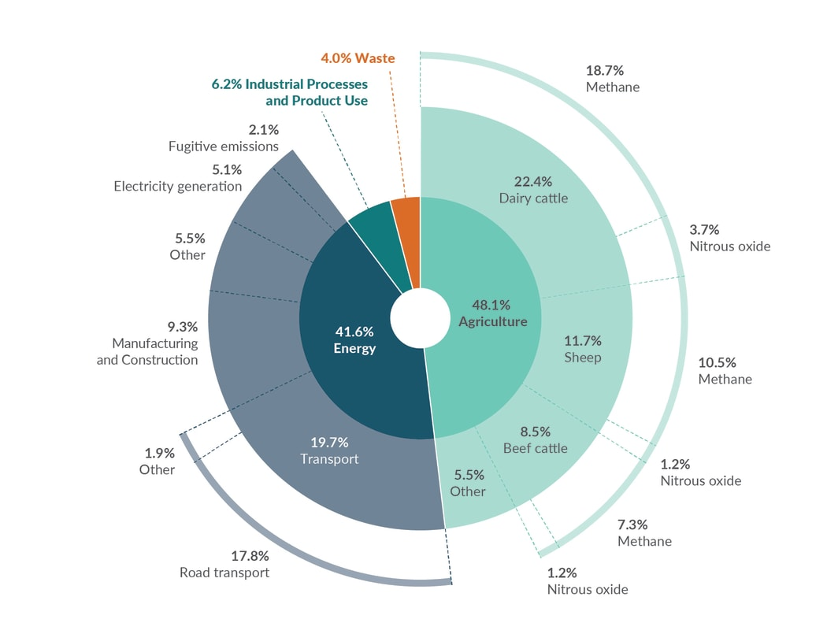
Of the total emissions, 46% is carbon dioxide, mainly coming from enegy sector, 42% is the main source of agriculture emissions, methane from livestock digestive systems and 10% is nitrous oxide mostly from agriculture. On the other hand our emissions are globally small but high per capital. Based on the latest available Inventory data for 2018 for Annex 1 countries (eg, the United Kingdom and Germany), New Zealand’s gross emissions ranked 24th among the Annex I countries, but New Zealand’s emissions per person were the sixth highest at 16.9 tonnes carbon dioxide equivalent per capita. (The comparison is made with Annex I countries because these countries all use the same methodologies to report their emissions.)
Recent outbreaks like COVİD-19 which affected the energy sector severely by repeated lockdowns and slowed transport, trade, economic activity because of the restricitons on mobility highlighted in energy in NZ. Energy sector was not immune to the effects however due to the goverment’s successfull elimination strategy, after containing the virus, the New Zealand economy had a sharp growth in what is known as a V-shaped recovery and ended the year with an overall economic expansion of 0.4%, better than the predicted 1.7% contraction.
With the Russian Invasion of Ukraine not long after, already high prices of the pandemic boosted again and reflected mostly on oil, gas and food prices leaving question marks for sustainable deliveries of energy. A potential embargo on Russia would put households in Europe in a squeeze thus probably leading to gas rationing. New Zealand imports from Russia, which are mostly crude oil, have dropped to close to zero in recent months. The most significant impacts on New Zealand of the invasion will be indirect, primarily through higher fuel and commodity prices, financial market volatility, and the potential drag on global economic activity.

To reduce the destructive effects to minimum in NZ we should and we are in the search of solutions for the short and the long-run depending on green sources to decrease the dependence of our economy. By seeing the fact that the fossiul fues usage and demand-supply chain has been challenged easily by the changes in economical and social areas, improvements regarding the renewable sources should and will be introduced immediately.
As one of the few countriest that have passed its Zero Carbon amendment to the Climate Change Response Act in 2019, which sets a target for all greenhouse gases except for biogenic methane – methane from agriculture and waste – to reach net zero by 2050 we can carefully and in a systematic way benefit the geological position our country is in.
Hydropower could be used as the dominant force in New Zealand’s electricity generation industry along with geothermal, wind and bioenergy would not only help us reach our goals but also provides the stability and predictability of the demand and supply of energy sources that would result in an affordable, secure, and sustainable energy system that provides for New Zealanders’ wellbeing in a low emissions world.
As of agricultural means, we cannot simply give up on our biggest industry, largest export earner accounting for 21% of exports. Doing so would bring nothing but economic crisis, bankruptcy, severe financial loss and collapse upon country but we can recover as much as we can by teaching, supporting and raising awareness amongst our society and especially farmers on the subjects of management of manure and livestock, conservation of soil and energy, sequestration of carbon and switching of fuel.

We are looking forward to cooperating with similarly responsible nations from around world to work towards a safe, sustainable, healthy, low carbon emission world.

References:
file:///C:/Users/Microsoft/Downloads/GCMUN'22%20UNEP%20STUDY%20GUIDE(1)%20(1).pdf
https://environment.govt.nz/publications/new-zealands-greenhouse-gas-inventory-1990-2019-snapshot/how-new-zealand-compares-to-other-countries/
https://www.stats.govt.nz/indicators/new-zealands-greenhouse-gas-emissions-published-april-2019
https://climateactiontracker.org/countries/new-zealand/
https://en.wikipedia.org/wiki/Climate_change_in_New_Zealand
https://www.rnz.co.nz/news/national/440352/nz-greenhouse-gas-emissions-agriculture-energy-sectors-biggest-contributors-in-2019
https://www.mbie.govt.nz/building-and-energy/energy-and-natural-resources/energy-strategies-for-new-zealand/
https://www2.gov.bc.ca/gov/content/industry/agriculture-seafood/agricultural-land-and-environment/climate-action/reducing-agricultural-ghgs

