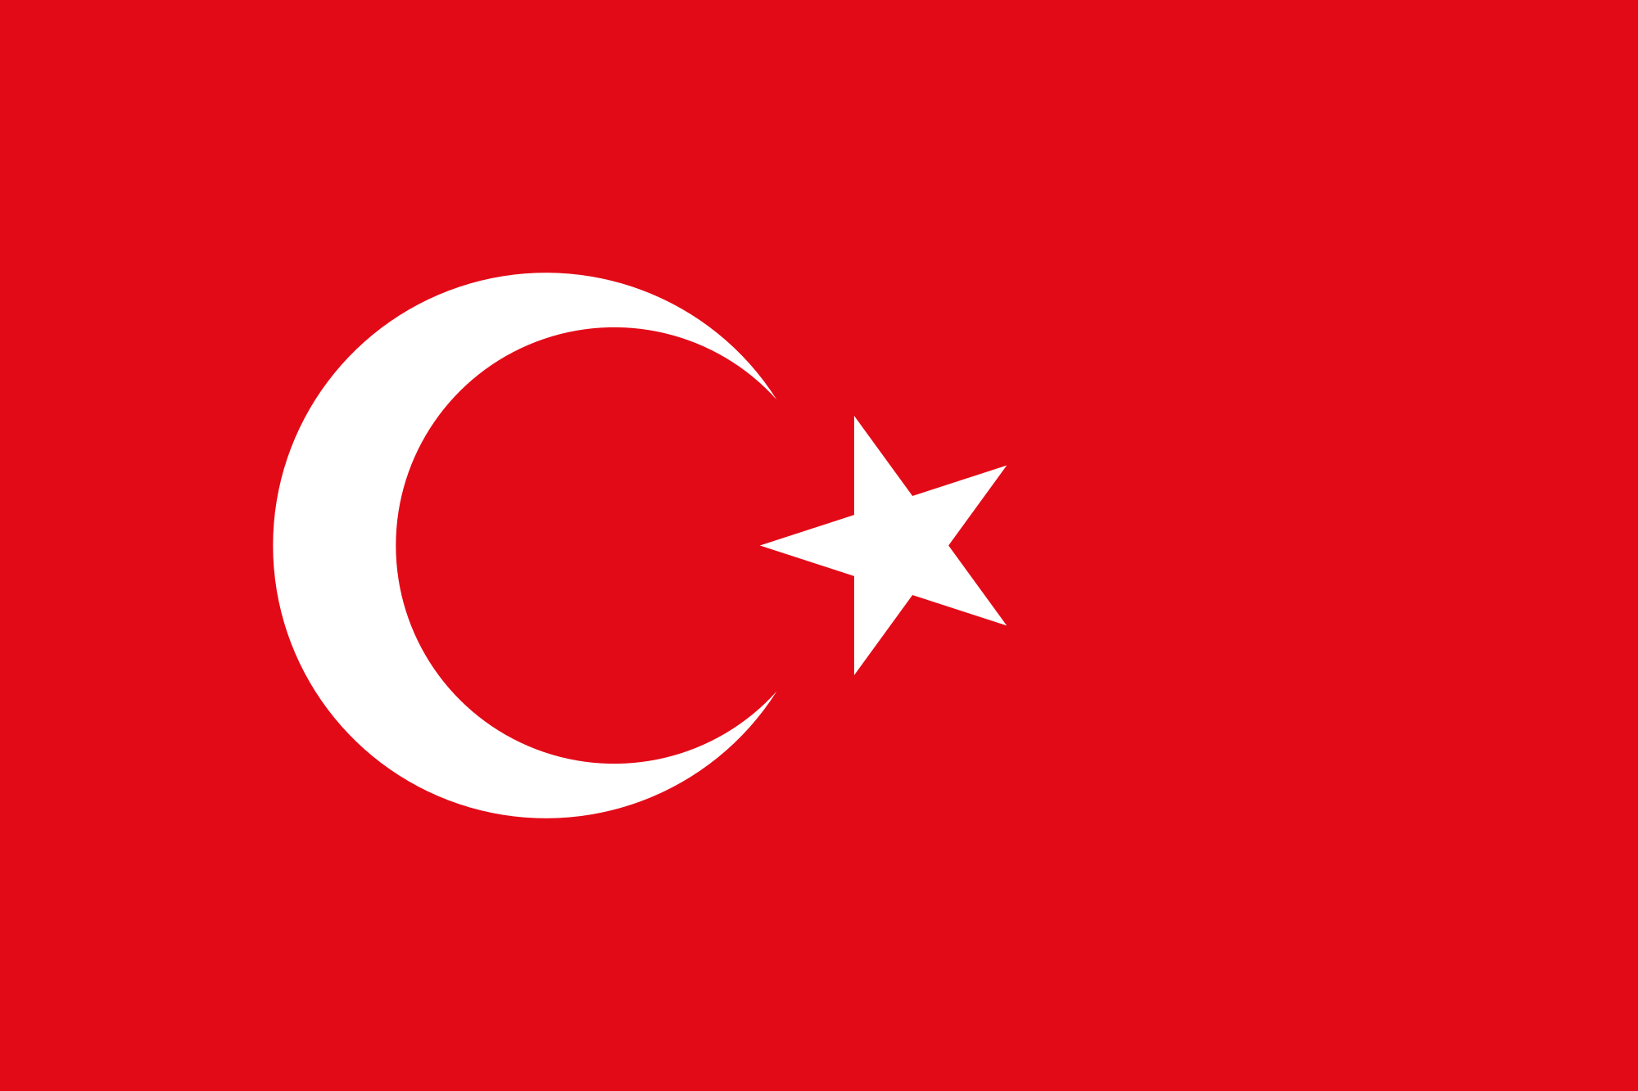

Country: Turkiye
Commitee: UNESCO
Agenda Item: Climate Change Education, Training and Public Awarness
Delegate: Ozan Özgen

In 2023, Turkiye is the 21. Most biggest country with 85 million 279 thousand 553 people. Istanbul has 16.067.031 people. It’s nearly %17 of Turkiye’s population. The main language is Turkey. Turkey is connecting Asia and Europe together. That’s why the place is very important. It also has efficent lands. The red color in Turkiye’s flag represents their lost soldiers blood. The moon and the star represents the reflexion of the moon and the stars on the soldiers blood. Turkiye has joined NATO but the Europen countrys are not accepting Turkiye to EU beacuse they are nearly %2 of Turkiye is only in Europe. Turkiyes landmass is 783.562 square kilometers. Turkiye had some really good scientists. For example Aziz Sancar, they have warned and educated the whole country about climate change, global warming exc.
The Republic of Turkey has taken some steps to increase education, training and public awarness on climate change. In 2012, Turkish Ministry Environment and Urbanization specified a Climate Change Coordination Board. Turkiye has started some projects and initiatives aimed at increasing awarness on climate change. For instance, the Ministry Environment and Urbanization had organized workshops and training programs to educate governments, NGOs (STK) and private sector organizations. Turkish goverment has also made some companys to raise public awarness on climate change. In 2014, the Ministry Environment and Urbanization made a company called “Climate Sensitive Cities” to encourage citizens to take actions to reduce carbon footprint and support sustainable living. The company contained lots of events and workshops across the country. Moreover Turkiye developed a national climate change strategy and action plan. The strategy aims to increase awarness on climate change and the impacts of it to the public, private sector, and other participants who targeted communucation and education companys.
As the Republic of Turkey, we are being conscious climate changes effects. It won’t only effect our country, it will effect the whole World. We recommend not only EU or not only NATO, all the countrys to unite and act like a one country. We are not enemys of each other. If we don’t want to lose our World than every single country should do their best by giving education to their citizens about raising public awarness on climate change.

