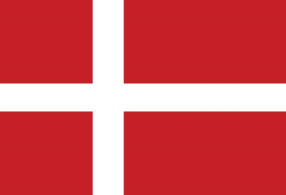
Country:Kingdom of Denmark
Committee:UNHCR
Agenda Item: Promotion and protection of human rights in the situation of human trafficking
Delegate:Metehan SARI

Kingdom of Denmark is a Scandinavian country that located in Europe. It is a country bordering the Baltic and North Seas. Most of Denmark is on the Jylland Peninsula. It’s total area covers 2,210,579 square kilometers. Danish is the official language of the country and the currency of the country is Danish krone. The country has the highest number of business lines in the service sector and agriculture.It’s not possible to receive refugees unregistered in Denmark and the total number of asylum seekers in country is 556.825.
If you are afraid to return your home country or the country where yo lived previously because of grounded fear of violence persecution,war or if you’re in danger of suffering serious harm in that country,you can apply for protection in Denmark.The first step to receiving international protection is to apply for asylum.We granted more than 10.000 asylum seekers in 2015 and only 600 people were granted asylum in 2020.The new law allows for deportation of asylum seekers from from the EU without any processing.These people will wait fort he application process to be completed in asylum centers located outside the EU.In addition,according to the public opinion,it was determined that asylum seekers do not create human trafficking in the country.
Denmark will abide by the decision of the committee.When global problem occurs,Denmark will take measures regarding this issue.This issue is open to discussion and Denmark awaits a definitive solution.In our opinion,a valid document should be obtained from the ministry of foreign affairs,and under no circumstances should anyone enter without a passport.

