Country: People's Republic of China

Committee: UNHCR

Agenda Item: Promotion and protection of human rights in the situation of human trafficking

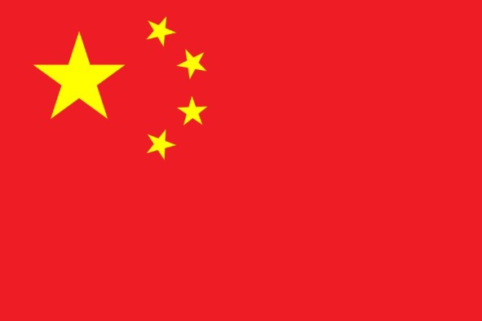

China, officially the People's Republic of China (PRC) is a country found in 1949 and located in Eastern Asia. People's Republic of China is the third largest country after Russian Federation and Canada, with 9.6 million square kilometers of total landmass. With the population of 1.412 billion, China is the first country with the biggest population. People's Republic of China's capital is Bejing with a landmass of 16.411 square kilometers, and it's economically most active city is Shanghai. The country's currency is Chinese Yuan, Renminbi. China borders in land with fourteen country: Vietnam, Laos , Bhutan , Afghanistan, India, Kazakhstan, North Korea, Mongolia, Nepal, Pakistan, Kyrgyzstan, Tajikistan, Myanmar and Russia. In the maritimes, Brunei, Indonesia, Japan, South Korea, Malaysia, the Philipines and Taiwan borders to People's Republic of China. The country's main language is Standard Mandarin. China's administrative system of governement is a one-party republic. People's Republic of China has the second biggest economy in the world, according to GDP, and has the world's biggest ecnomy as the purchasing power among citizens. The country's biggest livelihood industries are electronic trade, technological devices etc.China is one of the fastest growing countries with the percentage of %6.

The subject of human trafficking is modern type of slavery, a situation that violates human's legal and moral rights among many countries. In human-trafficking, the victims get retained for many purposes; forced labor, abuse, commercial sex slavery, and to make trade. Since it's a global and fast spreading situation in society, effective and sustainable initiatives should be taken. First federal law that was made in order to prevent and adress human trafficking was by TVPA( Trafficking Victims Protection Act). People's Republic of China approved UN's "Prevention of Human Trafficking" law in 2009 in order to inlegalize the crime. Furthermore, China Cabinet regulated the law in China's constitution about Human Trafficking, and made it more detalized about the abuse in human trafficking that's made my marriage and how to spot them in 2021. People's Republic of China is ready to take more action in order to prevent human trafficking and protect human rights of the victims.

As the delegate of the People's Republic of China, we would like to state thet we are considerably aware of the fact that Human Trafficking is a major and global threat for humanity , human rights and the world. Since it's also a social obstacle, we have to be a full union in order to prevent this from every single people and protect the human rights at every cost.