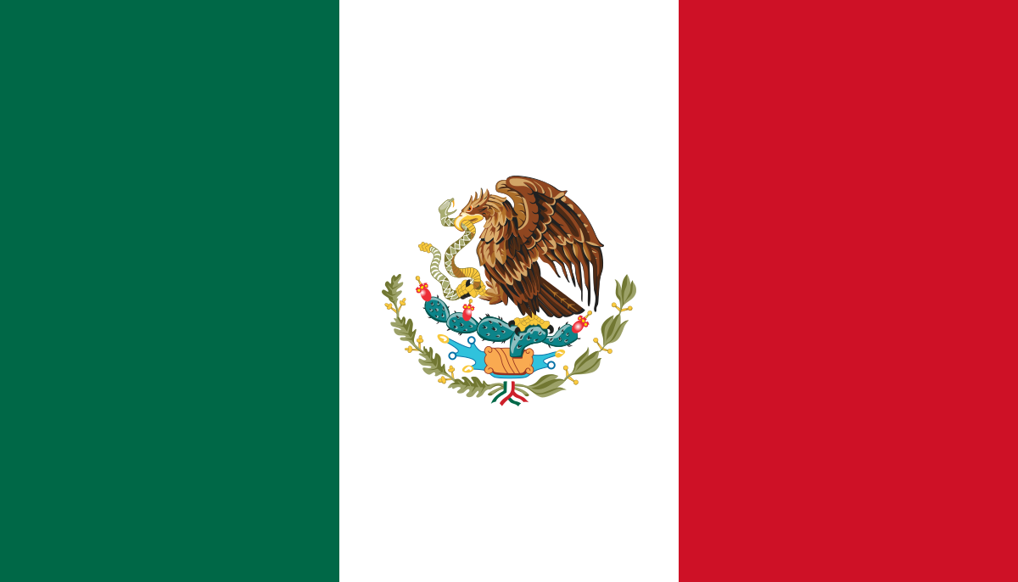
United Mexican States.
United Nations High Commissioner for Refugees
Refugee Crisis: Forcibly displaced and stateless people

Mexico, officially the United Mexican States, is a country in the southern portion of North America. It is bordered to the north by the United States; to the south and west by the within Pacific Ocean with a population of over 126 million people. Mexico is one of the 51 founding members of the United Nations and was admitted into the organization in 1945. Since then, Mexico is a full member of all the UN agencies and participates actively the organization and has diplomatic relations with most member states.In June 2020, Mexico was elected for its fifth two year Non-Permanent seat at the United Nations Security Council.

Refugees from the North of Central America access the Mexican territory, the southern border and apply for asylum in towns in the south of Mexico. Others access the territory by air. Many refugees live in Mexico City and other cities. Mexico has a strong national legal and institutional framework to protect asylum seekers and refugees. Mexico's law concerning refugees and asylum incorporates the broader definition of "refugee" found in the 1984 Cartagena Declaration, including gender as one of the causes of persecution in the definition of ‘refugee’. If an individual does not qualify for refugee status under this extended definition, Mexico's Commission for Refugee Assistance may grant complementary protection, preventing cases of possible returns of individuals to a country where their life would be in danger. Mexico is one of seven countries participating in the Comprehensive Regional Protection and Solutions Framework since the initiative was adopted in October 2017 as a regional contribution to the Global Compact on Refugees.

Human trafficking is a serious problem in Mexico and a violation of human rights that involves the exploitation of individuals, often for sexual or labor purposes. Mexico has taken steps to address human trafficking and promote and protect the human rights of victims.
Mexico has established various laws and policies to combat human trafficking. The country has implemented the General Law on Human Trafficking, which provides a legal framework to investigate, prosecute, and punish human trafficking crimes. The law also establishes victim protection measures, including access to medical and psychological assistance, shelter, and legal representation. Mexico has also established various programs and initiatives to support victims of trafficking, including the National Program to prevent, penalize, and eradicate human trafficking, which focuses on prevention, protection, and assistance to victims. The program aims to raise awareness about the risks of human trafficking and to provide training to law enforcement, prosecutors, and social service providers to identify and assist victims. Mexico has also established specialized services for trafficking victims, including shelters, medical care, and legal assistance. These services aim to address the specific needs of trafficking victims and provide them with the necessary support and resources to rebuild their lives.

