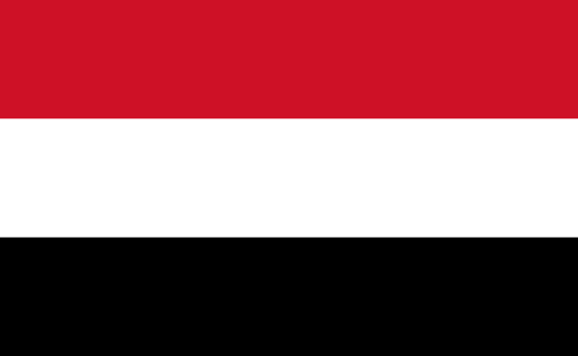

As The Republic Of Yemen, we are aware of the fact that this is a huge thread for our, humans future and ready to take an action. We hope to find solutions for medical incapatiy, wrong procedure, and many other complications against this problem. We are suggesting to make an union and work as it, supporting since it's a general problem. We are expecting to find the best, suitable and valid solutions and apply them as fast as possible to prevent any more damages.

The virus that had appeared in very-beginning of 2020 from China-Wuhan (Covid-19) affected many countries, all continents and all living things as it affected Yemen. The effects of the virus can't be ingored on all of the livings, especially humans. In The Republic Of Yemen, there had been 11822 of Covid-19 cases and 2149 of death caused by the virus since the first case was detected in Yemen, Hadramut of 10th of April. Only %77 of them could be cured, %18 of them -eventually- died,which's a high percentage. Besides Yemen, also around the world, the statics are shown. There are 531 millions of cases at all and also 6,3 millions of deaths caused by Covid-19.Even though the physical effects are major on adults than children; tthe psychological, the communal and the concidental damages was left on the children, which are pretty crucial for their futures and also the direction of the world.Considering environmental factors and transaction as a crucial matter, they are also decisive for the person's future, personality. The important part is, the damages that these factors may get can be permanent. So,all the aspects that causes damages on children is also damages that the world gets.

Yemen, officially The Republic of Yemen, is a country placed in Western Asia, at the lower parts of The Kingdom of Saudi Arabia. It borders to Saudi Arabia and Oman ; Somalia, Eritrea, Djibouti from the seaside.The Republic of Yemen is the second largest [Arab](https://en.wikipedia.org/wiki/Arabs) [sovereign state](https://en.wikipedia.org/wiki/Sovereign_state" \o ") in the peninsula by covering 555,00 square kilometres( 214 square miles), 2,000 kilometres of coastline. The administrative systems of governement are: republic, presidental governement, unitary state and constitutional republic. The official language of Yemen is Arabic, also languages such as Russian and Balochi are spoken in some parts of the country by the citizens. Yemen's capital city, also the largest city of the country is the city Sanaa by covering 5.552 kilometres. The population that had been counted in 2021 was estimated at 30,491,000, making Yemen the 48th most crowded country in the world. Most of the population consist from Arabic People, and the other part is from Southwest Asia- Africa , Europeans who came for business.Yemen is a least-developed country according datas. Yemen is a member of the United Nations, the Arab League, the Non-Aligned Movement and the Organisation of Islamic Cooperation.

Country: The Republic of Yemen

Committee: JR UNICEF

Agenda Item: Impacts of Covid-19 On Children