Country: Venezuela
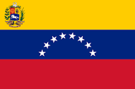jjjjjjjjjjjjjjjjjj
Committee: The United Nations Environment Programme (UNEP)
Agenda Item: enhancing the transition to sustainable energy

Venezuela is located at the northern end of South America. It is counted among the top ten most biodiverse nations on Earth. The Venezuelan landscape includes mountains, tropical jungles, broad river plains, and arid coastal plains, all of which provide a diversity of natural habitats and a range of challenges to social integration and economic development. Although it has many endemic species and landscapes, its climate and environment are endangered due to the excessive use of fossil fuels. As a result of its usage, the rise in sea levels causes a decrease in biodiversity, and most importantly, carbon dioxide emissions and air pollution.

Venezuela is a major producer of oil products. Venezuela's economy improved during Chávez’s presidency, trending positive until the worldwide oil price collapse in 2013. From 1999 through 2013, inflation dropped to its lowest levels in the country since the late 1980s. Following Chávez's death and the election of his successor Maduro in 2013, shortage rates continued to increase and reached the top.

In 2020, fossil fuels were the main source of primary energy consumption in Venezuela. Combined natural gas and oil made up about 80 percent of the total consumption in the country. At the same time, hydropower was used as one of Venezuela's primary energy consumption.

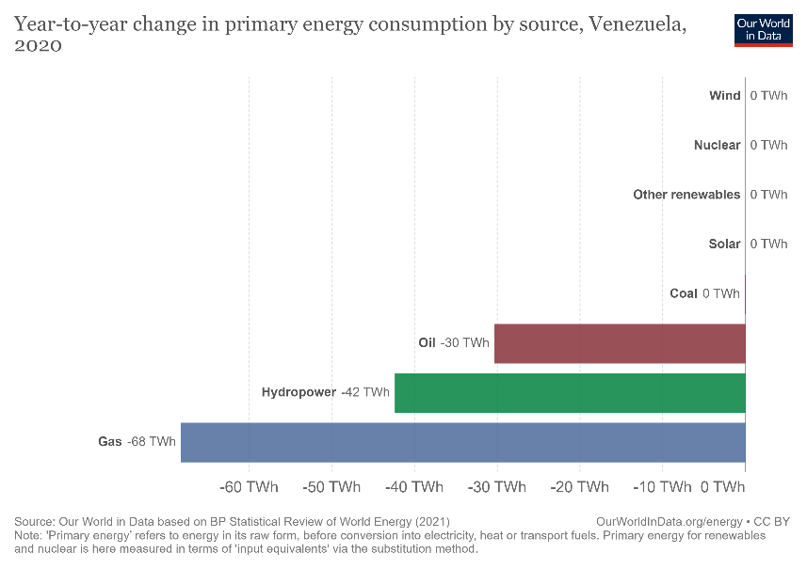

As a result of Venezuela's economic crisis and falling welfare, the government has focused on pleasing the public rather than switching from fossil fuels to renewable energy sources. Although there is an infrastructure that will enable Venezuela to be effective in such projects about renewable resources, Venezuela is more inclined to dismiss the importance of air pollution and CO2 emissions. Meanwhile, with the destruction of natural habitats and species, the polluted air in Venezuela has become more harmful and unbreathable for the people and the other living.

We should concentrate on the economic policies for the wealth of Venezuela, to make changes about enhancing the transition to renewable resources. The people should be informed in order to raise awareness of the public. Besides that, the government has to make announcements to make the public gain consciousness. Furthermore, the government should also have the advantage of the infrastructure of renewable energy resources by proceeding with the projects.

With the precautions we are going to take solutions to environmental problems, we can make Venezuela much more livable and comfortable for the world. Renewable energy sources are the priority for a better life.

References:
https://www.sciencedirect.com/science/article/abs/pii/S1364032119301078
https://www.statista.com/statistics/984159/primary-energy-consumption-venezuela-source/
https://ourworldindata.org/energy/country/venezuela
https://www.britannica.com/place/Venezuela/Drainage
https://en.wikipedia.org/wiki/Shortages_in_Venezuela
https://www.tandfonline.com/doi/abs/10.1080/17565529.2016.1146120
https://borgenproject.org/renewable-energy-in-venezuela/

