Country: Belgium
Committee: World Health Organization
Agenda Item: Legalization of Euthanasia

Belgium is a country in the west of Europe which has borders with Germany, Netherlands, Luxembourg and France. Belgium is being ruled with federal constitutional monarchy. Belgium’s capital is Brussels. Belgium is a member of multiple international organizations such as United Nations (since 1945), European Union (since 1958), North Atlantic Treaty Organization (since 1948).
World Health Organization was founded in 1948 to devote public health issues as an United Nations organization to devote public health problems. Since the day it was contributed, World Health Organization has established various achievments in the history of medicine. WHO strives for everyone to be healthy and defines health as "A state of whole physical, mental, and social well-being and not only the absence of disease or infirmity.
Since the concept of legalizing euthanasia was first proposed, it has been a constant issue of discussion which happened in Greece, 4th century BC. Euthanasia is the act of ending the life of a patient with patients own or people who are legally in charge of the patient. Euthanasia is not allowed in many countries and considered as murder.
When Euthanasia is not supported, there is always different options such as Assisted Suicide. Voluntarily dying can be euthanasia or assisted suicide. Difference between them is that euthanasia is done by doctors and assisted suicide is done by the patient themselves. There are several things that could be viewed as helping suicide; a prescription medication dose is not always necessary. It can be buying a ticket for the person to go to a country they can reach drugs to suicide or giving them drugs. Assisting suicide can be dangerous for patients if they are not receiving medical drugs from a doctor since taking imprecise amounts of drugs may end up with suffering and not give the results expected. Assisting suicide can be done by anyone. Euthanasia has to be done by a doctor or a medical licensed worker.
Death can be considered as a human right and must be protected. Everyone has right to choose death as much as life and forcing somebody who has diseases to live is just violating personal rights. In this sense, involuntary euthanasia is murder as it should be. Killing someone without any wish of death is definitely considered as murder and performing involuntary euthanasia is outlawed by every country as 2022.
Euthanasia elicits arguments of an ethical, religious and legal. Many religions agree with the idea of the life is a gift from god and to reject this precious gift is considered unholy. In today’s world, 21st century, many countries do not have laws that are based on religious sources. In Belgium, there are many different religions which can be seen in the latest poll that was made in 2018. There are 57.1% Roman Catholic, 2.3% Protestant 2.8% other Christian, 6.8% Muslim, 1.7% other, 9.1% atheist, 20.2% non-believer/agnostic In countries such as Belgium, there cannot be defined a religion to effect laws. Many may found it wrong religions affecting laws too.
Ethical arguments upon euthanasia and assisted suicide are continuously ongoing since Hippocrates has adopted ‘first, do no harm’. Which is the basic of Hippocratic Oath. Hippocratic Oath is an amendment of Hippocrates that occurred back in 300-400 BC. Hippocratic Oath is definitely lost the old necessary. Defining our morality of medicine with a amendment which was written 2500 years ago is definitely not suitable for the socially and technologically developed world of 2022. Ethics of euthanasia has been changing ever since people are now socially more independent. Do no harm is not even much possible today, people just prefer to die instead of suffering until the end of their lives which is definitely a human right.
Belgium Parliament legalized euthanasia on 28th May, 2002. In all cases of euthanasia since 2002, unbearable suffering was reported. The Belgian Senate agreed in December 2013 to include children with terminal illnesses in the country's euthanasia law. Children who request euthanasia must meet the following requirements: "the patient must be conscious of their decision and understand what euthanasia means," "the request must have been approved by the child's parents and medical team," "their illness must be terminal," and "they must be in excruciating pain with no effective treatment."
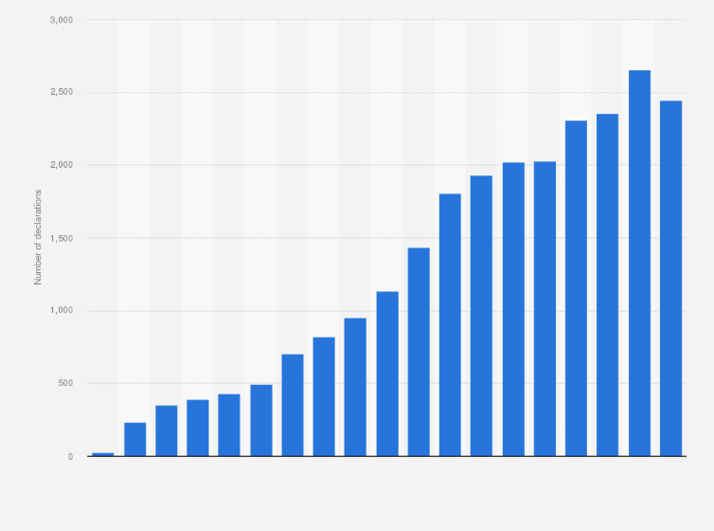
Number of registered euthanasia instances in Belgium from 2002 to 2020
Palliative care is another way of treatment for terminally ill patients. WHO statement upon palliative care is “palliative care is an approach that improves the quality of life of patients and their families facing the problems associated with life-threatening illness, through the prevention and relief of suffering by means of early identification and impeccable assessment and treatment of pain and other problems, physical, psychosocial and spiritual.” Belgium ranked 26th out of 81 countries, graded B.
Approximately 27.000 people have received euthanasia in Belgium. It is possible to say that belgium is way further than other countries about euthanasia. While many others are still considering to legalize it, Belgium show a great number of cases. Belgian laws protect everybody’s right to live and right to get a voice about their choices upon their living. In 2021 one of everey five euthanized people wer not expected to die subsequently altough they were in external pain and government of belgium respected their choices as any other government should be doing.
Euthanasia is definetely a topic effecting society. Death and life are the basics of humans. Many people around the world are having trouble to end their lives with their own dignity since many governments are against euthanasia. Unfortunately International Covenant on Civil and Political Rights do not include ‘right to die’ at the moment. A person dying with their own wish, patient and relatives being fully prepared for death is definetely more healthy for the mourning process. In spite of the fact death is the most affecting thing upon a human life and society, handling death and making a decision upon that is way more important.
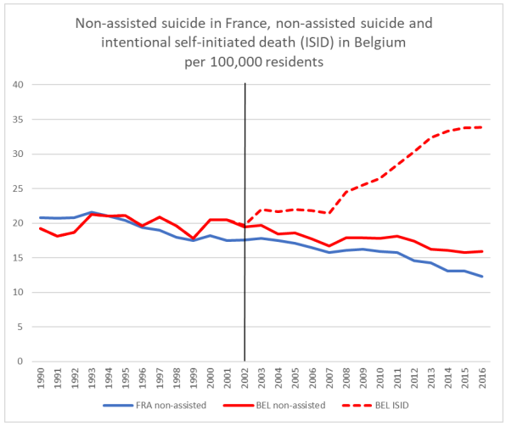
Graphic from Journal of Ethics and Mental Health compared to France where assisted suicide is illegal
As seen in the graphic above, people prefer assisted suicide since it became legal and choose death to suffering. That proves citizens need physician assisted suicide to be legal worldwide.
To legalize euthanasia it is an important step to reduce religious pressure on people. Governments should improve their palliative care systems and financially support patients. Social media is the most efficient communication platform in 2022 and manipulations on social media affects citizens. Governments should lower these impacts on society. Death is definetely heartbreaking for relatives and impacts of death on close ones should be recovered by mentally preparing them death and organise anonymus meetings.

Resources:
https://european-union.europa.eu/principles-countries-history/country-profiles/belgium_en
https://www.who.int/belgium
https://www.britannica.com/facts/Brussels
https://www.who.int/about/history
https://en.wikipedia.org/wiki/World_Health_Organization
https://www.bbc.com/news/uk-47158287
https://www.maxim.org.nz/article/faq1-euthanasia-and-assisted-suicide/
https://www.euronews.com/2022/05/28/right-to-die-belgium-marks-two-decades-since-it-legalised-euthanasia
https://www.health.harvard.edu/blog/first-do-no-harm-201510138421
https://www.statista.com/statistics/1098051/number-of-euthanasia-instances-registered-in-belgium/
https://www.iris.unict.it/retrieve/dfe4d2272054bb0ae053d805fe0a78d9/brief%20history%20pdf.pdf
https://www.cia.gov/the-world-factbook/countries/belgium/
https://kce.fgov.be/sites/default/files/2021-11/d20091027342.pdf
https://www.washingtonpost.com/news/morning-mix/wp/2015/10/07/its-better-to-die-in-the-uk-than-in-america-according-to-a-new-quality-of-death-index/
https://www.wya.net/op-ed/debating-death-3-what-are-the-social-consequences-of-euthanasia/
https://www.bostoncatholic.org/pro-life-office/understanding-suffering-and-death
https://www.youtube.com/watch?v=i9Q3ohzB25I
https://adfinternational.org/20-years-euthanasia/
https://www.ohchr.org/en/instruments-mechanisms/instruments/international-covenant-civil-and-political-rights
https://jemh.ca/issues/open/documents/JEMH%20article%20EAS%20and%20suicide%20rates%20in%20Europe%20-%20copy-edited%20final.pdf

