Country: Oman
Committee: UNEP (United Nations Enviroment Program)
Agenda Item: Enchancing The Transition to Sustainable Energy as a Response to The Energy Crisis and Climate Change
Climate change is the enourmous problem that the whole world is facing. Global warming gets more serious everyday. It is the most important thing we should solve at the moment.
Oman is a multicultural country with 5.1 million population. Climate change is one of the biggest issues Oman is dealing. Oman takes climate change seriously and parted in many agreements. Climate change affects people’s well living in the country. During COVID-19, even the human powered acts stopped, Oman still could stand with oil reserves. Oil is the biggest income for Oman. Ukranian-Russian war didn’t stop energy flow to Oman since they use their own energy. But war affected food prices accross the country.
There are many options for transmitting to green energy. None of them are available all around the country for Oman. Altough, there can be a individual change. Oman land is mostly desert so it cannot be built a geothermal etc.
Oman is in an absolute monarchy. Oman’s capital is Muscat. Oman's Basic Statute of the State expresses that the national economy is based on justice and the principles of a free economy. Oman's reserves of petroleum total about 5.5 billion barrels, 25th largest in the world. Oman has recently growed in the tourism sector with the coastline of the country. Oman has challenges in industry according to United Nations Sustainable Goals index. There is a huge discrease at the oil producing charts. Nearly half of the population are expatriates. Oman plans to end hunger by 2030.
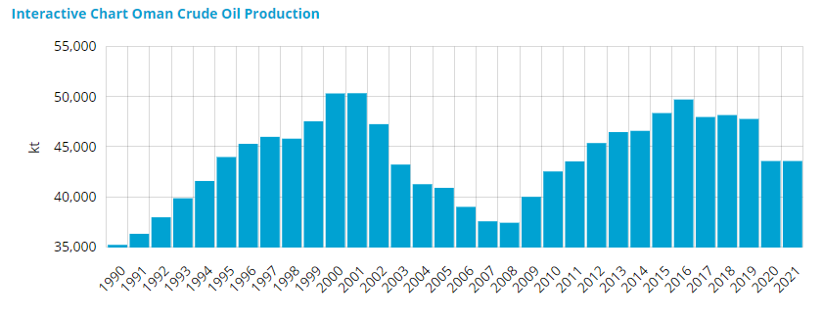
As for corporality due to air pollution Oman's rate was 53.9 percent. In 2019, the World Health Organization choose Oman as the least polluted country in the Arabia, with a percent of 38 in the pollution results. Oman listed 112th in the list of highest polluted countries.
Oman also has projects about renewable electric energy
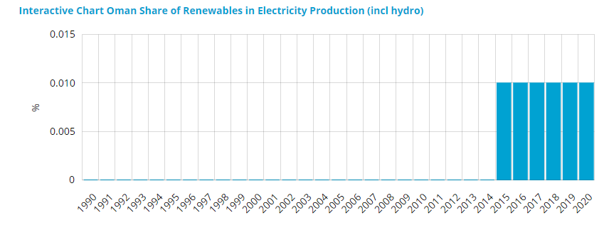
Biggest problem causing pollution in Oman right now is transportation. We can solve this with electricity powered motors in vehicles. Our biggest income is petroleum. Unfortunately giving up on this action will cause our countrys economy to collapse but we can use filters in the process of the petroleum being distillated. People in the country can prefer sollar panels on their roofs. To prevent pollution in the sea, we can place a law about companies polluting and clean water with chemicals won’t harm the sea living.

References:
https://www.unep.org/resources/policy-and-strategy/air-quality-policies-oman
https://leap.unep.org/countries/om/case-studies
https://en.wikipedia.org/wiki/Oman
https://www.worldometers.info/oil/oil-reserves-by-country/
https://www.enerdata.net/estore/energy-market/oman/
https://www.cia.gov/the-world-factbook/countries/oman/

