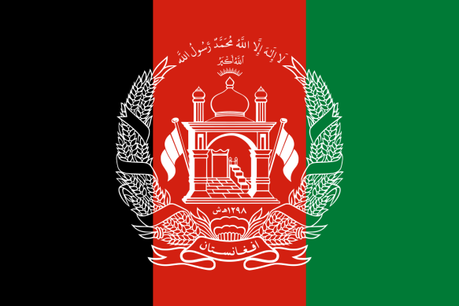
Country: Islamic Emirate of Afghanistan
Committee: United Nations Environment Programme
Agenda Item: Enhancing the transition to sustainable
energy as a response to the energy crisis and climate change

Islamic Emirate of Afghanistan is landlocked country in Central Asia. Some of its neighbors to the west are Iran and Turkmenistan. It also borders Uzbekistan and Tajikistan to the north. China and Pakistan are the eastern neighbors of the country. Its capital city is Kabul. Mountains and dry desserts cover most of the landscape of Afghanistan. Mountain peaks are snow covered most of the year. Its climate is arid, hosting cold winters and hot summers. Afghanistan is a multi-national state. Its population consists of Pashtun, Tajik, Hazara, Uzbeks, Nuristanis, Aimaq, Turkmen, Baloch and some others. Even though Afghanistan is ethnically diverse, the predominant religion is Islam.
Islamic Emirate of Afghanistan is bears in mind that climate change is a problem that should not be underestimated. It is avare After the conflict, United Nations Environment conducted an assesment that revealed land and resource deffiency, lowered water levels, loss of plant coverage and wildlife loss are the main problems of the country. These problems also affect the agriculture sector, animal husbandry and artisanal mining which provides over 80 percent of the population jobs. Poor infastructure also bolster the problem causing poverty. Because of the reasons stated above, severe and sudden floods, droughts and landslides happen causing unrest across the state. There is no social safety net to help people cope in times of crisis, and most families will not have savings to fall back on. Each time they are hit by disaster, their ability to cope worsens and any progress they had made is wiped out. This disasters also destroy the ecosystem and causes damage to natural sources.
As a growing economy, Afghanistan is rapidly urbanising. The government is avare that this process should be supervised. Highly profit based housing strategies of investors also worsen the problem of incompatible infrastructure to the natural environment.
Afghanistan has been identified as one of the defenseless countries in the world in the context of climate change. Since 1950, Afghanistan's temperature has risen by 1.8 degrees Celsius due to climate change. Climate change is projected to have a significant impact on the country in the coming decades, according to the UN, which predicts extreme temperature rises of more than 6 degrees Celsius if global carbon emissions are not reduced. Climate change consequences are becoming more pronounced for Afghan people and it affects their well-being.Climate change increases the risk of illness though increasing temperature.And it also effects Afghan people’s source of incomes especially particularly subsistence farmers. Climate change wreaks havoc on the poorest people, who are typically already living on marginal land. The drought problem caused by climate change harms agriculture critically. Because of this reason people living on agriculture have financial difficulties.
Afghanistan has a wealth of energy resources.In addition to a rich biodiversity,Afghanistan is estimated to hold some one trillion dollars in mineral reserves. Hydropower is the primary source of energy in Afghanistan, followed by fossil fuels and solar power. The total consumption of 5.53 billion kWh of electric energy per year is the most important measure of Afghanistan's energy balance. Afghanistan is capable of producing some of its own electricity.Energy is imported as well from neighbouring countries and will affect Afghanistan to a high degree.
Droughts caused by climate change affect greenhouse gas emissions, and the country contributes very little to global warming in terms of greenhouse gas emissions. Also Afghanistan is one of the least polluting countries on the planet.In 2018, Afghanistan emitted 0.3 tons of carbon dioxide per capita.
Hydropower,solar and wind power are Afghanistan’s primary renewable energy sources. Because of Afghanistan has mountainous environment, hydropower has become the main source of renewable energy. Afghanistan has the ability to generate about 23,000 MW of hydropower. Also solar and wind power is becoming more widely used across the country.
The Islamic Emirate of Afghanistan is aware that the climate change and energy crisis should not be underestimated. Afghanistan may experience more health problems, deprivation crises, and natural disasters in the future if measures are not taken.We are ready to take action to reach a healthy world where energy crises and climate change problems are over.

Sources:
https://en.wikipedia.org/wiki/Renewable_energy_in_Afghanistan#:~:text=Hydropower%20is%20currently%20the%20main,other%20facets%20of%20hydro%20energy.
https://www.undp.org/afghanistan/publications/climate-change-scenarios-agriculture-afghanistan?c_src=CENTRAL&c_src2=GSR
https://www.unep.org/explore-topics/disasters-conflicts/where-we-work/afghanistan
https://wedocs.unep.org/bitstream/handle/20.500.11822/22447/Report_CC_Governance_Afghanistan_EN_v2.pdf?sequence=1&isAllowed=y
https://www.irena.org/IRENADocuments/Statistical_Profiles/Asia/Afghanistan_Asia_RE_SP.pdf

