Comittee: GA:1 Dısec
Country: Maleysia
Agenda item(s): Weaponization of Data and Cyber Security
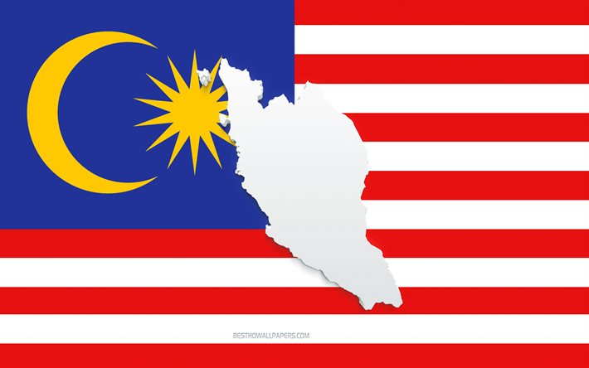

Maleysia is a Southest Asian country and federal state that divided as the Penisular Maleysia and East Maleysia. Maleyisa shares a border with Thailand, Singapure, Vietnam, Brunei and Philippines. Maleyisa has a population over 33 million people which is the world’s 44th most populous country. There is a socio-cultural structure consisting of Chinese and Hindus the majority of which are Bumiturpas. Maleysia’s offical religion is Islam with %60 of the population and the rest of the population is Buddhist. Maleysia is made up of 13 states as well as three federal territories. The political system of the country is a constitutional monarchy based on the Westminster parliamentary system of the United Kingdom. Maleysia which is also an island country has 878 islands.

Weaponization of data and misinformation is a crutial international problem that is growing very speedly, therefore Maleysia is devoloping a strategical plan that aims secured, trusted and resilient syberspace. Understanding that cyber security is a movement about human interaction and technology attitudes, Maleysian government is now working on this essential issue. We believe that in this condition we should raise our awareness, work with coordination and need to enhance syber threats. For these and more we are considering this problem as national priority. This has led us to formulate National Cyber Security Policy in 2006. Maleysia co-operating with National Cyber Security Agency (NACSA) in order to decrease the impact of syber security threats, combating cybercrime in a collabrated manner against cyber criminals. To ensure that cyber attacks and cyber crisis are managed proactively through a coordinated approach at a national level, a national policy and procedure for managing cyber crisis has been developed.

This issue constitutes risks to the nation’s overall economic well-being and security and besides threatens the civilians and break the peace in community. According to corporate leaders and government authorities, today’s cyber attacks are capable of causing more physical and financial harm than physical terrorism. That shows us the need of education that must be ensured to societies more about the use of internet and cyber awareness in the technological era we are living in.
Under this circumstances Maleysian government has made these elemental establishments and currently, relevant agencies and organizations are implementing several cyber security awareness efforts throughout this foundations.
- Maleysian Modernisation and Management Planning Unit: This Unit has been organizing public-sector cyber security programmes, such as the Cyber Security Awareness Month.
- National Cyber Coordination and Command Center: This is a center in a national level that deals with cyber threats.
- NC4 is developed under the guidance of National Cyber Security Agency.
- Cyber Security-Operating center (SOC) and Cyber Defense-operating center (SDOC)

Regarding to this, Maleysia is the most cyber savvy country in Asia and it is still developing itself and planning the steps to be taken in this regard.
In conclusion, the importance of this issue is is real and the issue of Cyber Security should be discussed and precautions should be taken in an international degree.

Sources:
https://asset.mkn.gov.my/web/wp-content/uploads/sites/3/2019/08/MalaysiaCyberSecurityStrategy2020-2024Compressed.pdf
https://www.nationsonline.org/oneworld/malaysia.htm
https://www.un.org/counterterrorism/cybersecurity
https://en.wikipedia.org/wiki/Malaysia
https://www.malaysia.gov.my/portal/content/142

