Country: The Republic of Lithuania
Committee: UNEP
Agenda Item: Enhancing the transition to sustainable energy as a response to the energy crisis and climate change

Climate change is a huge problem which affects all countries in the world. The World Health Organization (WHO) calls climate change the greatest threat to global health in the 21st century. threatens people with food and water scarcity, increased flooding, extreme heat, more disease, and economic loss. Therefore it is extremely important to take action immediately to forestall this issue without further progress.
Lithuania like all other countries, is negatively affected by energy crisis and climate change. Based on the results of previous studies in Lithuania, the Baltic Sea coast region is most vulnerable to climate change. Coast, coastal ecosystems, as well as local population are mostly affected by sea level rise, storm and hurricane winds, sea and Curonian Lagoon water warming and salinity changes.
Lithuania has contributed to the solution of this problem by increasing the use of different renewable energy sources over the years due to this serious problem. When Lithuania's energy and natural resources ministry aligned its sustainable energy aspirations with Europe's zero-emission policy, the plan was to phase out fossil-based energy supplies by 2050 by scaling and developing renewable energy options. Following comprehensive targeted investments and market restructuring, Lithuania is now well on its way to ensuring that its major energy outlines are achieved by 2025. In 2010, Lithuania became a net importer of electricity. By 2030, the government aims to reverse import dependency and produce 70% of its electricity needs domestically. Renewable energy in Lithuania constitutes some energy produced in the country. In 2016, it constituted 27.9% of the country's overall electricity generation. Previously, the Lithuanian government aimed to generate 23% of total power from renewable resources by 2020, the goal was achieved in 2014 (23.9%). Lithuania also signed The Paris Agreement which is a legally binding international treaty on climate change 22nd of April, 2016.
In Lithuania, in 2019, 60.1 percent of total electricity was produced from renewable energy sources.The greatest renewable energy potential in Lithuania is shown by solid biofuel – firewood, wood and agricultural waste. In 2019, electricity produced from biogas amounted to 154.4 million kWh, by 10.4 percent more than 2018.The use of biofuel reduces environmental pollution. Two kinds of biofuel are used in Lithuania – biodiesel and bioethanol. In 2019, biodiesel and bioethanol consumed in transport amounted to 74 thousand and 15.1 thousand tonnes respectively. In 2019, the largest amount thereof was used for the production of electricity and centralised heat supply (50.1 percent) and in households (37.6 percent). In 2019, In Lithuania, wind farms together with small wind power plants produced 1.5 Twh of electricity, which is slightly more than one-third of total electricity produced in the country, or over 11.2 percent of electricity consumed in the country. Currently, there are 23 wind farms in Lithuania. Together with small power plants, the total capacity of the installed power plants amounted to 534 MW at the end of 2019. As regards renewable electricity, in 2019, electricity produced by solar power plants amounted to 91.1 million kWh, or by 5.2 per cent more than in 2018. This is quite important as it promotes local electricity generation and contributes to the implementation of the international climate change mitigation goals. In 2019, hydropower plants produced 345.4 million kWh of electricity.

Renewable energy resources consumption structure, 2019
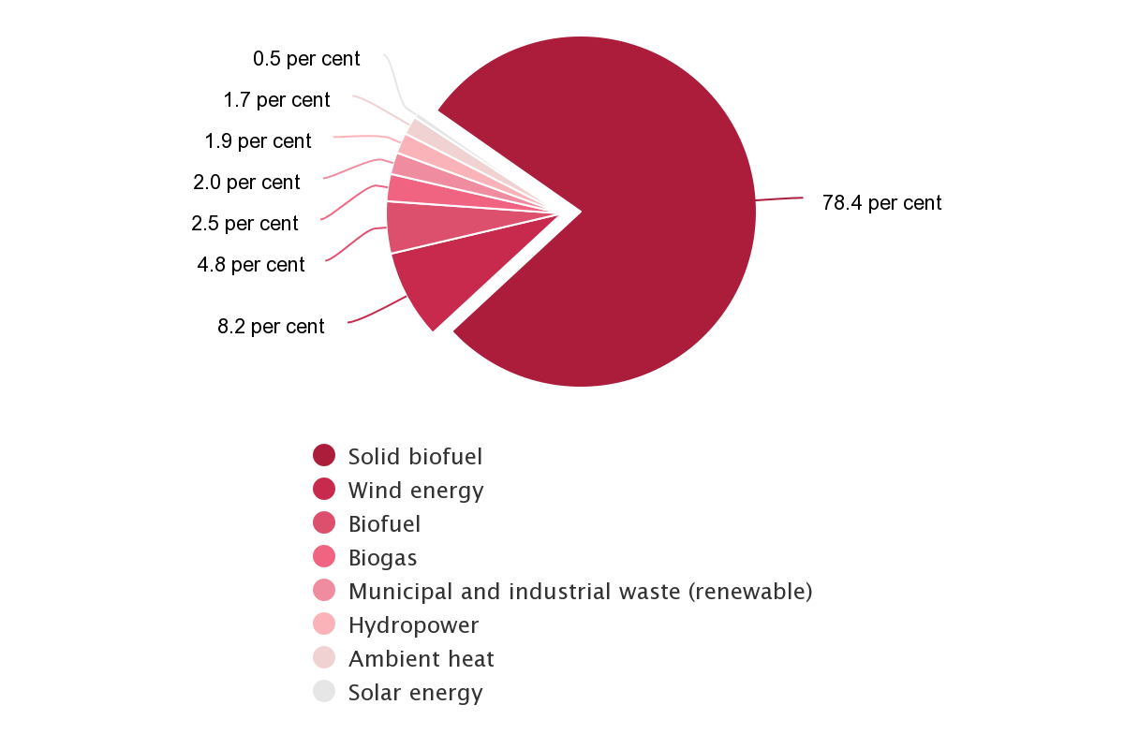

Share of renewable energy resources in consumption, 2015–2019 (Percent)
 | 2015 | 2016 | 2017 | 2018 | 2019
In final gross energy consumption | 25.8 | 25.6 | 26.0 | 25.3 | 25.5
In final energy consumption for heating and cooling | 46.1 | 46.6 | 46.5 | 45.6 | 47.4
In gross consumption of electricity | 15.6 | 16.9 | 18.3 | 18.4 | 18.8
In final energy consumption in transport sector | 4.6 | 3.6 | 4.3 | 4.3 | 4.0

Although a certain progress has been made in this regard, unfortunately, the situation is still quite serious for everyone. Lithuania believes there is still so much work to be done to save and protect our planet. We recognize the importance of the issue and are ready to discuss the solutions that can be offered in this regard .

Works Cited

United Nations Treaty Collection treaties.un.org

International Renewable Energy Agency irena.org

European Parliament europarl.europa.eu

Official Statistics Portal osp.stat.gov.lt

Hive Power hivepower.tech

Wikipedia en.wikipedia.org

