Country: Belize 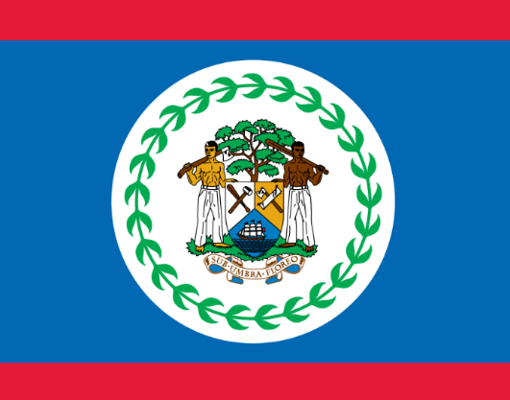
Comitte: UNEP
Agenda Item: Enhancing the transition to sustainable energy as a response to the energy crisis and climate change
Belize is a country on the northeastern coast of Central America. It borders Mexico to the north, the Caribbean Sea to the east, and Guatemala to the west and south. It has an area of 22,970 square kilometres.It’s population is 419,199 for 2020. It has the lowest population in that area. The biggest city of Belize called Belize city also it was the capital city in last years. The capital moved to Belmopen. Belize divided to two parts; the lowland area forms the north and the daps and forests form the south
It was discovered by English colonies to use natural sources.They would like to evaluate all sources and begun to trading. African people came as a slave there. In 1840 it became a British colony known as British Honduras, and a Crown colony in 1862. It achieved its independence from the United Kingdom on 21 September 1981.
African people make up the vast majority of the country. the west and north are also inhabited by Spanish citizens. They used to speak different languages but they only have one offical language which is English. Spanish is most common second language followed by Mayan languages, German dialects, and Garifuna
We have a high prevalence of diseases such as respiratory diseases and intestinal illnesses. It’s accure because of tornados gives lot of damage. A number of kindergartens, secondary, and tertiary schools in Belize provide quality education for students. Education level isn’t that much high. That means people don’t know how can protect themselves or decrease the effects.
Belize has various natural sources so every changes in climate effect our country deeply. Our country discovered to reach sources. Then,lots of country began to consume. Our sources was used instead of researching renewable energy. It has finished or approximately come to end. We have to find solution to use new and renewable energy.
Since energy is also necessary forthe development of a country, and even if it means the safe and clean water and food for the society, the lack of access poses a critical problem to be solved.

Greenhouse gas emissions causing climate change all over the world. Especially during the Covid-19 we aware of the importance of energy. When people stayed at home and only exhausted every sources for instance foods,water,energy sources. We never take step to production or find new and sustaible energy which is really goverments concern about.
All around the world fuel oils was used because of they are cheap or easy to reach more than sustaniable energy.We ignored that they gonna end. While we consume that,they also consume our world, ıt damages to climate and inderectly may cause of end our lifes. Co2 and other greenhouse gas percentage is increaing day by day which is the main reason of climate changing. As aresult we completely aware of the risks of climate changing
Decreasing of usage cars or fuel oils,we lack to live a fresh air. We support to green economy which is reuse,reduce and recyle.As a small country, transfortation without private cars should be solved.We would prefer bycles instead of cars. These things are simple and personel cautions to stop climate change.
As a bigger step,we find solutions as a green energy. Our county is windy which means really suitable to use wind power as a sustainable energy. most advanced and applicable renewable energy source in the world. It requires a profound investment made by intergovernmental organizations or the states themselves. We expect the economical support from developed countries to save the world. since the country's economy is based on agriculture we don’t have financal ability to use the sustainable energy sources.
Our country also suitable for biodisel energy.Leftover food products, such as animal wastes andvegitable oils and crops grown just for the purpose of energy source production. In everywhere in our country,people made agriculture which makes leftover food products or that type of waste.
As a result, biomass and wind power are practicable way to use sustainable energy. Our aim is reduce the greenhouse gas which is dangerous whole world. If we could find financal support, we have big goals to save the world

