Country: Republic of Iraq
Comitee: United Nations Environmental Programme (UNEP)

Agenda Item: Enhancing the transition to sustainable energy as a response to the energy crisis and climate change
Climate change, as the identification united nations made, is long term shifts in temperatures and weather patterns due to large chunks of global emissions caused by generating electricity and heat by burning fossil fuels. It is one of the major problems the world has been facing especially since the 1800’s. It has increased wildfires, declining water supplies, reduced agricultural yields, health impacts in cities due to heat, and flooding over time. With finding solutions for the energy crisis and climate change by transitioning into renewable energy is still an issue we are halting on, we are open to resolutions and to countries that are open to contribute to us financially or politically.
Since the led invasion of the U.S. it has been 19 years and Iraq hasn’t had the slightest bit of stable democracy the United States promised. The reality that the worlds sixth largest oil producer now suffers from fuel scarcity and power outages explains the obvious truth: the dysfunctional plannings and unreliable electricity sources obtain to exist in Iraq. An average household in Baghdad gets 6 hours of electricity per day from the national grid. While the ones that are able to afford a private generator provider can cover the shortfall, millions of people ,who can’t afford a private generator provider, power might be out for hours.
The history of environmental pollution due to climate change and increasing heat waves in Iraq are not very promising. Iraq has been dealing with water pollution for the past 30 years. This pollution is due to household food waste thrown away into the rivers and the regularly increasing heat waves (recently above 50 degrees). Government arranged some regulations about cutting 50% of the available land for farmers to culvate wheat and barley because of the severe water scracities. To lighten the negative impact on the living standarts of farmers and relatively the society, the government claimed to have financal support on farmers. But did not stop the demands of the farmers for sustainable interventions. Food security remains indecisive still with the unstable weather.
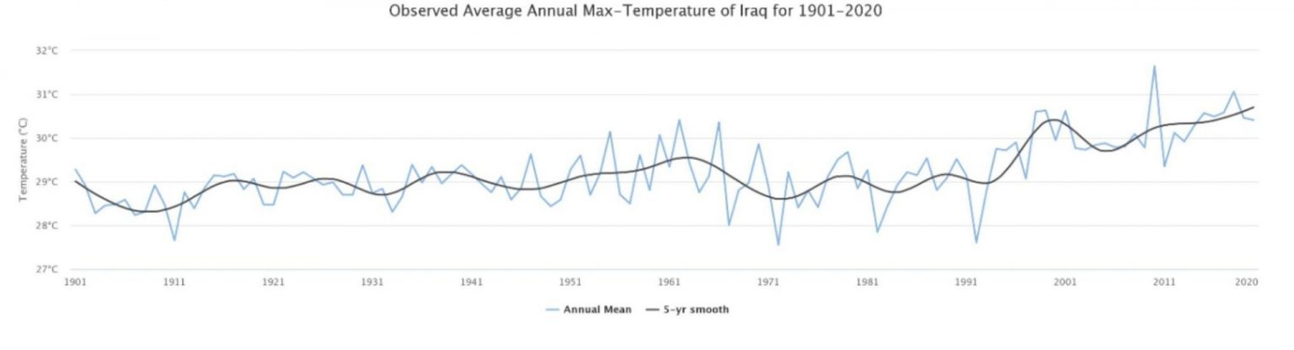

As seen from the graphic, average temperature of Iraq has been increasing severely for the last 20 years making today the hottest temperature seen the last century. In 2019, Iraq government stated that 8% of the worlds methane emissons and 0.5% of world carbon dioxide emissions come from the country, making greenhouse gas emissions per person above the world average.
Energy sector in Iraq suffered due to war with United States of America therefore making energy demand greatly in the foreground. Iraq’s primary energy consumption is mainly from petrolium and natural gas. Considering the serious power shortages Iraq faces, the government claims to increase the generation expansion with natural gas and renewable energy facilities, aiming to have 2.24 GW of electricity generation come from renewable energy by 2025.
To recoup the decreased income from low oil prices during the COVİD-19 pandemic was the motivation to gain the climate finance from Green Climate Fund which is hooked to set the meeting the conditions that were put forward by the Paris Agreement, promising Iraq government to step up to the impact of climate change. Iraq hopes for financal investments to be recieved from industrialised countries for clean energy for the prospects of boosting agriculture and food production.
Iraq has beeen making renewable arrangements to decrease the dependance on oil and gas as raw materials for power generation. Aiming to draw external investors for the formation of 3 major solar energy projects and a wind energy project. For instance in september 2021 Iraq signed $27 billion worth of contracts with TotalEnergies that contains building a 1 GW solar power plant.

Recent studies shown that there are interesting biomass materials and they have positive potential for fuel energy utilization.
As Latif said in an interview at his office in Baghdad: “We have several forecasts that show that without nuclear power by 2030, we will be in big trouble” it is not easy to get rid of the non renewable, environment polluting energy sources without using nuclear power; Iraq government is working on a plan to build nuclear reactors. Nuclear energy is not identified as renewable energy beacause of what “renewable” refers to: energy from sources that are constantly charged. But this doesn’t have to mean that it is a bad thing. As nuclear energy is heating the water into steam, turning a tirbune and generating electricity by splitting atoms in a reactor; the green gas emissions are the lowest.
There are possible solutions to decrease green gas emissions and consequently end climate change. The whole world should come together and collectively take parts in actions to decrease usage of fossil fuels for energy. The petrolium in Iraq plays a huge part in making financal profits. As a matter of fact, Iraq’s access to its own petrolium is limited and it is possessed by big international companies and developed countries. Diverting these profit making companies into taking advantage of Iraq’s naturel features to conduct into renewable energy would be the solution. Iraq is abunded by sun beam. By disseminating solar pannels, the profit making companies would not only make financal profit but also help reduce carbon dioxide emissions.

References:
https://timep.org/commentary/analysis/iraqs-climate-change-response-the-private-sector-and-civil-society/
https://www.hrw.org/report/2019/07/22/basra-thirsty/iraqs-failure-manage-water-crisis#:~:text=Iraqi%20authorities%20have%20failed%20to,in%20a%20report%20released%20today.
https://www.rcreee.org/member-states/iraq/4021?page=2#:~:text=Iraq%20suffers%20from%20serious%20power,from%20renewable%20energy%20by%202025.
https://foreignpolicy.com/2022/04/21/iraq-oil-fuel-shortage-energy-crisis-electricity/
https://www.argusmedia.com/en/news/2255697-iran-names-iraq-energy-envoy-in-move-to-bolster-ties
https://www.spglobal.com/commodityinsights/en/market-insights/latest-news/electric-power/100721-iraq-seeks-75-gw-of-renewable-power-as-it-inks-2-gw-deal-with-uaes-masdar
https://iopscience.iop.org/article/10.1088/1757-899X/671/1/012006
https://www.asiawind.org/research-data/market-overview/iraq/
https://www.aljazeera.com/economy/2021/6/8/iraq-plans-nuclear-power-plants-to-tackle-electricity-shortage#:~:text=Iraq%20is%20planning%20to%20build,in%20the%20oil%2Drich%20economy.&text=Iraq%20is%20working%20on%20a,that%20have%20sparked%20social%20unrest.
https://www.nei.org/fundamentals/what-is-nuclear-energy
https://www.nhm.ac.uk/discover/quick-questions/is-nuclear-energy-renewable.html

