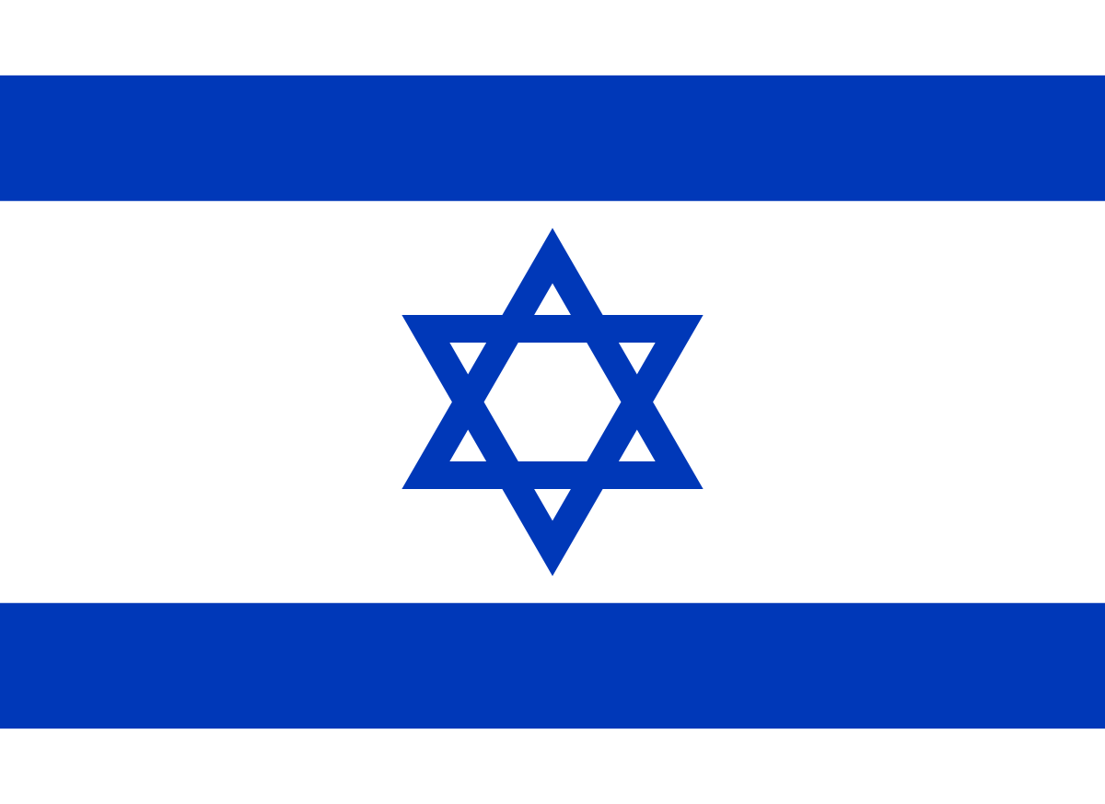
Country: Israel
Comittee: United Nations Environment Programme
Agenda Item: Enhancing the transition to sustainable energy
as a response to the energy crisis and climate change

Israel is a Western Asian country. It is located on the southeastern shore of the Mediterranean Sea and the northern shore of the Red Sea, with Lebanon to the north, Syria to the northeast, Jordan to the east, and Egypt to the southwest; it is also bordered to the east and west by the Palestinian territories of the West Bank and Gaza Strip. Tel Aviv is the country's commercial and technological hub, while Jerusalem, the country's designated capital, is the seat of government, despite Israeli authority over East Jerusalem being unrecognized internationally.

The majority of Israel's energy comes from fossil fuels. The country's overall primary energy demand exceeds its total primary energy production, forcing it to rely largely on imports to meet its energy requirements. In 2016, total primary energy consumption amounted to 1.037 quad (304 TWh), or 26.2 Mtoe (million tonne of oil equivalent).

In 2017, Israel's electricity consumption was 57,149 GWh, with production at 64,675 GWh and net exports of 4.94 TWh. In 2014, installed generating capacity was around 16.25 GW, mainly entirely from coal and gas-fired power plants. Renewable energy represented for a modest percentage of total electricity output, with just a little amount of solar photovoltaic capacity constructed. However, as a result of mandated solar water heating rules, approximately 1.3 million solar water heaters have been installed.
In 2018, natural gas provided 70% of electricity and renewables provided 4%, with solar PV accounting for 95% of it.

Israel's renewable energy production capacity was 1,500 MW in 2019, almost entirely made up of solar energy (1,438 MW). Wind power (27 MW), biogas (25 MW), hydroelectric electricity (7 MW), and other bio energy sources were also used (3 MW). Photovoltaics produced 1,190 MW of solar energy, while concentrated solar electricity from the Ashalim Power Station contributed another 248 MW.

The government pledged in 2020 that renewable energy will account for 30% of total energy consumption by 2030.
This goal was updated in 2021, when Israel announced at the United Nations Climate Change Conference (COP26) that it would phase out coal for energy generation by 2025 and achieve net zero emissions by 2050.

Israel is a world leader in the per capita usage of solar thermal energy. The government has mandated the installation of solar water-heating systems in all new residential buildings since the early 1990s, and Israel's National Infrastructure Ministry estimates that solar panels for water-heating meet 4% of the country's total energy consumption. With over 90% of residences employing solar hot water systems, Israel and Cyprus are the per-capita leaders in the adoption of solar hot water systems. Solar water heating is estimated to save Israel 2 million barrels (320,000 m3) of oil per year, according to the Ministry of National Infrastructures.

Climate change is a factor that contributes to natural disasters and, in particular, puts public health at risk. The world's governments should work together to identify answers and collaborate on them in order to reduce the severity of these disasters, if possible, prevent them, and leave a planet that is safe for future generations. The greatest solution would be to prioritize energy production from renewable sources before attempting to reduce energy usage.

As the Israel, we can assure you that we will contribute in the greatest possible way to this goal, allocating a significant portion of our country's budget.

References
https://www.iea.org/countries/Israel
https://en.wikipedia.org/wiki/Energy_in_Israel
https://dergipark.org.tr/en/download/article-file/2182006
http://www.solar.co.il/water-heaters.htm
https://www.irena.org/publications/2020/Mar/Renewable-Capacity-Statistics-2020

