Committee: United Nations Environment Programme
Country: Republic of India
Agenda Item(s): Enhancing the transition to sustainable energy as a response to the energy crises and climate change.

India is a South Asian country that encompasses the majority of its continent. Its capital, New Delhi, was established in the twentieth century to serve as India's administrative center, just south of the historic city of Old Delhi. Its government is a constitutional republic that represents an extremely varied population, with thousands of ethnic groups and hundreds of languages. India is the world's second-most populous country, after China, with nearly one-sixth of the global population.

According to UN predictions, India will overtake China as the world's most populated country by 2027. India, as the world's third-largest energy user and with the promise of rapid population and economic expansion in the years ahead, faces the challenge of satisfying rising energy demand while reducing CO₂ emissions by 40% by 2030.

Due to India's rising economy and the dynamics of urbanization and industrialization, there is a significant potential for the continuing rise in energy service demand. However, there are serious concerns regarding how demand growth will be fulfilled. India is typically resource-constrained, with the significant exceptions being solar, coal, and wind. India is also highly populated, with significant levels of water stress and land-use limits, as well as structural poverty and other socioeconomic problems, making energy affordability a key challenge. And despite all this, India supports its transition to renewable energy with large projects and is developing rapidly in this regard. Another data showing the importance of India's rapid transition to renewable energy is that India is the world's third-largest electricity consumer and third-largest renewable energy producer.

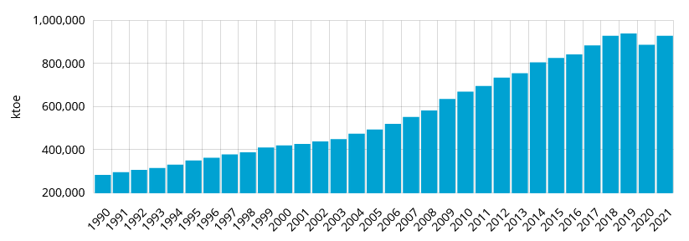

Chart: Annual Total Energy Consumption of India

Environmental pollution is not a new issue -since the beginning of the 19th century, the human race has been rapidly depleting natural resources and polluting the environment- but it is still the world's most serious problem and one of the top causes of many diseases among humans and all living creatures. Urbanization, industrialization, mining, and exploration are all examples of human activities that contribute to global environmental pollution.

India is aware of problems such as global warming and environmental pollution that pose a great threat to the future of the world. That's why, from past to present, our country has joined the Climate & Clean Air Coalition (CCAC) as the 65th participating country. Also, India made major commitments in 2021, putting climate change at the center of its environmental policies, with Prime Minister Narendra Modi declaring at the key international climate summit COP 26 that India is the only country delivering on the Paris Agreement's commitments in "letter and spirit." From pledging to become a net-zero emitter of carbon by 2070 to achieving 500 gigawatts of non-fossil energy capacity by 2030, India led from the front on environmental issues this year, grabbing eyeballs across the world.

In the light of all this information, it is an indisputable fact that India will fight fossil fuels, environmental pollution, and global warming for the future of humanity and the world, with all the means at its disposal. We fully believe that our country and other countries will take action in a short time with rational and effective solution proposals and cooperation for the solution of this extremely critical problem.

References:

https://www.unep.org/news-and-stories/press-release/india-joins-climate-and-clean-air-coalition

https://en.wikipedia.org/wiki/India

https://en.wikipedia.org/wiki/Renewable_energy_in_India

https://www.iea.org/countries/india

https://www.cia.gov/the-world-factbook/countries/india/#environment

https://www.britannica.com/place/India

https://www.enerdata.net/estore/energy-market/india/

https://www.forbes.com/sites/rrapier/2020/06/20/bp-review-new-highs-in-global-energy-consumption-and-carbon-emissions-in-2019/?sh=2628fac866a1

https://economictimes.indiatimes.com/news/india/india-put-climate-change-at-the-centre-of-its-environmental-policies-in-2021/articleshow/88542444.cms

https://www.unicef.org/india/what-we-do/climate-change

