Country: Hungary
Committee: United Nations Environment Programme
Agenda Item: Enhancing the transition to sustainable energy as a response to the energy crisis and climate change

Hungary is a landlocked country located in the Carpathians in Central Europe. Austria and Slovenia to the west, Slovakia to the north, Romania and Ukraine to the east, Serbia and Croatia to the south. Hungary, whose capital is Budapest, is a member of OECD, NATO, EU, Visegrad Group, and Schengen. The official language in the country is Hungarian. The capital is Budapest. The population is approximately 9,672,000 citizens. The form of government is a unitary multiparty republic with one legislative house; János Áder is the President of Hungary, and Viktor Orbán is the Prime Minister of Hungary. In an economic view, high-earnings EU and OECD financial systems
Hungary's total energy delivery is ruled with the aid of fossil fuels, with natural gas occupying the most important share, followed by way of oil, and coal.
In June 2020, Hungary passed a law binding itself to a target of net-0 emissions by 2050. As part of a broader restructuring of the kingdom's energy and climate policies, Hungary also prolonged its countrywide strength approach to 2030 to look even similarly, adding an outlook till 2040 that prioritizes carbon-impartial and value-powerful energy while specializing in reinforcing strength security and energy independence.
Key forces within the united states’ 2050 goal consist of renewables, nuclear power, and electrification of end-use sectors. massive investments inside the electricity sector are anticipated, inclusive of the construction of new atomic strength generating units. Renewable electricity capability has extended appreciably, but in current years increase within the renewables sector has stagnated. what's more, certain rules that restrict the improvement of wind power are expected to negatively impact the renewables region.
Hungary's emission of greenhouse gases has dropped along with the financial system's reducing use of carbon-primarily based fuels. however, impartial analysis has recognized the area for Hungary to set more ambitious emissions discount goals.
Hungary is a member of the ECU Union and hence takes elements within the ECU strategy to boom its percentage of renewable energy. the EU has followed the 2009 Renewable strength Directive, which covered a 20% renewable strength target by using 2020 for the European..through 2030 wind has to produce on average 26-35% of the EU’s energy and store Europe’s fifty-six ix billion a yr in averted fuel charges
The countrywide authors of Hungary forecast are 14.7% renewables in gross power intake through 2020, exceeding their thirteen% binding target by way of 1.7 percentage factors. Hungary is the European country with the smallest forecast penetration of renewables of the electricity call for in 2020, namely simplest eleven% (consisting of biomass 6% and wind electricity three%). The forecast includes four hundred MW of the latest wind electricity ability between 2010 and 2020. EWEA's 2009 forecast expects Hungary to attain 1.2 GW of set up wind potential at this time. ultimately in 2010 wind energy capacity turned to 295 MW.
In Hungary, the generation of electricity from renewable sources is a growing industry. According to preliminary data, renewables accounted for 8.5 percent of total electricity consumption in 2018, with biomass serving as the primary renewable energy source (RES). In its National Action Plan, Hungary decides to commit to sourcing 14.65 percent of its energy from renewable sources by 2020, compared to the EU's 13 percent goal. In 2017, this indicator was 13.3 percent.
The government procedures seek to encourage the installation, use, and distribution of renewable energy systems in Hungary. There is some vocational training that is relevant to RES installations. There is also a recommendation for considering the use of renewable energy sources in new buildings. According to government standards, this suggestion will become an obligation for all buildings quantified after December 31, 2020, but it will already apply to authority-owned or used buildings operationalized after December 31, 2018. Policies on RES installation certification programs and RES-H supporting infrastructure are typically performed in the Environment and Energy Efficiency Operational Programme and the Economic Development and Innovation Operational Programme
The worldwide strength crisis and marketplace tumult spark off using Russia’s moves have considerably complicated the photograph for governments, agencies, and traders as they are trying to determine what energy initiatives to encourage, develop or fund. as the main worldwide authority chargeable for strength security and the easy energy transition, the IEA has been providing the records, analysis, and coverage advice to assist selection-makers around the sector – especially governments – make properly-knowledgeable picks on power investments that help at ease and low-priced strength materials whilst driving down emissions.
Between 1907 and 2017, Hungary's annual average temperature increased by 1.15°C, outpacing the global average temperature change (+0.9°C). Its rate of warming has increased significantly over the last four decades, with summertime warming being especially strong. The rising temperature trend is expected to continue, with summer and autumn temperatures rising more sharply in the country's east and south.
Even though no significant trend in annual precipitation has been detected or forecast, Hungary is at high risk of flooding and medium risk of drought. Changes in the seasonality of flood and drought risks, as well as regional precipitation patterns, have also occurred. These changes could exacerbate in some areas,putting energy supply security at risk by limiting coolant water availability and increasing the incidence of floods
Sustainable energy transitions necessitate the development of effective policies that encourage the use of biomass resources, boost the use of renewable and low-carbon energy sources, and punish and discourage the use of fossil fuels and unsustainable natural resource usage. Using agricultural resources to increase food production. Renewable energy sources such as sun, wind, and hydropower can be utilized to generate electricity.

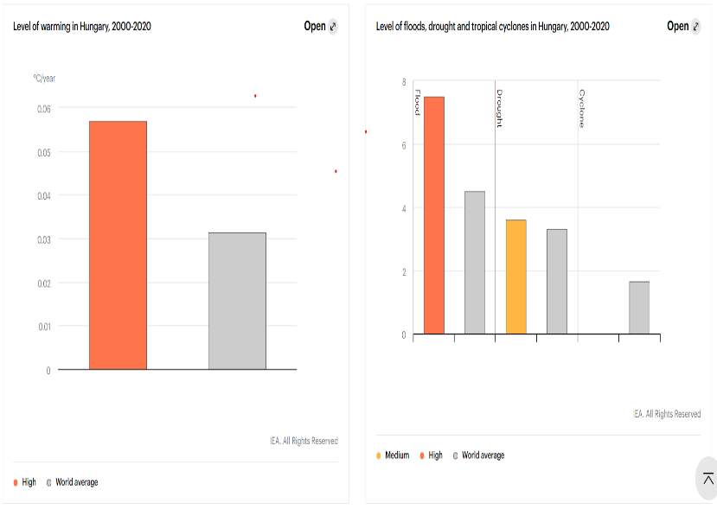
To promote sustainability, a variety of tactics, metrics, and technology can be applied. Energy efficiency, increasing renewable energy's contribution to electricity generation, using Carbon Capture and Storage (CCS) in fossil and biomass power plants, using low-carbon nuclear power, using hydrogen in transportation, and reducing energy and electrification demand, as well as using biofuels in transportation services, are among them. Lack of acceptability and behavioral adjustments, as well as economic limits and the availability of inexpensive fossil fuels, are the key problems that various choices and technologies face.
References:
https://www.iea.org/countries/hungary
https://ourworldindata.org/energy/country/hungary
https://alcse.org/energy-alabama/our-work/education/what-is-sustainable-energy/
https://en.wikipedia.org/wiki/Energy_in_Hungary
https://en.wikipedia.org/wiki/Energy_for_Sustainable_Development
https://www.mdpi.com/journal/sustainability/sections/energy_sustainability
https://www.iea.org/commentaries/what-does-the-current-global-energy-crisis-mean-for-energy-investment
https://www.un.org/sustainabledevelopment/energy/
https://www.britannica.com/facts/Hungary
https://cms.law/en/int/expert-guides/cms-expert-guide-to-renewable-energy/hungary#:~:text=In%20its%20National%20Action%20Plan,of%20RES%20for%20power%20generation.
https://renewablesnow.com/news/hungary-reaches-192-renewables-share-in-2021-power-773769/
http://www.res-legal.eu/search-by-country/hungary/summary/c/hungary/s/res-hc/sum/144/lpid/143/
https://www.iea.org/articles/hungary-climate-resilience-policy-indicator

