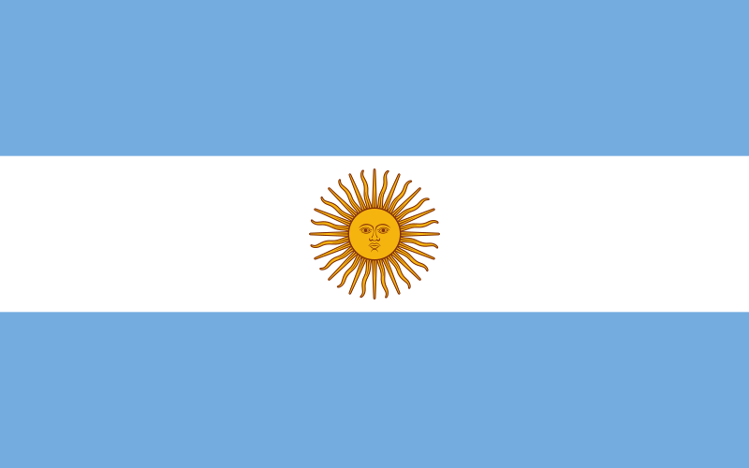
COMMITTEE: UNICEF
COUNTRY: Argentina
AGENDA ITEM: Preventing Child Trafficking in Less Developed and Developing Countries

Argentina, officially the Argentine Republic, is a country in southern South America. It is the second-largest country in South America after Brazil and the eighth-largest country in the world, covering an area of 2,780,400 km2. With a population accounting for approximately 0.58% of the global population, Argentina shares borders with Chile, Bolivia, Paraguay, Brazil, Uruguay, and the South Atlantic Ocean. It is a federal state consisting of twenty-three provinces and one autonomous city, Buenos Aires. Argentina also claims sovereignty over the Falkland Islands, South Georgia and the South Sandwich Islands, and a part of Antarctica.

Child trafficking refers to the abduction, sale, or use of children for commercial purposes. It can manifest in different forms, including sexual exploitation, forced labor, begging, involvement in criminal activities, and subjecting children to other hazardous conditions.

Argentina is committed to prioritizing child rights and has implemented various legal regulations to protect children. However, issues such as child trafficking still persist and require serious attention.

Argentina has taken several national and international measures and laws to combat this issue and protect children. The country's laws are designed to safeguard children's rights, prevent trafficking, and punish offenders.

Furthermore, Argentina works in collaboration with civil society organizations, local and national governments, international organizations, and other stakeholders to raise awareness, provide education, and develop protective measures against child trafficking. These efforts aim to enhance the effectiveness of combating child trafficking.

While Argentina has made progress in its fight against child trafficking, more work is still needed. The country continues its efforts to protect children's rights and keep them safe from dangerous situations such as trafficking.

To combat child trafficking, every country should strengthen legislation with comprehensive and enforceable laws, enhance law enforcement efforts through adequate resources and training, and improve border controls to prevent the illegal movement of trafficked children. Raising awareness and providing education about the dangers of child trafficking is crucial, along with establishing comprehensive support services for trafficked children. Strengthening international cooperation, empowering communities, and implementing monitoring and evaluation systems are also essential steps in addressing this issue effectively.

