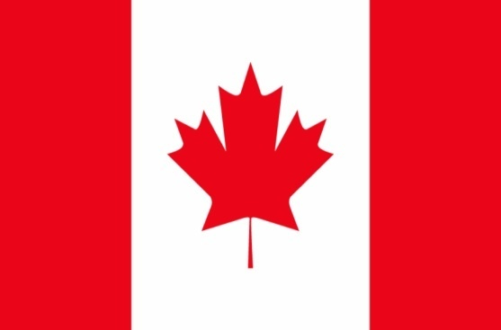
Country:Canada
Committee:Special Political And Decolonozition Committee(SPECPOL)
Topic:The Somalia Conflict:Implications for peacemaking and peacekeeping efforts
Delegation:Özge Emir

BACKGROUND
Somalia is located at the easternmost tip of Africa,in the northwest Cibutilt is surrounded by Kenya to the southwest,the Gulf of Aden and Yemen to the North,The İndian Ocean to the east,And Ethiopia to the west.Near the Indian Ocean,about %65 ot the Somalia economy is based on animal husbandry and farming.
Located at a very strategic point at the tip of the Horn of Africa; very rich in natural sources,a country with a homogeneous ethnic group ,speaking the same language,belonging to the same religion and sharing the same culture:Somalia.
However despite this rather positiicture,Somalia still appears an unstable country after a civil war that started in 1991 and was one of the most horific wars Africa has ever witnessed.Somalia has had no central government for decades,following its last dictator,General Mohammed Said Barre;and it doesen’t even have a unity within its borders.In the country,which is considered one of the most dangereous pieces of land in the world,almost three-quartes of the regions that the government cannot control are under the domination of rebel groups. Such as Al-Shabaab an their groups and persons is very dangereous.We think terrorist groups most important reason of somalia conflict.It was decided to make an agreement before,but no conclusion could be reached.

Possible Solutions:
Besides the solutions proposed,Canada has some possible solutions regarding the issue.
- We as Canada and other countries can make a greyzone in safety area.
- We should solve the fundamental’s of Somalia Conflict.Most important reason is terrorist groups in Somalia so we can make meetings with all UN countries to this issue.
- As Canada we suggest both of countries (Somaliland and Somalia) should have right to live in humane conditions.
References:
https://en.wikipedia.org/wiki/Somali_Civil_War

