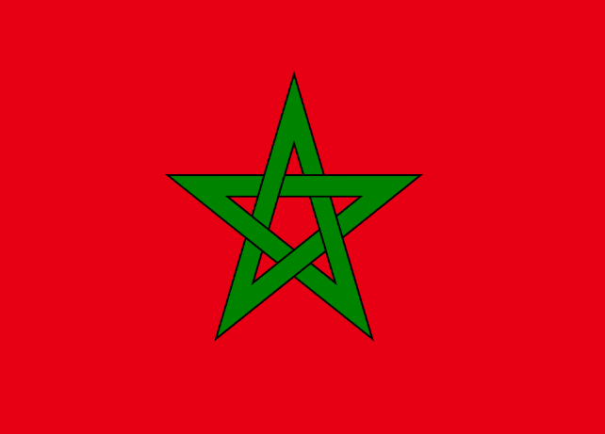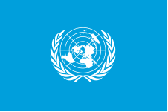

Country:Morocco
Committe:Food and Agriculture Organization (FAO)
Agenda Item :Ensuring sustainable food production and distribution to accommedate the increasing world population.

Morocco is a country located in North Africa with three types of climate in general.Morocco has a Mediterranean climate on the Mediterranean coast, an offshore climate on the Atlantic Ocean coast, a harsh climate in the middle of the country and a Desert climate in the Southeast .40% of the Moroccan workforce is engaged in agriculture, which means that agriculture is the best line of business in the country, and this is due to the fact that the Moroccan territory is suitable for agriculture.

Morocco is the 5th largest in Africa. it has an economy. The country has grown in the economic field by 8% every year since 1999 compared to the previous year, the biggest reason for this is that the state has been constantly innovating and implementing reforms for the last 25 years, opening new cooperatives, developing food industries based on agriculture, and increasing chemical and fertilizer production. Farming and agriculture-based sectors, which are in a very important position for the country's economy, are currently in great danger.One of the biggest reasons for this is events such as climate change, drought and natural pollution. Due to the geographical location of Morocco, there are not many fresh water resources. In the ranking of water wealth among the world's countries 46. and in terms of total renewable water supply 114. it ranks next, and these rankings show that Morocco is poor in terms of water richness. Unfortunately, due to these water problems and climate changes in the country, the drought is constantly increasing.With the Moroccan drought problem, 31 hectares of forest area are turning into desert every year. Agricultural diversity is decreasing and becoming difficult in the lands that have turned into deserts, which harms both the country's economy and labor force.

As a solution, a farmer who has a bad financial situation may need a loan for this loans to farmers for this can reduce interest rates, and if the farmer's economic situation is not good, the loan payment can start after the harvest of the crop he has sown, so that the farmer can sell the crop he has harvested and pay off his debts with the Money has .The state should charge farmers as little taxes as possible, it may not charge taxes on all kinds of technological tools used in agriculture, so the use of technology in agriculture increases, which makes agriculture easier and needs less human power. In order to increase the country's production rate in agriculture, the state can cover the insurance of workers working in agricultural fields in the country.

