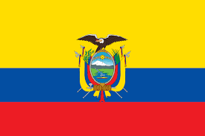
Country: Ecuador
Committee: GA:DISEC
Topic: Weaponization of Data and Cyber Security
Ecuador straddles part of the Andes Mountains and occupies part of the Amazon basin. Situated on the Equator, from which its name derives, it borders Colombia to the north, Peru to the east and the south, and the Pacific Ocean to the west. It includes the Pacific archipelago of the Galapagos Islands (Archipiélago de Colón). The current population of Ecuador in 2022 is 18,113,361.
It is important to access the right information and to use the information correctly. Spreading the information without certainty has bad results. We support spreading the information correctly. Our state attaches importance to both the auxiliary organs of the National Digital Security System and the Cyber ​​intelligence Subsystem. On 19 October 2021, Member of Parliament Rodrigo Fajardo submitted the draft Digital Security, Cybersecurity, Cyber ​​Defense and Cyber ​​Intelligence Act for review and approval by the National Assembly of the Republic of Ecuador.

The bill aims to prevent and combat crises and recover information in case of cybernetic threats or attacks. In addition to establishing a Cyber ​​Security Subsystem for this purpose, various reforms are proposed in existing laws such as the possibility of the Banks Inspectorate to require controlled entities to implement corrective measures in cyber and technological crimes and even to impose sanctions for non-compliance.
The purpose of the bill is to establish a digital security system that enables the prevention, neutralization and management of crises, and access to information in cases of threats, risks and cyber attacks, and coordination with the participation of different public and private institutions.

https://www.dataguidance.com/
https://www.britannica.com

