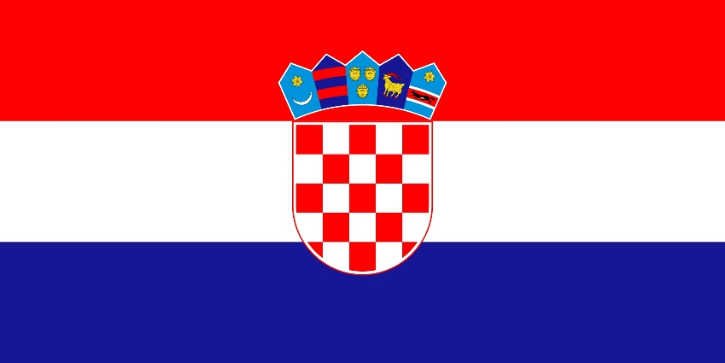
Country: Croatia
Committee: GA:1 DISEC
Topic: Weaponization of Data and Cyber Security

Republic of Croatia is a country at the crossroads of Central and South-east Europe. It shares a coastline along the Adriatic Sea, and borders Slovenia to the northwest, Hungary to the northeast, Serbia to the east, Bosnia and Herzegovina and Montenegro to the southeast, and shares a maritime border with Italy to the west and southeast. It is a member of the European Union, the United Nations, the Council of Europe, NATO, the World Trade Organization, and a founding member of the Union for the Mediterranean.
Data desolation may be a vital threat to everyone's privacy and security. Several organizations have collected huge amounts of users’ personal knowledge as a part of their daily operations. If used just for the meant purpose, this knowledge will be priceless in up and providing the services they provide. However, several recent events have incontestible that organizations frequently use collected knowledge for functions that weren't approved or expected by the shoppers.
Therefore, protecting data plays an important role in maintaining social order. Croatia has some local data protection laws. They are: Act on Implementation of General Data Protection Regulation, Electronik Communications Act, Electronik Commerce Act, Consumers Protection Act, Specific data protection provisions may also be found in other acts, such as Employment Act.
A mysterious hacker group has targeted, and most likely infected, Croatian government employees between February and April in 2019. Attackers, which are suspected to be a state-sponsored unit, have targeted victims using a campaign that mimicked delivery notifications from the Croatian postal or other retail services.
As a solution data weaponization which is a crime is cannot be ignored. As long as it continues, people and states will suffer because of this. So I hope we can prevent this problem with crackdown security measures and bigger sanctions.

https://tr.m.wikipedia.org/wiki/Anasayfa
https://avertium.com/blog
https://cms.law/en/int
https://www.zdnet.com

