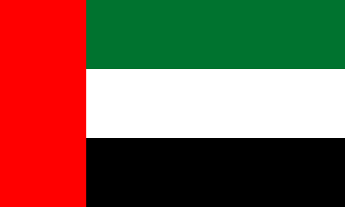
Committee: United Nations Environmental Programme
Country: United Arab Emirates
Agenda Item: Enhancing the transition to sustainable energy as a response to the energy crisis and climate change
The United Arab Emirates is a country which located in Middle East, bordering the Gulf of Oman and the Persian Gulf, between Oman and Saudi Arabia and have natural resources such as oil, natural gas and solar energy. United Arab Emirates have succesful efforts at economic diversification. Approximately 30% of the United Arab Emirates’s GDP is directly based on its oil and gas output, contributing to almost 13% of the value of its total exports.
The climate change is well known fact since the 20th century but because of expensive prices and less type of energy production, till 2010 countries didn’t do something worth to mention with few exceptions.( like Montreal protocol)

This caused to earth getting warmer by each year. After seeing nothing done by their politicians people started to lose their hope.We have seeen rapid natural disaster with 2021 shaping up to be one of the worst, if not the worst, years ever. From devastating wildfires in the Western states to ferocious hurricanes and flooding in the Gulf and East Coast states, the losses caused by extreme weather events will only continue to get worse in the years and decades to come. Flooding accounts for 90% of all natural catastrophe losses, and four hurricanes since 2005—Katrina, Maria, Sandy, and Harvey—caused over $900 billion in damage collectively. Hurricane Ida’s damage could surpass $95 billion, according to an AccuWeather estimate. This natural disasters especially dangerous for underdeveloped countries such as Afghanistan, Ethiopia, Democratic Republic of the Congo, Pakistan and Nigeria.

In 2010, Stockholm Environment Institute's US Center (a research affiliate of Tufts University in Massachusetts) completed a report for Abu Dhabi, addressing how climate change will affect ecosystems, infrastructure and the economy and what impact it might have on the health of residents. The UAE has nearly 1,300 kilometres of coastline. Approximately 85 per cent of the population and over 90 per cent of the infrastructure of the UAE is located within several meters of sea level in low-lying coastal areas as per the report Climate Change - Impacts, Vulnerability & Adaptation (PDF) by Environment Agency - Abu Dhabi.

Also The UAE is classified among the categories of countries with highest rate of vulnerability to the potential impacts of climate change in the world. This will result in warmer weather, less precipitation, droughts, higher sea levels and more storms. The Stockholm report found that the UAE could lose up to 6 percent of its populated and developed coastline by the end of the century because of rising sea levels. There will be several problem titles caused by climate change such as sea levels, water resources, natural disasters, agriculture, human health, animals and plants, cities, air.
The UAE straddles the Tropic of Cancer. The Abu Dhabi emirate, in particular, is influenced by direct sun. The climate generally is hot and arid; yet, on the coast, humidity can reach over 90 percent in summer and autumn. Inland is far less humid although the temperature is higher; sometimes, exceeding 50 degrees Celsius before midday in July. Change in sea-surface temperatures could mean intensified coral bleaching, which affects species' reproduction and migration. Massive pollution could heighten effects of climate change in the area. The UAE suffers high pollution, with an 80 tonne per capita emission of the greenhouse gas carbon dioxide compared to only 14 tonnes per American head yearly. It comes mostly from cars.
Carbon dioxide in the air traps the sun's heat, warming temperatures worldwide. Also, a high number of air conditioners, desalination plants and power stations run on power produced from carbon-based fuel. The compound is also toxic at certain levels to humans.
There was a apocalpyse scenarios such as in future worldwide temperature will be by 4 degree and 4-8 degree there will be apocalpyse but there is also a lot of good thing to need to mention. Some fossil fuels isn’t competitive anymore like coal because technology is rising binary and thanks for that countries started to use more renewable energy. Since 2015 three quartes of planned coal plants have been cancelled and 44 countries have comitte to stop building them.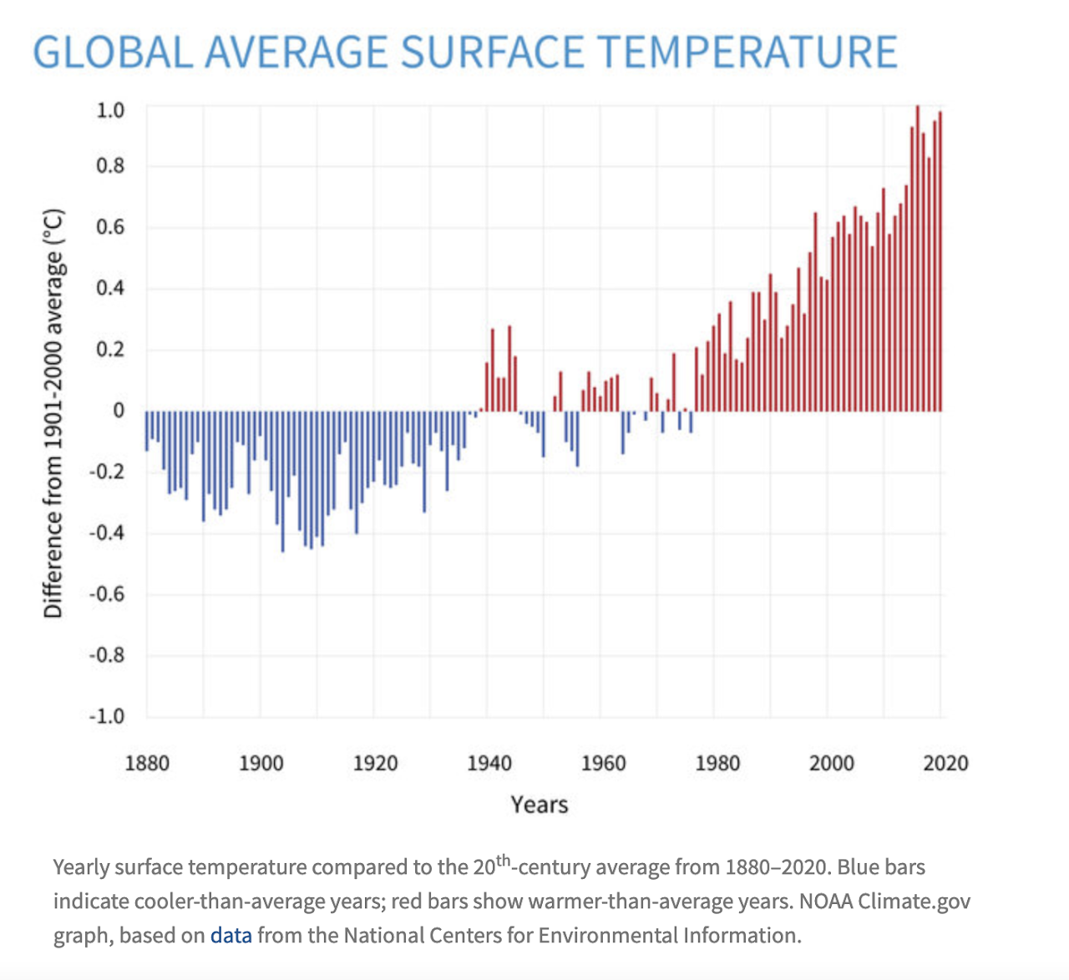
Like how we said before, thanks to technologhy, renewable energy produciton much cheeper than before. Wind energy is three times cheeper than before and solar energy is ten times cheeper than before.
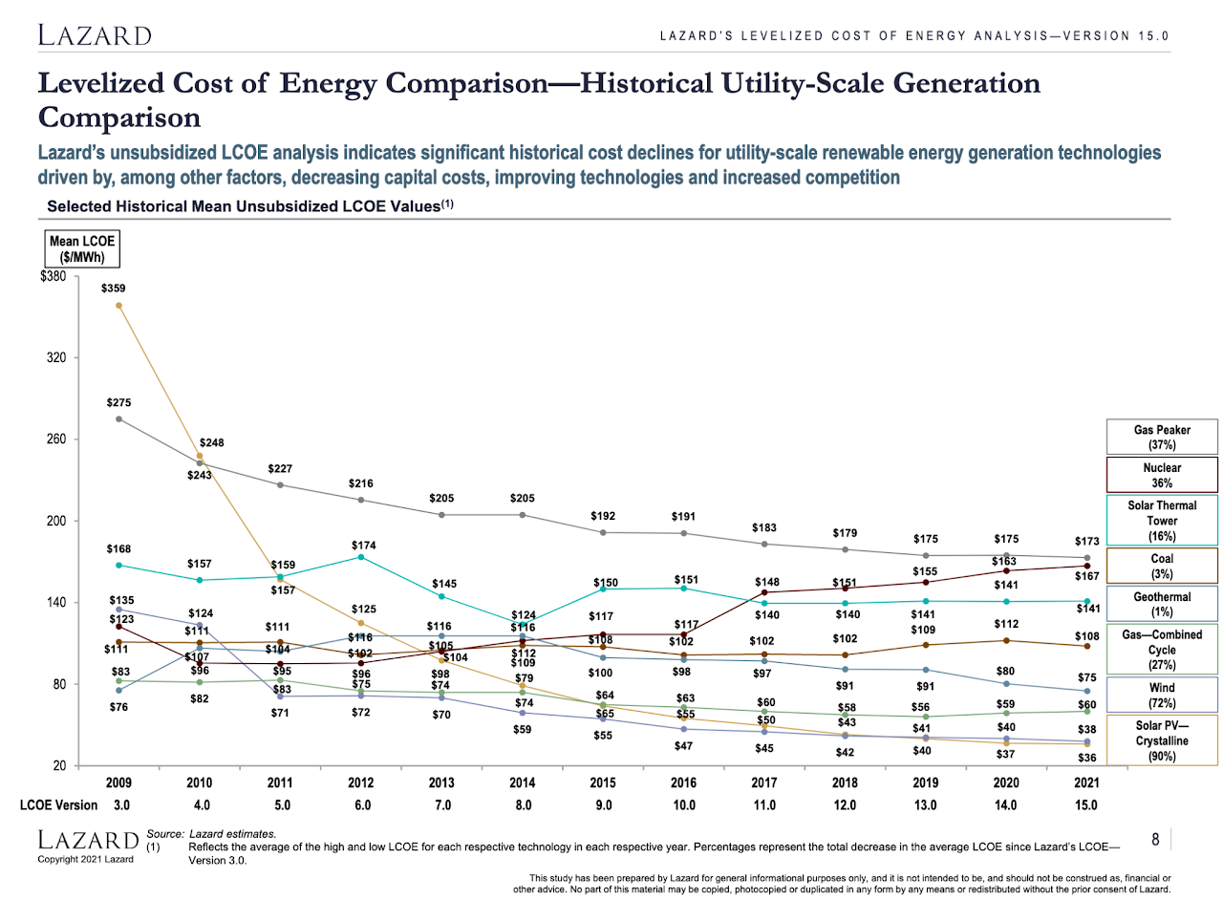
As a United Arab Emirates, we play a central role in the world’s energy economy as a supplier of fossil fuels, which gives us an important stake in finding solutions to cutting emissions while still providing the world with the energy it needs. We are at the frontline of the energy transition in the MENA region with strong government commitment and several milestones: the establishment in 2006 of the Abu Dhabi Future Energy Company Masdar and the first carbon-neutral zero waste city Masdar City, the hosting of the annual World Future Energy Summit in Abu Dhabi since 2008, the establishment of the Emirates Nuclear Energy Corporation (ENEC) in 2009, the International Renewable Energy (IRENA)’s designation of Abu Dhabi as its headquarters in 2009 and IRENA’s relocation on the edge of Masdar City campus in 2015, the development of strategic mega solar projects and its climate change action efforts culminating in the signing of the Paris agreement in 2016, the designation of a UAE Special Climate Change Envoy and we will bid to host Cop 28 in November 2023.
We are expecting that our renewables sector will continue to register robust growth over the coming decade with capacity growing at an annual average of 16.7 per cent between 2021 and 2030 to account for 11.3 per cent of the power mix by 2030. We are also looking to revisit our energy strategy with increased focus on solar energy and green hydrogen over the coming decade.

Sources
https://sites.google.com/view/sources-can-we-fix-climate/
https://www.cia.gov/the-world-factbook/countries/united-arab-emirates/#economy
https://www.trade.gov/energy-resource-guide-united-arab-emirates-renewable-energy
https://www.trade.gov/country-commercial-guides/united-arab-emirates-oil-and-gas
https://u.ae/en/information-and-services/environment-and-energy/climate-change/climate-change
https://inhabitat.com/the-10-countries-where-climate-change-and-pollution-is-killing-the-population/

