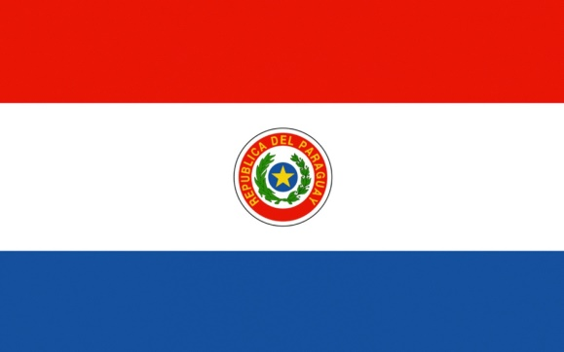Country: Paraguay  
Committee: JR UNICEF  
Agenda Item: Impacts of Covid-19 on Children

Paraguay, is a country which is in the South America continent. As the delegate of Paraguay, we are pleased to attend this conference. Because of Covid-19, almost 20 percent of children have not been able to get an education. We, as Paraguay, have been concerned about problems that have occurred because of Covid-19. For example, children, youth and adults have been in lockdown because of the pandemic, which caused massive negative effects on physical health. During the Omicron variant outbreak, there have been 1.15 million cases reported in 1 week, and there have also been 5.5 million cases reported in 2022.   
  
UNICEF, the World Health Organization (WHO) and more have stated children and youth between the ages 4-16 have been diagnosed with learning disabilities during the lock down that was caused by the pandemic. Due to the lockdown, education took place with online electronic devices and therefore children could not have fruitful education. 1 in 10 families doesn’t have enough electronic devices to support their children and work at home at the same time. We as Paraguay, suggest that devices can be sent to families in need or free internet can be provided.  
  
During the Omicron variant outbreak, there have been 1.15 million cases reported in 1 week, and there have also been 5.5 million cases reported in 2022.There are 18 people per square kilometer. There are currently 600 thousand cases in Paraguay. In addition, almost 9 percent of cases in Paraguay are children, which is around a whopping 50 thousand children. Since the pandemic and the lockdown began, almost 19 percent of cases have been children.  We suggest, as Paraguay, trying to raise awareness, educate the children.

Thanks for listening.