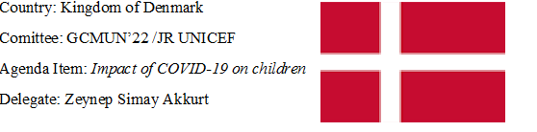

Kingdom of Denmark is a Scandinavian country that located in Europe. It is a country bordering the Baltic and North Seas. Most of Denmark is on the Jylland Peninsula. Its total area covers 2,210,579 square kilometers. Danish is the official language of the country and the currency of the country is Danish krone. The country has the highest number of business lines in the service sector and agriculture. Denmark first met with Covid-19 on 27 February 2020.
As the Kingdom of Denmark, part of the covid-19 process, we have taken many measures for children as any other country. We were among the first European countries to implement quarantine measures starting from March 13, 2020. We started to vaccinate children gradually starting from January 30, 2021.The first of two plans to be implemented for schools in Denmark during the pandemic period has been chosen. Schools were closed in Denmark on 16 March and homes were adjusted to school environment where parents are responsible for informal learning activities and formally ensuring their children follow the curriculum. Additionally, although schools provided online instruction or guidance during the quarantine, the school day has shortened significantly, which – coupled with the closure of most other organized activities – meant that children had more free time at home. This has led children to use the internet significantly. We have a population of 5,831 million in the Kingdom of Denmark and accordingly the internet users are quite high. During the quarantine, we opened a helpline where patients, children and their relatives can contact a rehabilitation counselor and ask questions about COVID-19 to reduce the impact of it on each person. From now on, with the effects of COVID-19 almost over through the measures we have gradually reduced.
From now on, there are only two things we have to do. First of all we need to follow the hygiene rules for this good cause and secondly we’ll take necessary precautions to decrease the number of the cases. As a result, all of our children will be able to go back to the days that they were happy and social. As the delegate of Kingdom of Denmark, we hope we can work together to end this suffering

