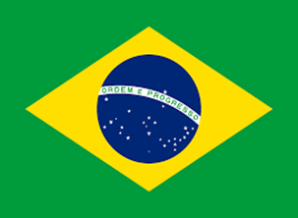
Country: Federal Republic of Brazil
Committee: JR UNICEF
Agenda Item: Impacts of Covid-19 on children
Brazil, officially the Federal Republic of Brazil, is the largest and crowded country in South America. Its capital is Brasilia. It borders all South American countries except Ecuador and Chile. As of 2021, the population of Brazil, which is the sixth most populated country in the world, is approximately 213,317.639 people. The largest cities in Brazil with a population of over 1 million are São Paulo and Rio de Janeiro. Its official language is Portuguese. Brazil is the largest country with Portuguese as an official language and the only country in America. It is also one of the most multicultural and ethnically diverse nations, due to over a century of mass immigration from around the world. The colors on the Brazilian flag represents ancient royal families, not forests and mines.

COVID-19 has harmed lots of people in Brazil as in every country. However, it hurt children the most. The Brazil ranks second with the most deaths of children from the coronavirus in the world. Unfortunately child mortality and fatality rates in Brazil are also among the highest compared to the other countries. The rate of domestic violence has increased due to the pandemic. For this reason, the psychology of children was badly affected. Sadness and nervousness in Brazilian youth was high in the Covid-19 pandemic. Also, in November 2020, more than 5 million boys and girls aged 6 to 17, didn’t receive education in Brazil. More than %40 of children were aged 6 to 10 years. Brazilian Ministry of Health has so far reported 832 deaths in children aged five years and younger. There is too much separation between the rich and the poor in Brazil. In fact, the number of deaths caused by not being able to receive the necessary health service because of poverty is very high.
As the Federal Republic of Brazil, we’re aware of this issue, which is a really huge and a horrible problem for humanity. We recommend all the countries to unite and overcome this crisis. Everybody should be aware of this problem because today’s children will be the future leaders. Therefore, every single country should try their best to save the children. In addition, we wanted to remind you that we’re always ready to take action. We urge you to find the best and necessary solution that is needed to reduce the impacts of the pandemic on children.

