Country: Saudi Arabia
Comitte: Disarmament and International Security Comittee
Topic: Weaponization of Data and Cyber Security

In today’s world we all have access to all kinds of knowledge that we could use to; gain knowledge, use for our projects,homeworks etc. But it could be a real danger because of the misinformations, trolls, hacking events and every data that we have used could be fake and unfortunately its out of control. Therefore we must check before using the data.

1. Cybersecurity Measures
Saudi Arabia has the largest information and communication technology market in the Middle East and it makes our country the target of cyber attacks. For example 22.5 million atacks took place in 2020 alone and its a big economic disruption and it makes a issue of trust to our systems. Since the first attack we introduced a series of measures to reduce it. In March 2021 Ministery of Education and the National Cybersecurity Authority signed an agreement to launch joint training and research programs in the field of cybersecurity. So are trying to develop our cybersecurity systems.

2.Ethical Aspects
Misinformation is a problem in our country. Study of a journal shows that despite the importance of the true information during COVID-19 pandemic, many of our citizens doesn’t considered the misinformation and thats what we should notice and think about. %91 of our population is actively uses social media and that makes our country the target of the misinformation.If we also think about gathering the personal data, ie. choices,thoughts,habits and worldview the danger is increasing. In order to prevent spreading of misinformation, we control and censor the content of internet. If we dont control them it will provacate the public in a chaos plus it impairs the authority of the goverment.
3.Legal Aspects
As we have a lot of misinformation we are trying and improving our law in order to get over it.For example according to Article 6 of the Law, gambling, human trafficking, pornography or any computer program or internet content that may be deemed to be against Islam or public morals and order; Prohibited to produce, possess, distribute, broadcast or store. And we have a regulation about the local producers, many publications are banned and censored by being included in the scope of terrorist acts, with abstract definitions such as activities that disrupt the public order, shake the integrity of the society, endanger the unity of the nation and the state, and damage the reputation of the state.
The whole internet traffic of our countr y is controled by King Abdulaziz Science and Technology Center and the secure computing fitting system is applied also 1982 dated law of censor is a thing to protect our country from all of misinformation that could come from a book, news paper and magazine. With the basic management law that came into force in 1992, an arrangement was made here as well. But about the filtering the first legal thing is a 2002 dated decree.

4.News Credibility

An analysis shows that a total of 34 out of 109 tweets (31.2%) in the dataset used in this study were classified as untrustworthy health information. These came mainly from users with a non-health care background and social media accounts that had no corresponding physical manifestation and traditionally trusted health sources are more accurate and trustworthy compared to that. Another interesting point is tweets posted in the morning are more trustworthy than posted at night.
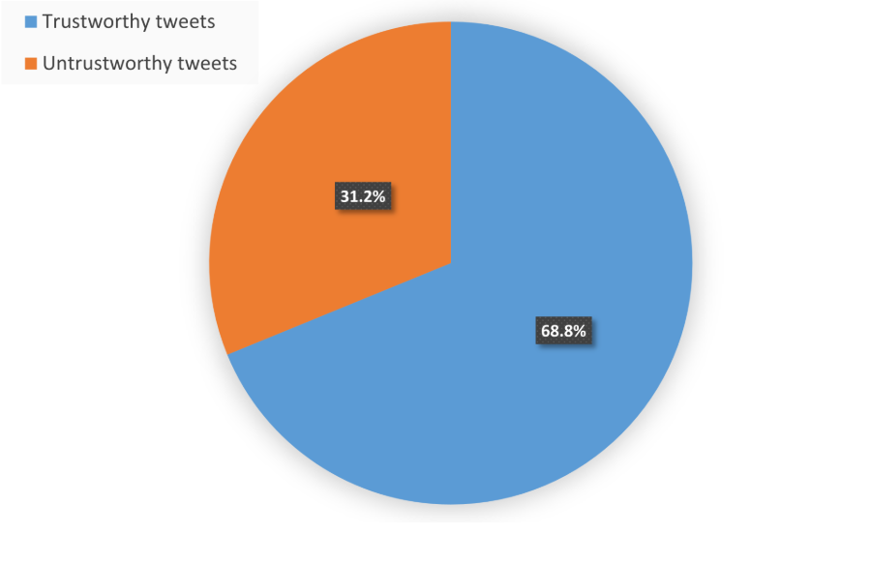
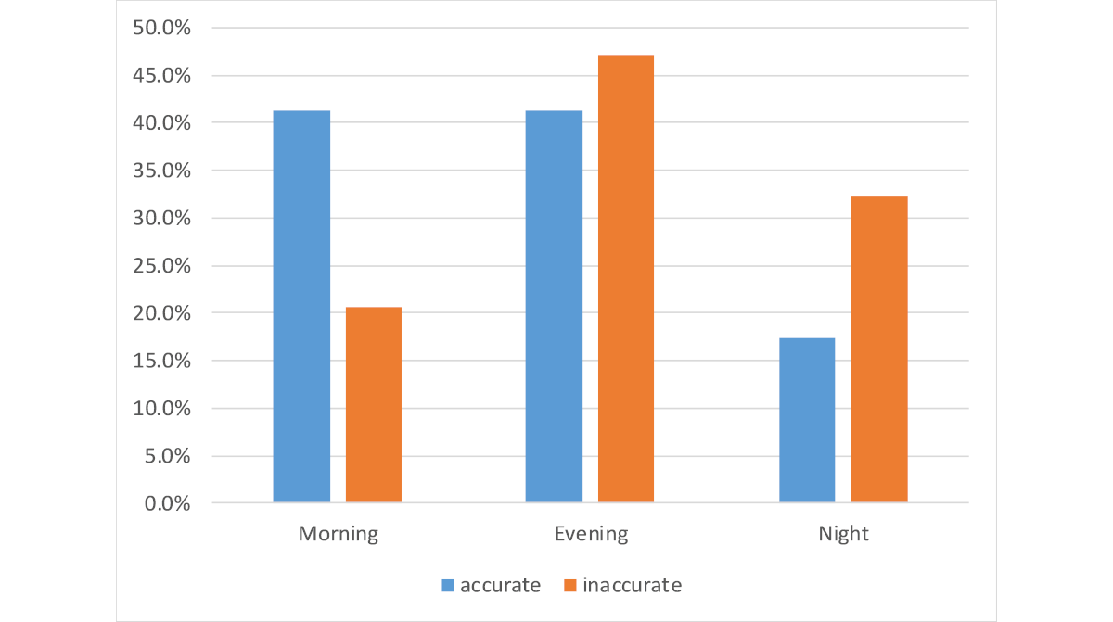

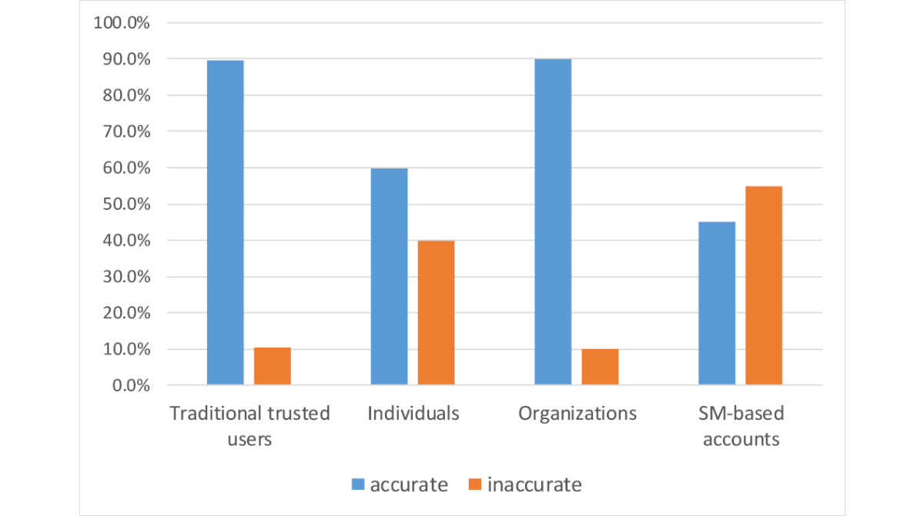

5.Solution Ideas
-There should be checking internet more and especially the things that could put community in a chaos.
-All countries should have a unit that will research about the misinformation and untrustworthiness because it could be a real danger.
-Penalties should be more deterrent.
-Informing the people about the danger is a crtitical point.
-A reporting system could be useful to avoid misinformation flow.
-Universitys about cyber protection and development would be a chance to prevent an outher attack.

Resources
-https://www.researchgate.net/publication/336346548_Trustworthy_Health-Related_Tweets_on_Social_Media_in_Saudi_Arabia_Tweet_Metadata_Analysis
-https://www.ijonses.net/index.php/ijonses/article/view/273
-https://www.jmir.org/2019/10/e14731/
-https://threatcop.com/blog/cyber-attacks-in-saudi-arabia/
-https://ine.org.pl/en/cybersecurity-in-saudi-arabia/
-https://en.wikipedia.org/wiki/Censorship_in_Saudi_Arabia

