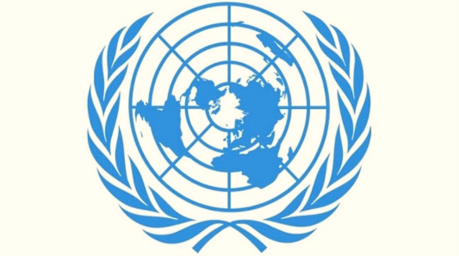

TOPIC: PREVENTING CHILD TRAFFICKING IN LESS DEVELOPED AND DEVELOPING COUNTRIES
COMMITTEE: UNICEF ( UNITED NATIONS INTERNATIONAL CHILDREN’S EMERGENCY FUND )
COUNTRY: FEDERAL REPUBLIC OF GERMANY
DELEGATE NAME: ROJİN
SCHOOL: ÇAYYOLU FİNAL SCHOOLS

• As a Federal Republic of Germany attach credence to must all begin by shining a light on violence and speaking up no matter where it occurs. By making the Invisible Visible. We must all begin by shining a light on violence and speaking up no matter where it occurs. By making the Invisible Visible. Let's reinforce this with a saying of the old years; ‘The death of one man is tragic, the death of ten people is dramatic, and the death of a million people is just a statistic. — Josef Stalin’. As much as we protect the bellies and minds of children, we must listen to the lives dedicated to them and their minds that they want to escape hope from evil. Because death is not an end that consists of four letters, it is not an easy thing, the greatest right of every soul is to live.
•Germany continued to be UNICEF’s second-largest resource partner, growing its 2021 contribution to $868 million in multi-year support. At the same time, Germany has been a champion for flexible funding, both in core resources and thematic funding. Germany is the first public sector partner to support the thematic area of safe and clean environments with flexible funding.
UNICEF’s partnership with the Government of Germany has a particular focus on the Middle East; West Africa; East and Southern Africa.
In 2021, Germany continued its strong investment in unearmarked, multi-year core contributions to UNICEF. It was the top resource partner to child protection; water, sanitation and hygiene (WASH); safe and clean environments; and social protection, inclusion and governance programme areas.
•In these developing and underdeveloped countries, there is a problem of human trafficking, which is the more general form of child trafficking. As simplified as it may seem, this issue is actually a universal problem with many things behind it.

•The Government of Germany complies with the minimum standards for the elimination of trafficking, but has not implemented European Union recommendations to reduce sexual slavery. The government made substantial progress in addressing forced labor. Available statistics indicate the majority of convicted labor and sex trafficking offenders were not required to serve time in prison, raising concerns that punishments were inadequate to deter traffickers.
• Ninety percent of identified victims of trafficking for commercial sexual exploitation came from Europe, including 28 percent from Germany, 20 percent from Romania, and 18 percent from Bulgaria. Non-European victims originate in Nigeria, other parts of Africa, Asia, Europe and the Americas. Almost one-quarter of identified trafficking victims were children. The majority of identified sex trafficking victims have been exploited in bars, brothels, and apartments – approximately one third of identified sex trafficking victims reported that they had agreed initially to engage in prostitution. Victims of forced labor have been identified in hotels, domestic service, construction sites, and restaurants.
Most convicted traffickers are not required to serve time in prison; however, the Government of Germany has made some progress regarding the conviction of sex and labor trafficking offenders. Germany prohibits all forms of trafficking; trafficking for commercial sexual exploitation is criminalized in Section 232 of its Penal Code, and forced labor is criminalized under Section 233. Prescribed punishments in these statutes range from six months’ to 10 years’ imprisonment.
• In 2023 and the other years, UNICEF and Germany will continue to expand joint programmes in MENA and East and Southern Africa as well as explore new opportunities for cooperation in the West and Central Africa it goes without saying all of the other countries within this map something out.
To improve the lives of children affected by conflicts and crises joint focus areas will include health, nutrition, child protection, education and water, sanitation and hygiene.
Together we will continue to collaborate on key policy dialogue issues of common concern including education in emergencies and strengthening the capabilities of government, communities and families to withstand shocks and crises.

