Country: Republic of Korea (South Korea)
Committee: Disarmament and International Security Committee
Topic: Weaponization of Data & Cyber Security
Every now and then we have been able to access any kind of data; news, theorical information, articles, many sites like Wikipedia that our students use for their home works and their thesis. The more we get access to data the more the internet gets wide, more full of information more dangerous. Every single data, every single information gets a possibility of getting hacked, stolen, getting in wrong hands and even exposure of the most precious and the most sacred data. The growth of “fake news” is getting more uncontrollable over the years and eventually it will get out of hand. Misinformation is big problem of our day. It can be classified as “ false or misleading content including hoaxes, conspiracy theories, fabricated reports, click-bait headlines, and even satire.” The more technology develops the more we get cyberattack threats, more fake news and more misinformation about mostly everything.
1) Cybersecurity Measures
The Republic of Korea is in the 1st place for the most digitally connected countries in the world with and overall “connected score” of 9.55 out of 10, so this makes us vulnerable to cyberattacks. These attacks can wreak havoc on institutions, disrupt the economy, and erode social trust. Our strategy is built around six strategic pillars: secured national critical infrastructure, enhanced cyberattack defense capabilities, trust– and cooperation-based governance, cybersecurity industry growth, fostering a cybersecurity culture, and strengthened international cooperation.
2) Ethical Aspects
Disinformation has long spread through a South Korean media ecosystem that combines online platforms with more traditional newspaper and broadcast outlets. As the Republic of Korea our experience with disinformation contains important lessons for other democracies on how to address this challenge. It’s crucial to bar government intelligence and military officers from domestic influence operations. For example, during the impeachment of ex-President Park Geun-hye in 2017, an internal investigation revealed that intelligence agents and military officials had engaged in political astroturfing to ensure Park’s election victory in 2012. Under the auspices of former director Won Sei-hoon, the National Intelligence Service (NIS) tasked 30 “extra-department teams,” including tech-savvy civilians, to spread pro-government opinions and slander anti-government views. In conclusion, Won Sei-hoon was sentenced to four years in prison for orchestrating an online smear campaign. Additionally, amid a deluge of disinformation around COVID-19, South Korea has mounted a mostly successful response to the pandemic. Openness and transparency lay at the heart of South Korea’s response, in which public-health officials took center stage. One crucial tool was effective health communications. To avoid an information vacuum and to maintain public awareness, South Korean authorities provided the public with updated information on a variety of platforms, including via twice-daily press briefings, text messages, and social media posts. The government also strengthened public-private partnerships to facilitate fact-checking, including by funding Fact Checker Net, an open platform for experts and ordinary citizens to confirm the veracity of COVID-19 reporting. Such tools and techniques offer a model to safeguard against politicized communications regarding future crises.
Despite all of this we, as the Republic of Korea, have taken steps to address online manipulation through prosecutions and investigations and it has demonstrated how the state can communicate effectively during crises like COVID-19. While it still remains a major challenge to us, that didn’t prevent effective state communications during the COVID crisis.
3) Legal Aspects
As like other countries like us, Republic of Korea, faces many misinformation and “fake news”. This mostly comes from our elder populations. Like people everywhere we are exposed to mountains of humbug. A noisy minority of mostly elderly right-wingers watch YouTube channels that spread misinformation about vaccines, American politics and the ex-president Moon Jae-in’s supposed chumminess with North Korea, the Chinese Communist Party, the devil, or all three. Most people get their news from online aggregators whose algorithms reward sensationalist clickbait and which take little responsibility for resourcing. Unsurprisingly, less than a third of South Koreans say they trust the news. Republic of Korea is all trying to prevent these situations by prosecuting and investigating every single detail of online manipulation.
4) News Credibility
Trustworthiness of news in South Korea 2021, by type of source
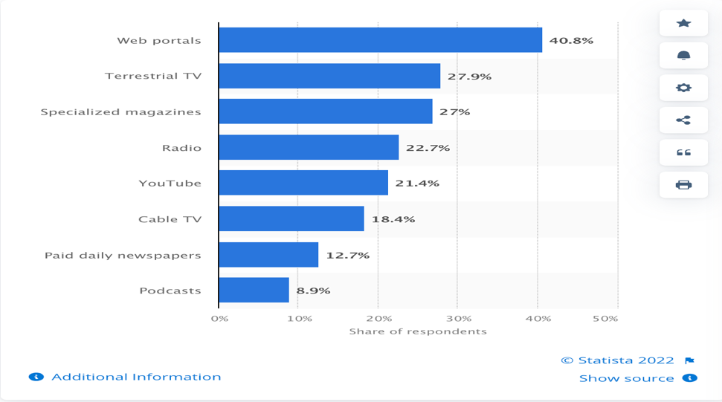
- According to a survey conducted in May 2021, around 40.8 percent of South Koreans stated that they considered web portals to be reliable source for news. Around a quarter of respondents also considered terrestrial Tv and magazines specializing in a given field to be trustworthy news sources. So overall the statistic given above shows that less than half of South Koreans across all age groups trusted the news in 2021.
Online counterparts and independent web-based newspapers, as well as exploring which factors influenced credibility of online sources during the 2004 general election in South Korea. Independent web-based newspapers were considered more credible for political information than either traditional media or their online counterparts. Reliance on online and traditional sources tended to be stronger predictors of credibility of online sources and political variables, such as campaign interest, political involvement and voting, also turned out to be significant predictors. Based on the findings, a shift in media credibility in Korea is discussed.
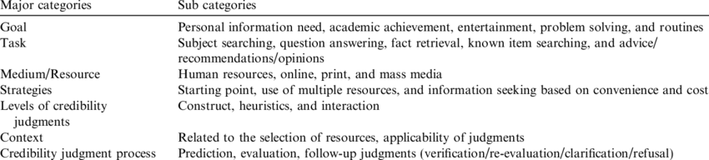
Coding categories of data analysis.
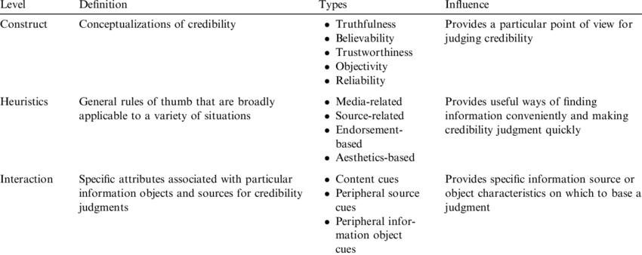
Three levels of credibility assessment.
Solution Ideas
* Prosecutions can be increased more including charges such as prison sentences, compensations…etc.
* More advanced data systems to detect any kind of possible cyberattacks and strengthening data systems’ construction.
* Government and military officers getting trained more thoroughly for these kind of situations mentioned above for more effective intervention.
* Checking every single content that is being uploaded in every single platform as much as possible.
* Improving censorship on any kind of content that might give people any kind of wrong idea or directing them to a wrong path.
* Increasing cybersecurity systems to their top performance and installing top of the class cybersecurity systems to people’s PC, phones or any kind of technological device and to places that hasn’t set it up yet or hasn’t own any.
* Encouraging people to keep their software and systems up to date.
* Reporting the false information to the platform administrators, double checking (verifying) the shared information
* Giving students lessons about how to differentiate “fake news” and misinformation as well as how to protect their personal information from cyberattacks.
Resources
1) https://carnegieendowment.org/2021/08/17/korean-policies-of-cybersecurity-and-data-resilience-pub-85164#:~:text=The%20strategy%20is%20built%20around,culture%2C%20and%20strengthened%20international%20cooperation.
2) https://www.brookings.edu/techstream/lessons-from-south-koreas-approach-to-tackling-disinformation/
3) https://www.economist.com/asia/2021/09/25/south-koreas-plan-to-fight-fake-news-could-hobble-real-journalism
4) https://journals.sagepub.com/doi/10.1177/1748048509102182
5) https://www.statista.com/statistics/1270724/south-korea-news-reliability-by-source-type/
6) https://mailchimp.com/en-ca/resources/fake-news-on-social-media/?gclsrc=aw.ds&gclid=CjwKCAjw7vuUBhBUEiwAEdu2pP4h03ZPXOOKcIM9V76uuMhfzKBWn1_icz6Xww4zthX2mJqsJ7JVaxoCFw8QAvD_BwE
7)https://www.researchgate.net/publication/239431607_A_Shift_in_Media_CredibilityComparing_Internet_and_Traditional_News_Sources_in_South_Korea
8) https://www.telecomstechnews.com/news/2021/jul/06/research-these-countries-are-the-most-connected-in-the-world/

