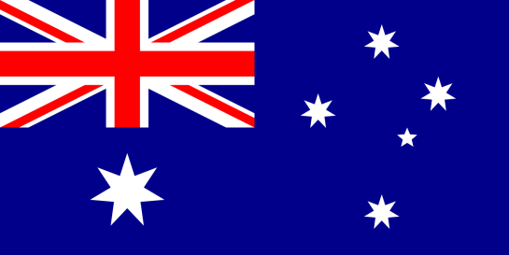
Country: Australia
Committee: DISEC
Topic: The Status of Donbas Region and the Oppression on Donetsk and Luhansk
Delegate: Mehmet Salih Dede

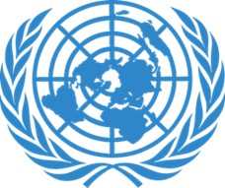
POSITION PAPER
The Commonwealth of Australia, is a sovereign country comprising the mainland of the Australian continent, the island of Tasmania, and numerous smaller islands. There aren’t any official languages at the federal level but English is the most spoken one. Canberra is the capital city of the country, while the largest city is Sydney. Australia's population is nearly 26 million and area of the country is 7,617,930 square kilometers. The currency is Australian dollar (AUD).

At first we would like to say we feel very sad about that this situation between Russia and Ukraine. Civilians in the Donbas region and at the Ukraine are one of the things that suffer the most from this situation, we absolutely do not like and condemn this conflict causing harm to civilians. As a republic of Australia we have provided and will continue to provide financial and any kind of support for Ukraine. We supporting Ukraine with our hearts and believe everything is will be better for everyone.

Our country was affected by this war like other countries. As the result of this war is likely to affect things like Australia's terms of trade, fuel and grocery prices and interest rates. We hope we take the minimum damage we can take. Again we believe everything is will be good and peaceful. Our hopes are that this war will end and there won’t be any other deaths. We hope our wishes comes true as soon as possible.

