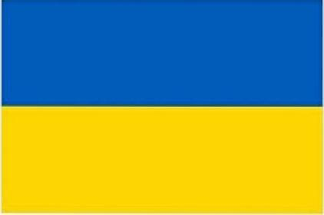
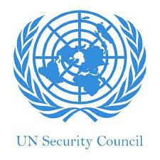
v

Country: Ukraine
Committee: UNSC
Topic: Nuclear Disarmament and İnternational Security
Delegate: İbrahim KÜÇÜK

ABOUT OUR COUNTRY
Ukraine is a country in Eastern Europe.It is the second largest country in Europe arter Russia, which borders it to the east and north-east. Ukraine also shares borders wih Belarus to the north; Poland,Slovakia and Hungary to the west ; Romania and Moldova to the south ; and has a costline along the Sea of Azov and the Black Sea. It covers about 600,000 km² with a population of about 40 million. The nation’s capital ad largest city is Kyiv . The offical and national laguage is Ukrainian, and most people are also fluent in Russian.

ABOUT NUCLEAR DISARMAMENT FOR UKRAİNE;

Ukraine have a bigger nuclear area than some countries nuclear area but The don't support nuclear weapons.
Ukraine had a nuclear explosion in the past so this nuclear explosion affected every where in other way.
Ukranian people are very unhappy because Ukraine had a so many dead people but it didn’t make us to lose nuclear power.We produce energy other way but nuclear energy is a very successful way to conpansate our energ

WHY WE HAVE TO USE NUCLEAR ENERGY EFFEİCİENT
-Don’t waste nuclear energy because producing nuclear energy is very hard.
-Nuclear energy is the most expensive energy than the other energy ways.
-Nuclear energy is very important because nuclear energy is everywhere so when we waste nuclear energy maybe we would have some disruptions in the work .

