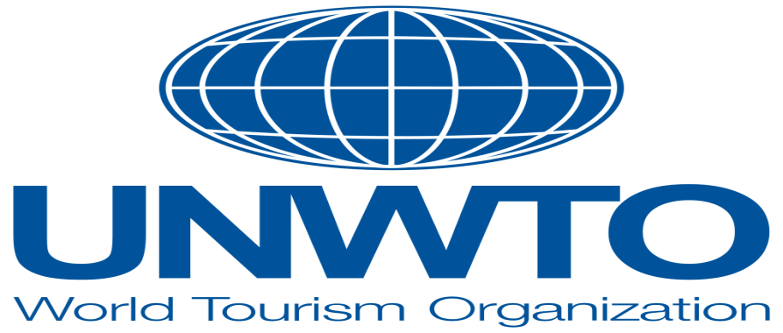
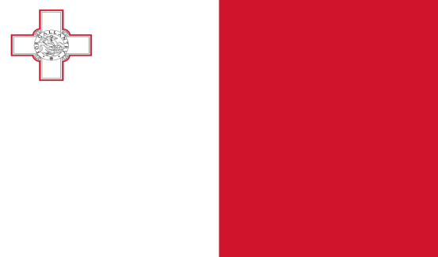

Country: Republic of Malta
Committie: World Tourism Organization (UNTWO)
Delegate: Tuna Güler , Sırrı Yırcalı Anadolu Lisesi

Republic of Malta is an island country in the European Union consisting of an archipelago in the Mediterranean Sea,and considered part of Southern Europe. It lies 80 km (50 mi) south of Sicily (Italy) 284 km (176 mi) east of Tunisia and 333 km (207 mi) north of Libya. The official languages are Maltese and English, and 66% of the current Maltese population is at least conversational in the Italian language. Malta has been inhabited since approximately 5900 BC. Its location in the centre of the Mediterranean has historically given it great strategic importance as a naval base
With a population of about 516,000 over an area of 316 km² (122 sq mi), Malta is the world's tenth-smallest country in area and fourth most densely populated sovereign country. Its capital is Valletta, which is the smallest national capital in the European Union by area and population.
Malta became a British colony in 1813, serving as a way station for ships and the headquarters for the British Mediterranean Fleet. It was besieged by the Axis powers during World War II and was an important Allied base for operations in North Africa and the Mediterranean. The British parliament passed the Malta Independence Act in 1964, giving Malta independence from the United Kingdom as the State of Malta, with Elizabeth II as its queen. The country became a republic in 1974. It has been a member state of the Commonwealth of Nations and the United Nations since independence, and joined the European Union in 2004; it became part of the eurozone monetary union in 2008.
Tourism in Malta is an important sector of the country's economy, contributing to about 15 percent of the nation's gross domestic product (GDP). Malta has a long and rich history, and this is reflected in the island's cultural attractions. The Phoenicians, the Carthaginians, the Romans and the Byzantines have all occupied Malta at some point in history, leaving a mix of many different architectural styles and artifacts to explore. There are also a number of aquatic activities to enjoy on Malta as well as Gozo and Comino.
Major event tourism especially events centred on Catholicism, is an important segment of the Maltese tourism sector. During Holy Week, processions and religious services dominate the country and food stalls are set up in the village squares of Malta. nother popular major event is Carnival, a five centuries-old traditional celebration lasting for the five days preceding Ash Wednesday. Celebrations for Carnival involve float-based pageants, street parties and street food stalls. They are mostly Roman Catholic.
Medical Tourism since 2010, the Malta Tourism Authority has been marketing Malta as a medical tourism destination. Focus areas for medical tourism include cosmetic surgery, orthopedics, ophthalmic, neurological, urological, oncology, diagnostic, bariatric and cardiac services.
Educational tourism highly contributes to the number of yearly inbound tourists in Malta. In recent years Malta has successfully become a dominant country in the ESL (English as a Second Language) industry. This can be attributed to the fact that English is an official language in Malta, as well as the congenial climate, cultural and historical heritage, the safe environment and high standard of living.

