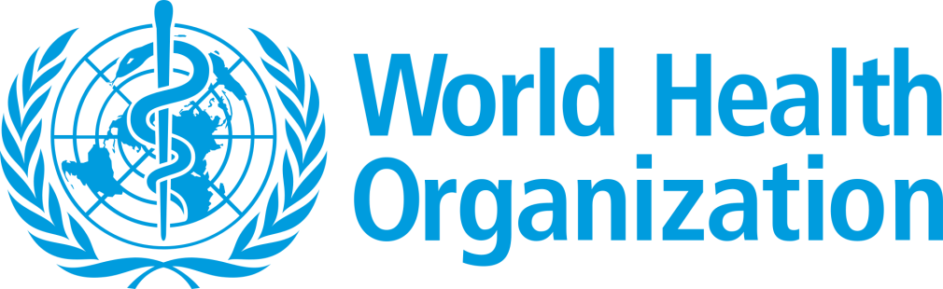
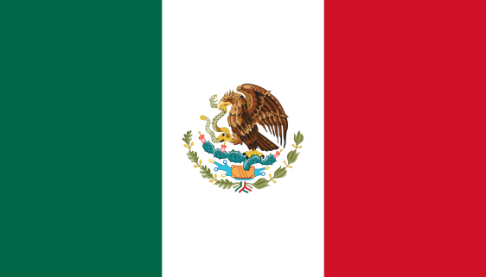
Country: United Mexican States
Committie: World Health Organization (WHO)
Delegate: Halil Kutay Taşaron , Sırrı Yırcalı Anadolu Lisesi

Mexico, officially the United Mexican States, is country in the southern portion of North America. It is bordered to the north by the United States of America; to the south and west by the Pacific Ocean; to the southeast by Guatemala, Belize, and the Caribbean Sea; and to the east by the Gulf of Mexico. Mexico covers 1.972.550 square kilometers. it is the 10th-most populous country and has the most Spanish-speakers.
Mexico is a developing country, ranking 74th on the Human Development Index, but has the world's 15th-largest economy by nominal GDP. United States of America is its largest economic partner.
Total health expenditure represented around 5% of GDP in 1995, which went up to around 6.2% in 2012; however, in 2015 it declined to 5.6%. Historically, out-of-pocket expenditure has been a big portion of health expenditure, going from around 56% in 1995 to below 50% since 2008, with the most recent data being 40.6% .
Healthcare in Mexico is provided by public institutions run by government departments, private hospitals and clinics, and private physicians. Every Mexican citizen is guaranteed no cost to access to healthcare and medicine.

Diabetes is a serious problem in United Mexican States. In 2011 alone, health spending attributed to diabetes in the country amounted to almost eight billion dollars.

Obesity in Mexico is a relatively recent phenomenon, having been widespread since the 1980s with the introduction of processed food into much of the Mexican food market. Prior to that, dietary issues were limited to under and malnutrition, which is still a problem in various parts of the country. Following trends already ongoing in other parts of the world, Mexicans have been foregoing the traditional Mexican diet high in whole grains, fruits, legumes and vegetables in favor of a diet with more animal products and processed foods.

Cost of healthcare services in Mexico is variable and dependent on the nature of the service and the institution utilized. Generally, health costs associated with use of the public healthcare sector are higher than their private counterparts.
National health policy and reforms since 1983 have aimed to integrate the segmented health system into a more coherent whole to attain greater equity and efficiency.
Factors that have demonstrated influence on the magnitude of accessibility available to healthcare include sparse distribution of institutional resources, and lack of specialized care services in isolated populations. Case studies involving clinical management of diarrheic disease in rural communities have emphasized concerns relating to the quality and range of services available to more isolated populations. Accessibility as it relates to rural communities has been a heavily studied topic and work here has revealed the existence of great disparities in breadth and effectiveness of services offered. Issues related to accessibility of specialized services, especially institutions offering forms of care related to , are prevalent in rural communities. Factors such as location, transportation, and the economic cost of implementation are the main factors associated with this.

COVID-19 was confirmed to have reached Mexico in February 2020. The National Council of Science and Technology (CONACYT) reported two cases of COVID-19 in mid-January 2020. On January 30, 2020, before the declaration of a pandemic by the World Health Organization the Government of Mexico designed a Preparation and Response Plan that was made by the National Committee for Health Safety, a working group led by Secretariat of Health composed by different health entities aiming to act upon the imminent arrival of the pandemic. This group carried out a series of alert measures, rehabilitation and updating of epidemiological regulations based on the International Health Regulations, being the first Latin America country that deployed a mathematical model of infectious disease. 1,584 deaths were confirmed on January 19, the highest single-day record since the pandemic began. Total Coronavirus Cases in Mexico is 5.740.080 and total Coronavirus Deaths in Mexico is 324.530

